Seventeenth Sunday in Ordinary Time July 27, 2014

Mass Intentions / Peticiones de Misa

Vacation Bible School (VBS)
August 11-14, 5:30-8:30 p.m.
Monday-Thursday
PK-6th Grade
Register Now!

Children's Mass,
Sunday, August 17 at 10 a.m.

Sat | Jul 26 | 4:00p D | 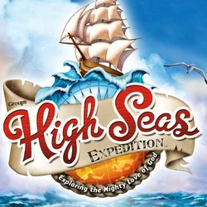(+)Jo Ann McCoy by Bill
 |  | 6:00p R | For the Parishioners
Sun | Jul 27 | 8:00a M | For the Parishioners
 |  | 10:00a D | (+)Jo Ann McCoy by Bill
 |  | 12:00p W | For Good Health for Susan Perry by Her Father
 |  | 2:00p D | Special Intention
Mon | Jul 28 | 12:10p D | (+)Milton Kalsu by  Joe & Nancy Litsch
Tues | Jul 29 | 12:10p D | (+)Al Bernal by Ann Boice
Wed | Jul 30 | 12:10p D | Int of The Moses Family
Thur | Jul 31 | 12:10a D | Int of Fr. Alan McDonald
Fri | Aug 1 | 7:00p D | For the Living & Deceased Members of the Knights of Columbus
Sat | Aug 2 | 4:00p D | For Good Health for Susan Perry by Her Father
 |  | 6:00p R | For the Parishioners
Sun | Aug 3 | 8:00a M | (+)Joe Lockovich by Marilyn Smith and Kay Johnson
 |  | 10:00a D | (+)Al Bernal by  Suzanne Bernal
 |  | 12:00p W | (+)Jay Kalvzny
 |  | 2:00p D | (+)Margaret Ramirez
Many Special Blessings, Fr. Peter
on the Fifteenth Anniversary
of your Ordination!
FIRST FRIDAY ADORATION
ADORACIÓN _{DEL} 1er VIERNES
August 1
from 12:30 pm (after mass) - 9 pm
Benediction will be from 8:45 - 9 pm
de 12:30 pm (después de misa) - 9 pm
La Bendición será de 8:45 - 9 pm

Catholic Food Bank
From January 1 through June 30, 2014 we served 1,905 families for a total of 5,588 people! Thank you to everyone for your generous support of our Food Bank!

Main Sanctuary Project Renovations Goal $27,000
As you can see the renovations of our church
through your generosity are almost completed. $25,000
However, the main sanctuary which includes the main
wall with the crucifix is still in need of the major update. $20,000
Therefore, as of this weekend we will take up second
collections for this project. The cost of the insulation, $17,000
lighting and facing of the wall is $27,000. Currently $15,000
we have $12,300 in our building fund designated $10,000
for this project. Hence, we still need $14,700. $5,000
Thank you for your generosity and support. May God Bless you! $3,000

You can have a Mass said for someone's intentions at their birthday, wedding, baptism, or in memory of your deceased loved ones. Contact he office for days and times that you wish to have the Mass celebrated. What a precious gift!

Abuse of Minors Pastoral Response Hotline 405-720-987 or DHS at 1-800-522-3511. Línea Telefónica Pastoral para Reportar Abuso de Menores 405-720-9878 o el Departamento de Servicios Humanos al 1-800-522-3511.

!!!Religious Education News!!!
The Religious Education 2014-2015 Program will begin on Wednesday, September 3 (6-7:15 pm) for grades 1-8 and September 7 (5-6:15 pm) for grades 9-12/Confirmation. By our Baptism, we are called to share the Good News. Please consider your gifts and talents. If you would like to be a part of helping our children become excited about God please contact Maria Martinez 580-467-0184 or Pat Neal 580-255-0590 or talk with Fr. Peter. There are many ways to help!
El programa de Educación Religioso para 2014-2015 comenzara septiembre 3 para grados 1-8 y septiembre 7 para grados 9-12/Confirmación. Por nuestro bautismo, somos Ilamados a dar la Buena Nueva. Considera los regalos y talentos que Dios te ha regalado y si quieres formar parte en ayudar que a los niños conozcan de Dios por favor de comunicarse con Maria Martinez 580-467-0184, Pat Neal 580-255-0590, o hable con Padre Pedro. Puedes ayudar de muchas formas.

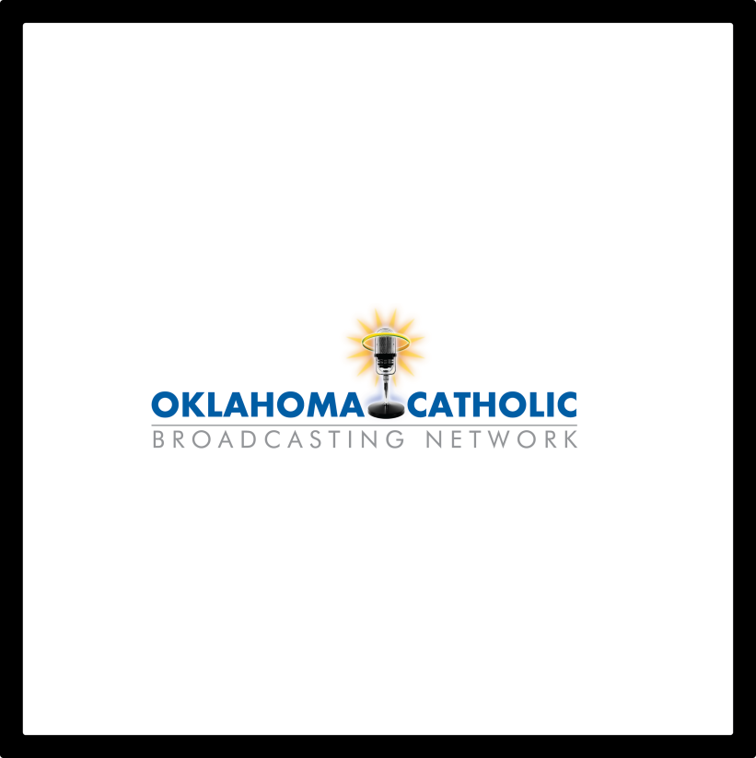
“Bringing quality Catholic programming to the Oklahoma air waves.”
Find us on your radio dial at:
97.3 FM Oklahoma City
88.3 FM Lawton Tambien en español:
Se puede escuchar los programas en español desde las 13:00 hasta anochecer de lunes a viernes - 890 AM Oklahoma City and 1570 AM Tulsa.
If you cannot pick up any of the area stations, you can listen online through our website at www.okcatholicbroadcasting.com and click on “Listen Online”. We hope to bring Catholic Radio to your area as well as other small communities in Oklahoma. CONTACT US at 405-255-7348. You may also email Jeff Finnell, President, OCB at jeff@okcatholicbroadcasting.com or Marlene Stapp, Secretary, OCB at mstapp4@gmail.com.

Emmaus Days is a retreat for young men in high school and recent graduates who want to learn about the call to the priesthood and explore their relationship with God. The retreat will be Tuesday, July 29 to Thursday, July 31. The retreat is held at Our Lady of Guadalupe Catholic Youth Camp in Arcadia, OK and is sponsored by the Vocations Office. There is no cost for this retreat. For more information contact the Vocations Office at 405-721-9351, e-mail jmulligan@archokc.org or complete an online registration form at http://archokc.org/vocations/home.

South Region -
Archdiocesan Council of Catholic Women (ACCW)
Planning Meeting Saturday, August 9 at Immaculate Conception Church in Marlow at 11 a.m. Lunch will be provided.

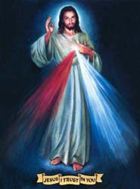
We pray the Chaplet of Divine Mercy and the Rosary
Monday through Friday
at 11:45 a.m.
before the 12:10 Mass.

Everyone is invited to
participate and
spend time with Jesus!

DUNCAN COLLECTIONs FOR july 19-20:
Duncan: $2,641.80
Weekly Electronic Donations: $1,200.00
Building: Sanctuary Project: $5,303.00
Food Bank: $42.00
St. Vincent de Paul: $122.00
Ryan: $289.00
Thank you for your generosity!!!

Saint Patrick Catholic Church
THIRD AND OHIO POST OFFICE BOX 151
Walters, Oklahoma 73572
**************************************
Collections:
July 13: Operating--$268.10
July 20: Operating--$728.00
Building--$250.00
Thank you for your generosity!!!

Please remember you can support
your Church with electronic donations!
Sign up today to electronically donate
your Sunday offering especially
during vacation times!
In order for us to process your electronic donation, we will need from you: voided check and a signed authorization form. Please come to the office after one of our weekend Masses or during the week.
For those of you that would like to increase your electronic donations please let us know. We encourage you to sign up for electronic donations if you haven't already!

Please remember your Parish in your will.

