Saint Peter and Saint Paul
June 29, 2014

Please notice: There will be no Masses Thursday-Friday, July 3-4 because of the holiday. Also the office will be closed.
Mass Intentions / Peticiones de Misa

Sat | Jun 28 | 4:00p D | (+)Barney Walsh by  The Bennie Wilson Family
 |  | 6:00p R | Intentions of Ethel  You are cordially invited to celebrate  Fr. Peter's  Fifteenth Ordination Day  Friday, July 25, 2014  Thanksgiving Mass at 7 p.m.  with dinner afterwards at  Interurban, Duncan Golf & Tennis Club  Adult Tickets are $20.00 each  The adult menu includes: appetizers, house salad, apricot chicken, bread, garlic mashed potatoes and candied carrots.  Children under twelve years $8.00 each  The children's menu includes:  hot dogs, macaroni and cheese  Tickets will be for sale this weekend until Tuesday, July 15. There will only be  200 Adult and 30 child tickets.  There will be a cash bar with  water, iced tea and coffee provided.  Buy your tickets early!!!  Fr. Peter has done many wonderful things for our Parish and Missions so  let's show him our appreciation!
Sun | Jun 29 | 8:00a M | (+)William Rotell by  Cheryl Lockovich
 |  | 10:00a D | Special Blessings for Fr. Peter on His Name Day
 |  | 12:00p W | For the Parishioners
 |  | 2:00p D | (+)Joseph Pham Pham
Mon | Jun 30 | 12:10p D | Int of Klarice Dant for Good Health & Special Blessings by Carrie Carney
Tues | Jul 1 | 12:10p D | For Good Health for Susan Perry by Her Father
Wed | Jul 2 | 12:10p D | For Good Health for Susan Perry by Her Father
Thurs | Jul 3 | 12:10a D | No Mass & Office Closed
Fri | Jul 4 | 12:10p D | No Mass & Office Closed
Sat | Jul 5 | 4:00p D | (+)George E. Coughlin
 |  | 6:00p R | For the Living & Deceased Members of the Altar Society
Sun | Jul 6 | 8:00a M | For the Living & Deceased Members of the Knights of Columbus
 |  | 10:00a D | (+)Joseph Pham Pham
 |  | 12:00p W | For Good Health for Susan Perry by Her Father
 |  | 2:00p D | For the Parishioners
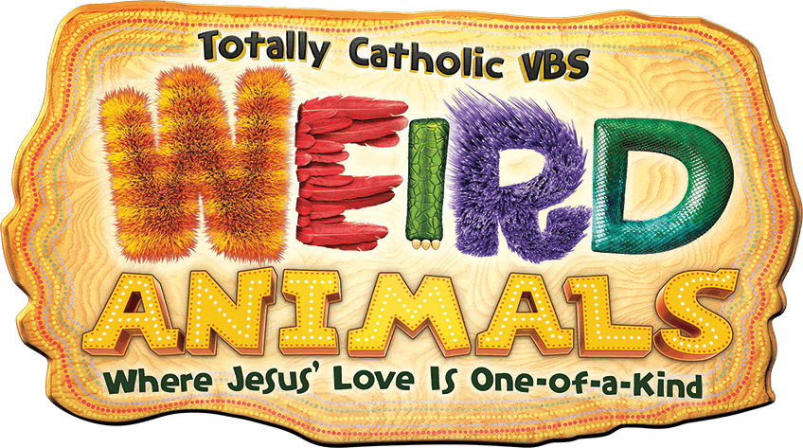

Fortnight for Freedom 2014
June 21 to July 4, 2014
As the archdiocese celebrates the third Fortnight for Freedom from June 21 to July 4, we are encouraged to pray for religious freedom in this nation and around the world. This year’s theme is “Freedom to Serve,” focusing on religious freedom and service to the poor, the sick and the elderly. To receive daily reflections from the Fortnight for Freedom devotional booklet, sign up for the list “Fortnight for Freedom 2014” at www.flocknote.com/archokc. More resources for the Fortnight are available at archokc.org.

Assumption Catholic Church - Duncan
Vacation Bible School Register Now!!!
Monday-Friday, July 7-11, 5:30-8:30 p.m.
Children PK-6th Grades (Donations appreciated.)
VBS Volunteer Meeting, Wednesday, July 2 at 6 p.m.
R.E. Building. Contact Veronica at 580-606-8226!

Abuse of Minors Pastoral Response Hotline 405-720-9878 You may also contact Oklahoma Department of Human Services at 1-800-522-3511.
Línea Telefónica Pastoral para Reportar Abuso de Menores 405-720-9878 También puede comunicarse con el Departamento de Servicios Humanos al 1-800-522-3511.

Main Sanctuary Project Renovations Goal $27,000
As you can see the renovations of our church
through your generosity are almost completed. $25,000
However, the main sanctuary which includes the main
wall with the crucifix is still in need of the major update. $20,000
Therefore, as of this weekend we will take up second
collections for this project. The cost of the insulation, $17,000
lighting and facing of the wall is $27,000. Currently $15,000
we have $5,200 in our building fund designated $10,000
for this project. Hence, we still need $21,800. $5,000
Thank you for your generosity and support. May God Bless you! $3,000

Duncan Altar Society News:
The Altar Society Gift Shop
has many new items!

K of C Garage Sale
Fourth Annual
Knights of Columbus
Garage Sale
Friday-Saturday
July 18-19
Immaculate Conception Church
All donations accepted. The garage sale proceeds benefit the Knights of Columbus charitable activities. Come enjoy breakfast of biscuits and gravy for $1.50 and add two eggs for an additional $1.00. We will also serve lunch of hot dogs and chips for $2.00 if served with kraut $2.50.

Please contact Mike Radtke at 606-0283 if you need items picked up or leave them at Duncan or Marlow’s Church before Thursday, July 17th.

Archdiocese to live stream diaconate,
priesthood ordinations
This summer, the Archdiocese of Oklahoma City celebrates the ordinations of eight archdiocesan seminarians - three to the transitional diaconate and five to the priesthood. At 10 am Saturday June 28 the archbishop will ordain Christopher Todd Brashears, Linh Ngoc Bui, Christopher De Loera, Carson Jerran Krittenbrink and Timothy Frank Ruckel to the Priesthood of Jesus Christ. For the first time in the history of the Archdiocese of Oklahoma City, these events will be broadcast to the public via the Internet. To view the ordinations live or to view a recording after the events, visit http://www.ckokc.org/archokc-ordination-2014. The June 7 ordinations of Aaron James Foshee, Daniel Gregory Grover and Lance Allen Warren to the Order of Deacon are available to be viewed.

Please remember you can support
your Church with automatic donations!
Sign up today to automatically donate
your Sunday offering especially
during vacation times!
In order for us to process your automatic donation, we will need from you: voided check and a signed authorization form. Please come to the office after one of our weekend Masses or during the week.
For those of you that would like to increase your automatic donations please let us know. We encourage you to sign up for automatic donations if you haven't already!

Cemetery Plots
There are only a few remaining plots in the Catholic Duncan Cemetery. Come to the office if you would like to purchase a plot and talk with Fr. Peter!
DUNCAN COLLECTIONs FOR June 21-22:

Duncan: $1,539.07
Weekly Direct Deposit Donations: $1,100.00
Building: Sanctuary Project: $705.10
Food Bank: $11.00
Jesse Moore Scholarship Fund: $15.00
Ryan: $115.00
Thank you for your generosity!!!

NEWS on Catholic Radio KKNG 97.3
Saint Patrick Catholic Church
THIRD AND OHIO POST OFFICE BOX 151
Walters, Oklahoma 73572
**************************************
Collections:
June 22: Operating--$467.50
Building--$250.00
Thank you for your generosity!!!

Religious Education Building Windows
We are replacing the windows in the Religious Education Building (old school). The new windows are very cost effective plus the building looks updated. The front and sides have been finished but we need to complete the back. Please consider making a donation to the building fund for the windows. The large windows are $2,500.00 and small windows $750.00. Just write windows in the memo section of your check! Thank you.
Please remember your Parish in your will.

