January 26, 2025
Third Sunday in ordinary time

Mass Intentions / Peticiones de Misa

Saturday | Jan 25 | 6:00p D | (+) John Jacobi
Sunday | Jan 26 | 8:00a M | For the Parishioners
 |  | 10:00a D
 |  | 12:00p D | (+) Angel Carrillo
Monday | Jan 27 | 6:00p D
Tuesday | Jan 28 | 6:00p D
Wednesday | Jan 29 | 6:00p D
Thursday | Jan 30 | 12:10p D
Friday | Jan 31 | 12:10p D

We have Adoration of the Blessed Sacrament, pray the Chaplet of Divine Mercy, and the Rosary thirty minutes before Daily Mass or Communion Service. Everyone is invited to participate and spend time with Jesus!

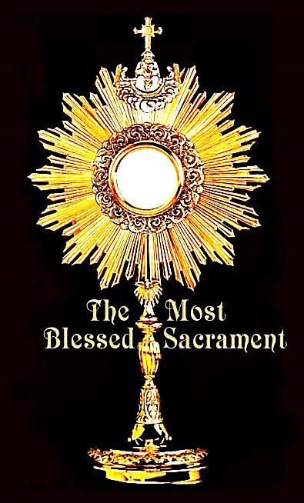

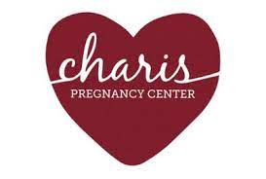

Knights of Columbus ‘Faith in Action’ Program
The Knights will be placing ‘Charis’ Baby Bottles in the entrance of the Church for parishioners to take and return to church with their loose change or for a collective donation to the ‘Charis Center’ located @ 1700 Jones, Duncan OK. ‘Charis’ is a pregnancy center that offers Ultrasounds, Adoption Referrals, Assistance for Prenatal Care, Parenting Classes and many other compassionate services. This Knights of Columbus Pro-Life program will start on January 4th and end at the end of February. 85% of women considering abortion have a change of heart when they see an ultrasound of their unborn child. Please consider taking a Charis Bottle and returning it with your coins or a donation for this worthy cause. Return to the Knights of Columbus or the church office. Raimond Barron, Program Director
P.S. make check out to the Knights of Columbus

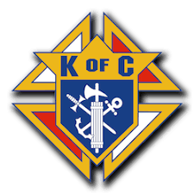

Lenten retreat
The Archdiocesan Council of Catholic Women will host a Lenten retreat “Chai Believe- Taste and Share the Goodness of the Lord” 9 a.m. - 3 p.m. March 1 at the Catholic Pastoral Center Conference Center, 7501 Northwest Expressway in Oklahoma City. The presenter is Joan Watson, a Catholic speaker, writer, podcaster, and associate editor of Integrated Catholic Life and the pilgrim manager for Verso Ministries. Doors open at 8:30 a.m. Cost: $40 includes lunch. For more information and to print a registration form, visit okcaccw.com or our Facebook page at ACCW Archokc and Regions.

Oklahoma Catholic Men’s Conference
The Oklahoma Catholic Men’s Conference is March 8 at the Oklahoma City Convention Center, 100 Mick Cornett Dr. Visit catholicmen.net.

Oklahoma Catholic Women’s Conference
The Oklahoma Catholic Women’s Conference is March 29 at the Oklahoma City Convention Center, 100 Mick Cornett Dr. Visit okcatholicwomen.com.

Abuse of Minors Response Hotline 405-720-987 or DHS at 1-800-522-3511.
Telefóno Pastoral para Reportar Abuso de Menores 405-720-9878 o el Departamento de Servicios Humanos 1-800-522-3511.

February 2, 2025
The presentation of the lord

Saturday | Feb 1 | 6:00p D | (+) John Jacobi
Sunday | Feb 2 | 8:00a M
 |  | 10:00a D | For the Parishioners
 |  | 12:00p D | (+) Maria Luisa Piñon
Monday | Feb 3 | 6:00p D
Tuesday | Feb 4 | 6:00p D
Wednesday | Feb 5 | 6:00p D
Thursday | Feb 6 | 12:10p D
Friday | Feb 7 | 12:10p D
Saturday | Feb 8 | 6:00p D | (+) John Jacobi
Sunday | Feb 9 | 8:00a M | For the Parishioners
 |  | 10:00a D
 |  | 12:00p D | (+) Alejandra Martinez

Mass Intentions / Peticiones de Misa

IMPORTANT I.R.S. NOTICE
If you require a 2024 tax letter for IRS stating your donations to Assumption Parish or other Missions please contact the office directly. We will NOT mail these statements unless you request them. Please make sure to leave your correct name and address while making your request. If you made cash donations, you're not entitled to receive this letter. Thank you.


AUTOMATIC DONATION
Did you Know? You can always donate via automatic withdrawal directly to our church's account. It is easy, simple and at the end of the fiscal year you will receive a tax letter acknowledging your donations. For more information stop by the office after each Mass.
Thank you for your support.

Religious Education (RE) Families: Please note the following tentative dates for 2025
This year Catechism classes for grades 1-12 will meet on Sunday between both Masses at 11:00-12:00.
SUNDAY
January 26 | Class
February 2 | Class
February 9 | Class
February 16 | NO CLASS-Teacher Meeting
February 23 | Class
March 2 | Class
March 9 | Class
March 16 | NO CLASS- Spring Break

IMmaculate Conception of the BVM
Collections: Sunday, Jan 19, 26:
General: $1,082.00/$646.00
Building: $305.00/$185.00

Assumption of the BVM
Collections: Saturday-Sunday, Jan 18-19, 25-26:
General: $1,932.00/$3,101.00
Building: $729.00/$357.00
Food Bank: $70.00/$20.00
Weekly Automatic Donations: $1,000.00
Abuse of Minors Response Hotline 405-720-987 or DHS at 1-800-522-3511.
Telefóno Pastoral para Reportar Abuso de Menores 405-720-9878 o el Departamento de Servicios Humanos 1-800-522-3511.

