Second Sunday of Lent
March 16, 2014

Mass Intentions / Peticiones de Misa MisaMisa

Adult Study with Fr. Peter,
"Introduction to the
Old and New Testament."
Come Learn How the Bible Came to Be!
Mondays , March 17 & 24
at 6:30 p.m. in Gillespie Hall.
Please bring your Bibles and a friend!
Sat | Mar 15 | 4:00p D | (+) Paula Estrada
 |  | 6:00p R
Sun | Mar 16 | 8:00a M | For the Parishioners
 |  | 10:00a D | Intentions of Julian Medrano  by Alicia Martinez
 |  | 12:00p W
 |  | 2:00p D |  | We would like to invite everyone to attend a Good-bye Party for Fr. Joseph on Sunday, June 30 at 5 p.m. in Gillespie Hall. The Knights of Columbus are providing hamburgers and hot dogs. We will have a money tree for Fr. Joseph.  We would like to invite everyone to attend a Good-bye Party for Fr. Joseph on Sunday, June 30 at 5 p.m. in Gillespie Hall. The Knights of Columbus are providing hamburgers and hot dogs. We will have a money tree for Fr. Joseph.
Mon | Mar 17 | 12:10p D | (+)Jim Garis by The Family
Tues | Mar 18 | 12:10p D | (+)George E. Coughlin
Wed | Mar 19 | 12:10p D | (+)Stella Josephine Dynerski
Thur | Mar 20 | 12:10p D | (+)George E. Coughlin  Holy Week and Easter Mass/Service Schedule  Holy Thursday, April 17 at 7 p.m.  Good Friday, April 18 at 7 p.m.  Holy Saturday, April 19 at 8 p.m.  Easter Sunday, april20:  Marlow at 8 a.m.  Duncan at 10 a.m.  Walters at 12 Noon  Please note that Holy Thursday, Good Friday and Holy Saturday will only be  celebrated in Duncan.
Fri | Mar 21 | 12:10p D | (+)George E. Coughlin
Sat | Mar 22 | 4:00p D | (+)Juan Martinez
 |  | 6:00p R |  | In memory of your deceased loved ones please have a  Mass offered for them.  Contact the office for days and times that you wish to have the  Mass celebrated.  What a precious gift!
Sun | Mar 23 | 8:00a M | (+)Ted Forsythe by AC & Brett Gray
 |  | 10:00a D | (+)Virginia Rivera by The Family
 |  | 12:00p W
 |  | 200p R | (+)Virginia Rivera by The Family | FIRST FRIDAY ADORATION  ADORACIÓN _{DEL} 1er VIERNES  August 2  from 12:30 pm (after mass) - 9 pm  Benediction will be from 8:45 - 9 pm  de 12:30 pm (después de misa) - 9 pm  La Bendición será de 8:45 - 9 pm  FIRST FRIDAY ADORATION  April 5  from 12:30 pm (after mass) - 9 pm  Benediction will be from 8:45 - 9 pm  FIRST FRIDAY ADORATION  April 5  from 12:30 pm (after mass) - 9 pm  Benediction will be from 8:45 - 9 pm
You can have a Mass said for someone's intentions at their birthday, wedding, baptism, or in memory of your deceased loved ones. Contact the office for days and times that you wish to have the Mass celebrated.
What a precious gift!

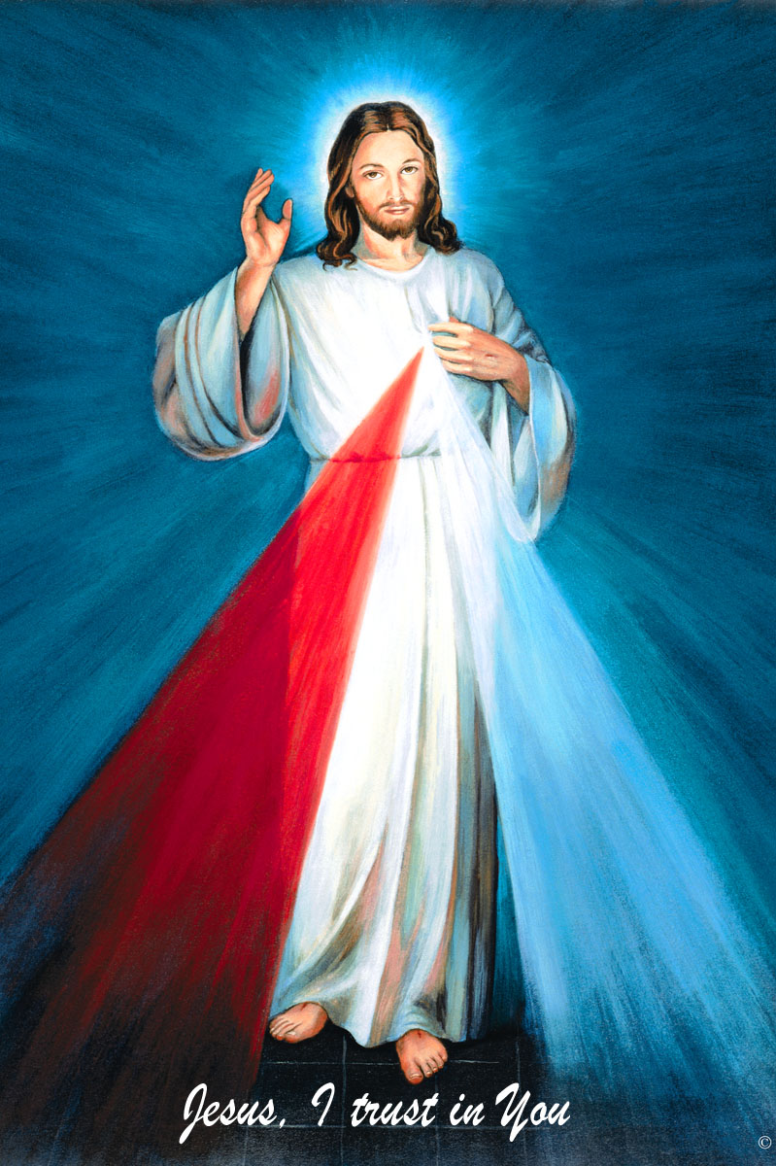
The Divine Mercy Chaplet
and Rosary are prayed
every day at 11:45 in our
Divine Mercy and
Blessed John Paul II Chapel
before our 12:10 Noon Mass.
Please come and
spend time with Jesus!

NEW on Catholic Radio KKNG 97.3

Stations of the Cross
at Assumption
Every Friday during Lent
7:00 p.m. in English
7:30 p.m. in Spanish
Everyone is invited!


Second Collection this Weekend!
Continuing this weekend until the Holy Week we will be taking a Second Collection for
Easter flowers. Thank you for your generosity!

Eighth Annual Catholic Women's Conference
Saturday April 5, 7 a.m. - 5 p.m.
Reed Center, Midwest City, Oklahoma
Through Mar 22 the registration fee is $55, and $30 for students. More information call 405-396-6292, email ocwc@OCWConference.com.

Abuse of Minors Pastoral Response Hotline 405-720-9878 You may also contact Oklahoma Department of Human Services at 1-800-522-3511.
Línea Telefónica Pastoral para Reportar Abuso de Menores 405-720-9878 También puede comunicarse con el Departamento de Servicios Humanos al 1-800-522-3511.

Duncan Altar Society News:
The Altar Society Gift Shop
has many new items!
Religious articles for First Communion, Confirmation, birthdays, anniversaries and even Easter baskets!

Have you seen the Lenten calendars for kids?
There's one on the bulletin board--take a look!

!!!Religious Education News!!!

Attention Parents: No Classes: Spring Break:
Sunday, March 16
Wednesday March 19

Teacher's Meeting Sunday March 23
after 10:00 a.m. Mass.
Lunch will be provided.

Children's Mass: Sunday, Mar 30
First Communion Retreat: Sun., Mar 30

Mandatory Parent Confirmation Meeting Sunday, April 6 at 4:30 p.m.

First Communion: Sunday, May 4
Confirmation: Friday May 16

Immaculate Conception, Marlow News:
Stations of the Cross on
Thursdays of Lent at 6:30 p.m.
Pot Luck Soup Supper following.

Friday Fish Fries During Lent, 5:30-7:30 p.m.
$9.00 for Adults, Children under 12 eat free!

Dinner Theater,
Friday April 4 at 6:30 p.m.
First United Methodist Church
Benefitting Christians Concerned
Tickets are $30.00 each
For tickets call Jackie at 252-2985

Catholic Charities agencies provided housing assistance and transitional shelter services to over 475,000 individuals in need last year. To learn more, visit www.CatholicCharitiesUSA.org

OLOG Summer Camp Scholarships
Catholic Foundation offers need-based scholarships for regular summer camp sessions. Applications available online at www.cfook.org Deadline: March 26, 2014 Questions? Call Archdiocese Youth Office (405)721-9220

Catholic Foundation Scholarships Available
The 2014-2015 Catholic Foundation of Oklahoma Scholarship Applications are now available. If interested, please visit the website at www.cfook.org. You may call at 405-721-4115 or mmills@achokc.org. Completed applications are due no later than Tuesday, April 1, 2014.
Attention
Choir Practice Schedule
Thursdays 7:00 - 8:15 p.m.
We invite those interested in singing in the Choir to join us for practice
in the Choir Loft!
Choir Review will be:
3:00-3:30 p.m. Saturdays
9:00-9:30 a.m. Sundays

DUNCAN COLLECTIONs FOR
March 9:
Duncan: $3,810.91
Weekly Direct Deposit Donations: $1,100.00
Building: $50.00
Food Bank: $47.00 St. Vincent de Paul: $90.00
Easter Flowers $347.97
Ryan $146.00

ATTENTION:
We have renewed the contract on our
Billboard on Highways 81 & 7!
We're looking for sponsors!
Thank you to Jim & Agnes Surjaatmadja
for sponsoring the bill board for March!

Please remember you can support
your Church with automatic donations!
Sign up today to automatically donate
your Sunday offering especially
during vacation times!
In order for us to process your automatic donation, we will need from you: voided check and a signed authorization form. Please come to the office after one of our weekend Masses or during the week. For those of you that would like to increase your automatic donations please let us know. We encourage you to sign up for automatic donations if you haven't already!

Saint Patrick Catholic Church
THIRD AND OHIO POST OFFICE BOX 151
Walters, Oklahoma 73572
**************************************
Collections:
Mar 9: Operating: $815.26/Building: $560.00

Please remember your Parish in your will.

