Second Sunday in Ordinary Time
January 20, 2019

Mass Intentions / Peticiones de Misa

Sat | Jan 19 | 4:00p D | (+) James Rintoul Coon
 |  | 6:00p R | For the Parishioners
Sun | Jan 20 | 8:00a M | (+) James Rintoul Coon
 |  | 10:00a D | Living & Deceased Members  Of the Altar Society
 |  | 12:00a W | (+) Ron Wedman
 |  | 2:00p D
Mon | Jan 21 | 12:10p D | (+) James Rintoul Coon
Tues | Jan 22 | 12:10p D | (+) James Rintoul Coon
Wed | Jan 23 | 12:10p D | (+) James Rintoul Coon
Thur | Jan 24 | 12:10p D | (+) James Rintoul Coon
Fri | Jan 25 | 12:10p D | (+) James Rintoul Coon
Sat | Jan 26 | 4:00p D | Good Health for Patsy Garner  By Ann Geurkink
 |  | 6:00p R | (+) James Rintoul Coon
Sun | Jan 27 | 8:00a M | (+) Charles Shell by KofC
 |  | 10:00a D | (+) James Rintoul Coon
 |  | 12:00p W | (+) Ron Wedman
 |  | 2:00p D
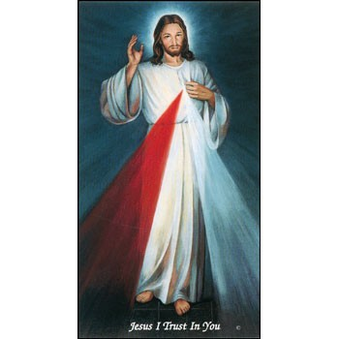

We invite you to join us for our daily Eucharistic Adoration with the
Divine Mercy Chaplet
and Rosary at 11:30-12:10 p.m.
Monday through Friday.
Everyone is invited to participate and
spend time with Jesus!

Church Donation Envelopes
The Church Donation Envelopes are here!
You can pick them up in Gillespie Hall.
Please Note: You can always donate via automatic withdrawal directly to our church's account. It is easy, simple and at the end of the fiscal year you will receive a tax letter acknowledging your donations. For more information stop by the office after each Mass.
Thank you for your support.


Gregorian Masses are for the Repose of the souls
of our loved ones

You can have Masses offered for
someone’s birthday, wedding, baptism or in memory of your deceased loved ones. Contact the office for days and times that you wish to have the Mass celebrated. What a wonderful spiritual gift!

Gregorian Masses are for the
faithfully departed.
The Holy Mass is celebrated
daily for thirty days.

To book a Mass please stop
by the office!

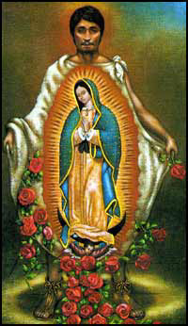

IMPORTANT I.R.S. NOTICE
If you require a 2018 tax letter for IRS stating your donations to Assumption Parish or other Missions please contact the office directly. We will NOT mail these statements unless you request them. Please make sure to leave your correct name and address while making your request. If you made cash donations, you're not entitled to receive this letter. Thank you.

Abuse of Minors Response Hotline 405-720-987 or DHS at 1-800-522-3511.
Telefóno Pastoral para Reportar Abuso de Menores 405-720-9878 o el Departamento de Servicios Humanos 1-800-522-3511.

Religious Education News!

Grades 7-12/Confirmation:
Sundays from 11-12:30
Jan 20, 27

Grades 1-6:
Wednesdays from 6:00-7:30 p.m.
Jan 23, 30

ATTENTION:
Confirmation 2 English Parent Meeting,
Sunday, January 27 a 11:15 a.m.

First Communion 2 English
Parent Meeting,
Sunday, February 3 at 11:15 a.m.


The Annual Immaculate Conception Valentine Steak Dinner
Saturday February 16, 2019
Gather at 6:00 PM Dinner at 6:30 PM

$25.00 a Couple
Filet, baked potato with fix‘ins,
Salad, Green Beans and
“The Chocolate Fountain”

Sign up no later than February 10, 2019

Sign up at the church, or call
Bill or Kathi Havron at
580-641-1867 or 580-512-6867
We will have the 50/50 game

Third Annual Christmas Bazaar
November 20, 21 and 22
Attention: There will be a work day on Saturday, October 10 at 10 a.m. in Gillespie Hall! We need your ideas! It will take all of us participating to make our Bazaar a success!!!

Eggrolls by Agnes, order now.
She will only make 20 dozen.
They are $40 per dozen.
Pick up will be Friday, October 16.
Place order and pay at the office.

Order Tamales by Carmen
at $25.00 per dozen.
Order and pay at the office.
Pick up will be
Saturday, Nov 14.

The profit will equally be divided between three Parishes: Walters, Duncan and Marlow for the purpose of the building fund. We need your time, talent and treasure to make this event successful.

Oklahoma Catholic Women’s Conference
The Oklahoma Catholic Women’s Conference will be Feb. 23 at Embassy Suites in Norman. Visit www.ocwconference.com.

Safe Environment
Our Archdiocese is mandated by the Conference of Catholic Bishops in the U.S. to re-run background checks every three years for all employees and volunteers in all Parishes. Therefore, we will begin this process in our Parish January 21, 2019. All volunteers and employees will be required to fill out new Safe Environment/Background check forms.
Oklahoma Catholic Men’s Conference
The Oklahoma Catholic Men’s Conference will be March 9 at Embassy Suites in Norman. Visit www.catholicmen.net.

DUNCAN COLLECTIONs FOR
Jan 12-13:
Duncan: $1,876.00
Weekly Electronic Donations: $1,200.00
Building Fund: $270.00
St. Vincent de Paul: $145.00
Food Bank: $45.00
Scholarship: $20.00
Ryan: $185.00
Thank you for your generosity!!!

Saint Patrick Catholic Church
THIRD AND OHIO POST OFFICE BOX 151
Walters, Oklahoma 73572
********************************
Collections:
Jan 13: Operating: $388.00

Immaculate Conception Church
Marlow
**************************
Collections:
Jan 13: General: $652.00
Building: $370.00

