The Epiphany of the Lord
January 6, 2019

Mass Intentions / Peticiones de Misa

Sat | Jan 5 | 4:00p D | (+) Special Blessings for Joan Conk
 |  | 6:00p R | (+) James Rintoul Coon
Sun | Jan 6 | 8:00a M
 |  | 10:00a D | (+) James Rintoul Coon
 |  | 12:00a W
 |  | 2:00p D
Mon | Jan 7 | 6:00p M | (+) James Rintoul Coon
Tues | Jan 8 | 10:00p D | (+) James Rintoul Coon
Wed | Jan 9 | 12:10p D | (+) James Rintoul Coon
Thur | Jan 10 | 12:10p D | (+) James Rintoul Coon
Fri | Jan 11 | 12:10p D | (+) James Rintoul Coon
Sat | Jan 12 | 4:00p D | (+) Maurice & Bernadette
 |  | 6:00p R | (+) James Rintoul Coon
Sun | Jan 13 | 8:00a M
 |  | 10:00a D | Living & Deceased Members of  The Altar Society
 |  | 12:00p W | (+) Ron Wedman
 |  | 2:00p D | (+) James Rintoul Coon
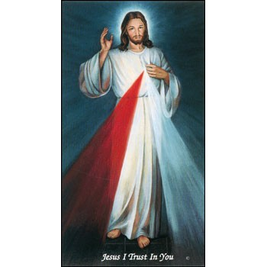

We invite you to join us for our daily Eucharistic Adoration with the
Divine Mercy Chaplet
and Rosary at 11:30-12:10 p.m.
Monday through Friday.
Everyone is invited to participate and
spend time with Jesus!


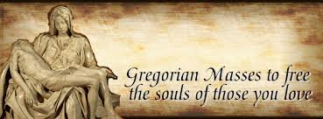

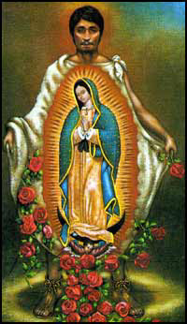

You can have Masses offered for
someone’s birthday, wedding, baptism or in memory of your deceased loved ones. Contact the office for days and times that you wish to have the Mass celebrated. What a wonderful spiritual gift!

A Gregorian Mass is for the
faithfully departed.
The Holy Mass is said daily for thirty days.

Please come by the office today and offer a Gregorian Mass for your loved one!
IMPORTANT I.R.S. NOTICE
If you require a 2018 tax letter for IRS stating your donations to Assumption Parish or other Missions please contact the office directly. We will NOT mail these statements unless you request them. Please make sure to leave your correct name and address while making your request. If you made cash donations, you're not entitled to receive this letter. Thank you.

Abuse of Minors Response Hotline 405-720-987 or DHS at 1-800-522-3511.
Telefóno Pastoral para Reportar Abuso de Menores 405-720-9878 o el Departamento de Servicios Humanos 1-800-522-3511.


Knights of Columbus will host a
Bingo Night along with a
Mexican Stack Dinner

When: Saturday, January 19, 2019
Where: Immaculate Conception Church – Marlow
Bingo Cost: $10 for 20 cards for 15 Games

Prize: Each Bingo game
pays $15
and several door prizes will be drawn and awarded
during the games

Dinner donations accepted
Dinner starts at 6:30PM
Bingo to start @7PM

The Annual Immaculate Conception Valentine Steak Dinner
Saturday February 16, 2019
Gather at 6:00 PM Dinner at 6:30 PM

$25.00 a Couple
Filet, baked potato with fix‘ins,
Salad, Green Beans and
“The Chocolate Fountain”

Sign up no later than February 10, 2019

Sign up at the church, or call Bill or
Kathi Havron at 580-641-1867//580-512-6867
We will have the 50/50 game



Third Annual Christmas Bazaar
November 20, 21 and 22
Attention: There will be a work day on Saturday, October 10 at 10 a.m. in Gillespie Hall! We need your ideas! It will take all of us participating to make our Bazaar a success!!!

Eggrolls by Agnes, order now.
She will only make 20 dozen.
They are $40 per dozen.
Pick up will be Friday, October 16.
Place order and pay at the office.

Order Tamales by Carmen
at $25.00 per dozen.
Order and pay at the office.
Pick up will be
Saturday, Nov 14.

The profit will equally be divided between three Parishes: Walters, Duncan and Marlow for the purpose of the building fund. We need your time, talent and treasure to make this event successful.

DUNCAN COLLECTIONs FOR
Dec 29-30:
Duncan: $1,276.00
Weekly Electronic Donations: $1,200.00
Building Fund: $2034.50
St. Vincent de Paul: $209.00
Food Bank: $20.50

Ryan: $105.00
Thank you for your generosity!!!

Saint Patrick Catholic Church
THIRD AND OHIO POST OFFICE BOX 151
Walters, Oklahoma 73572
********************************
Collections:
Dec 30: Operating: $443.85
Building: $125.00

Immaculate Conception Church
Marlow
**************************
Collections:
Dec 24: General: $542.00
Building: $75.73
Dec 30: General: $623.00
Building: $407.50

