The Holy Family of Jesus, Mary and Joseph
December 30, 2018

Mass Intentions / Peticiones de Misa

Sat | Dec 29 | 4:00p D | (+) James Rintoul Coon
 |  | 6:00p R
Sun | Dec 30 | 8:00a M
 |  | 10:00a D | In Honor of St. Sylvester  By Rita Arze
 |  | 12:00a W | (+) James Rintoul Coon
 |  | 2:00p D
Mon | Dec 31 | 6:00p M | (+) James Rintoul Coon
Tues | Jan 1 | 10:00p D | (+) James Rintoul Coon
Wed | Jan 2 | 12:10p D | (+) James Rintoul Coon
Thur | Jan 3 | 12:10p D | (+) James Rintoul Coon
Fri | Jan 4 | 12:10p D | (+) James Rintoul Coon
Sat | Jan 5 | 4:00p D | Special Blessings for Joan Conk
 |  | 6:00p R | (+) James Rintoul Coon
Sun | Jan 6 | 8:00a M
 |  | 10:00a D | (+) James Rintoul Coon
 |  | 12:00p W
 |  | 2:00p D

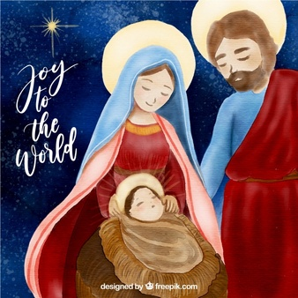
May you have a blessed and
Happy New Year.
Fr. Peter & Fr. David

Fr. Peter and Fr. David
New Years Mass Schedule
Monday, Dec 31, 2018
6 p.m. Marlow

Tuesday, Jan 1, 2019
10 a.m. Duncan

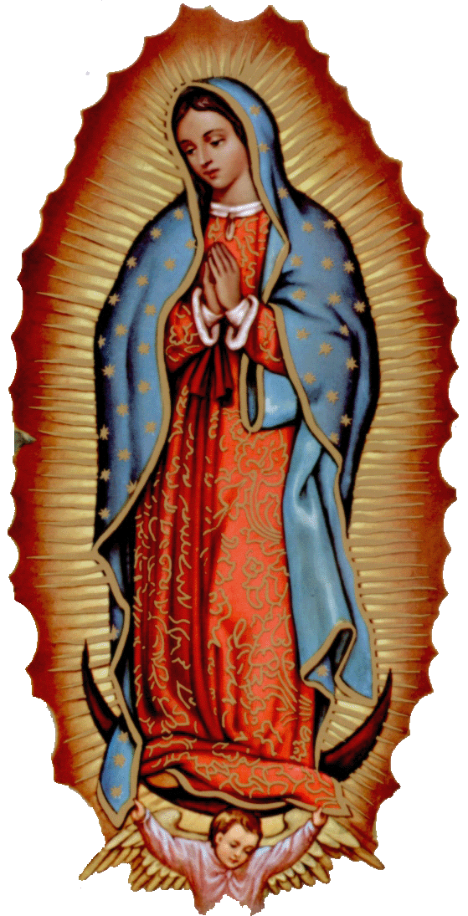

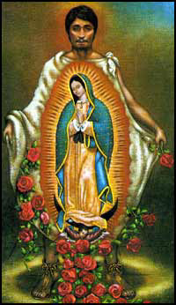

The office will be closed
Monday, December 24 through Tuesday,
January 1 for the Holiday Season.
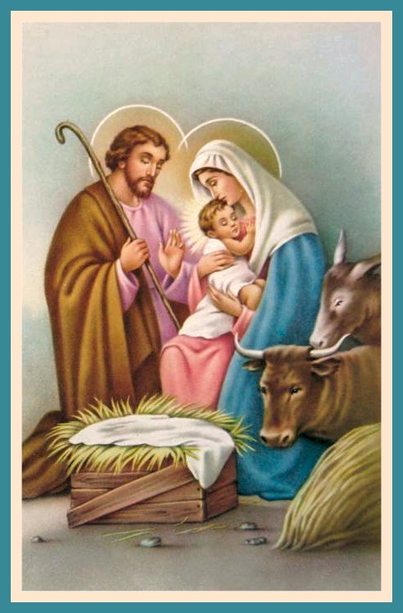

Abuse of Minors Response Hotline 405-720-987 or DHS at 1-800-522-3511.
Telefóno Pastoral para Reportar Abuso de Menores 405-720-9878 o el Departamento de Servicios Humanos 1-800-522-3511.


Knights of Columbus will host a
Bingo Night along with a
Mexican Stack Dinner

When: Saturday, January 19, 2019
Where: Immaculate Conception Church – Marlow
Bingo Cost: $10 for 20 cards for 15 Games

Prize: Each Bingo game pays $15
and several door prizes will be drawn and awarded during the games

Dinner donations accepted
Dinner starts at 6:30PM
Bingo to start @7PM



Third Annual Christmas Bazaar
November 20, 21 and 22
Attention: There will be a work day on Saturday, October 10 at 10 a.m. in Gillespie Hall! We need your ideas! It will take all of us participating to make our Bazaar a success!!!

Eggrolls by Agnes, order now.
She will only make 20 dozen.
They are $40 per dozen.
Pick up will be Friday, October 16.
Place order and pay at the office.

Order Tamales by Carmen
at $25.00 per dozen.
Order and pay at the office.
Pick up will be
Saturday, Nov 14.

The profit will equally be divided between three Parishes: Walters, Duncan and Marlow for the purpose of the building fund. We need your time, talent and treasure to make this event successful.

DUNCAN COLLECTIONs FOR
Dec 22-25:
Duncan: $1,867.00
Weekly Electronic Donations: $1,200.00
Building Fund: $1,371.50
St. Vincent de Paul: $140.00
Food Bank: $48.50
Christmas: $1,762.00
Ryan: $139.00/Christmas: $169.00
Thank you for your generosity!!!

Saint Patrick Catholic Church
THIRD AND OHIO POST OFFICE BOX 151
Walters, Oklahoma 73572
********************************
Collections:
Dec 23: Operating: $458.35
Building: $250.00
Christmas: $397.10

Immaculate Conception Church
Marlow
**************************
Collections:
Dec 23: General: $673.00
Building: $200.00

