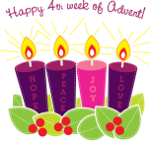

Fourth Sunday of Advent
December 23, 2018

CHRISTMAS SCHEDULE
Monday, December 24

4 p.m. Ryan
4 p.m. Marlow
6 p.m. Duncan
6 p.m. Walters
Midnight Mass in Duncan
Tuesday, December 25
10 a.m. Duncan

Mass Intentions / Peticiones de Misa

Sat | Dec 22 | 4:00p D
 |  | 6:00p R
Sun | Dec 23 | 8:00a M | (+) Joseph M. Lockovich by Cheryl
 |  | 10:00a D | God’s Blessing for Victoria
 |  | 12:00a W | (+) Henry Renschen
 |  | 2:00p D
Mon | Dec 24 | 4:00p R
 |  | 4:00p M
 |  | 6:00p D | (+) Alice Barnes
 |  | 6:00p W
 |  | Midnight | Special Intention
Tues | Dec 25 | 10:00a D | (+) Irena
Wed | Dec 26 | 12:10p D | NO MASS
Thur | Dec 27 | 12:10p D | NO MASS
Fri | Dec 28 | 12:10p D | NO MASS
Sat | Dec 29 | 4:00p D | (+) James Rintoul Coon
 |  | 6:00p R
Sun | Dec 30 | 8:00a M
 |  | 10:00a D | (+) St. Sylvester by Rita Arze
 |  | 12:00p W | (+) James Rintoul Coon
 |  | 2:00p D



The office will be closed Monday, December 24 through Tuesday, January 1 for the Holiday Season.
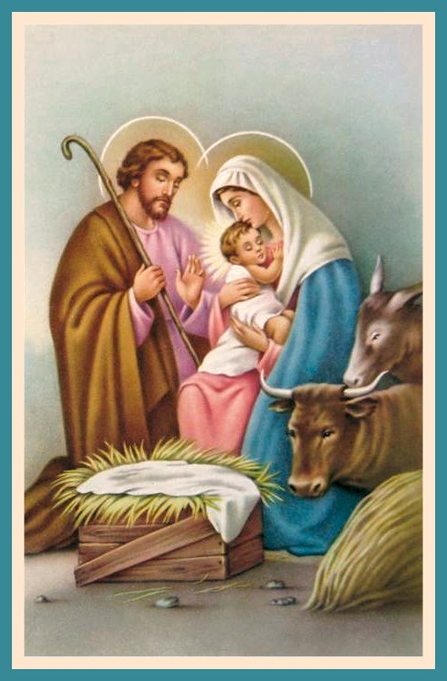
ATTENTION:
The office will be closed
Monday, December 24 through Monday, January 1, 2019
for the Holidays.
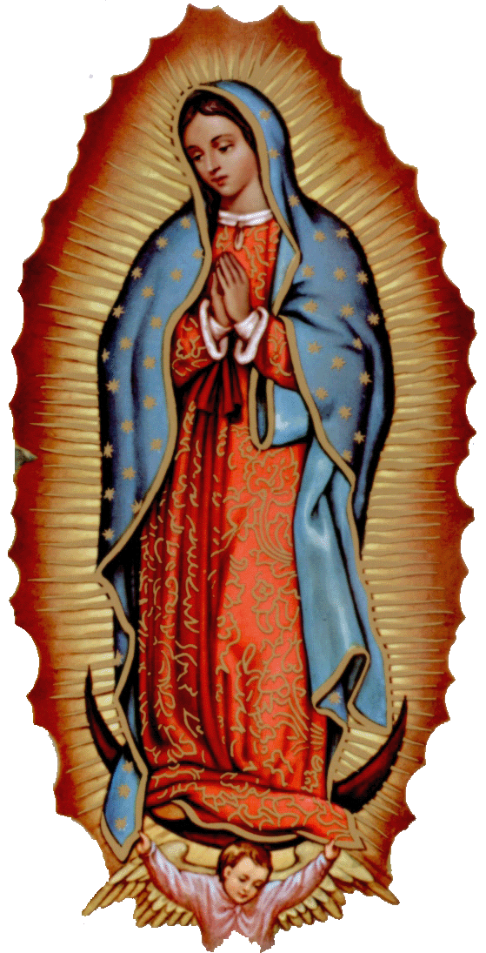

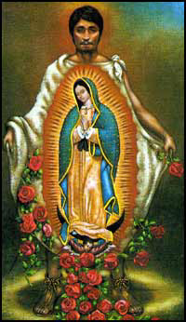

There will be no 12:10 pm daily MASSES Wednesday through Friday,
December 26-28.

New Years Mass Schedule
Monday, Dec 31, 2018
6 p.m. Marlow

Tuesday, Jan 1, 2019
10 a.m. Duncan

Abuse of Minors Response Hotline 405-720-987 or DHS at 1-800-522-3511.
Telefóno Pastoral para Reportar Abuso de Menores 405-720-9878 o el Departamento de Servicios Humanos 1-800-522-3511.

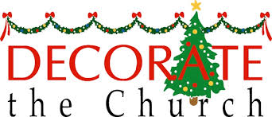

We invite all those who
would like to help with our
Christmas decorations to join us
Sunday, December 23 at 3 p.m.

Third Annual Christmas Bazaar
November 20, 21 and 22
Attention: There will be a work day on Saturday, October 10 at 10 a.m. in Gillespie Hall! We need your ideas! It will take all of us participating to make our Bazaar a success!!!

Eggrolls by Agnes, order now.
She will only make 20 dozen.
They are $40 per dozen.
Pick up will be Friday, October 16.
Place order and pay at the office.

Order Tamales by Carmen
at $25.00 per dozen.
Order and pay at the office.
Pick up will be
Saturday, Nov 14.

The profit will equally be divided between three Parishes: Walters, Duncan and Marlow for the purpose of the building fund. We need your time, talent and treasure to make this event successful.


Saint Patrick Catholic Church
THIRD AND OHIO POST OFFICE BOX 151
Walters, Oklahoma 73572
********************************
Collections:
Dec 16: Operating: $310.00

Immaculate Conception Church, Marlow
**************************
Collections:
Dec 16: General: $830.00
Building: $150.00

DUNCAN COLLECTIONs FOR
Dec 15-16:
Duncan: $1,565.00
Weekly Electronic Donations: $1,200.00
Building Fund: $600.00
St. Vincent de Paul: $60.00
Thank you for your generosity!!!

DUNCAN ALTAR SOCIETY
CHRISTMAS BAKE SALE
This weekend after
All Duncan Masses
December 22-23
Everyone plan to purchase your Christmas desserts and goodies!

Ladies, please make
homemade desserts to sell!

The pies and cakes will be ready for pick up on
Friday-Saturday,
Dec 21-22.

