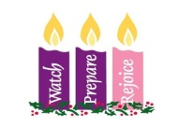
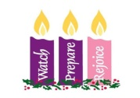
Third Sunday of Advent
December 16, 2018

CHRISTMAS SCHEDULE
Monday, December 24

4 p.m. Ryan
4 p.m. Marlow
6 p.m. Duncan
6 p.m. Walters
Midnight Mass in Duncan
Tuesday, December 25
10 a.m. Duncan

Mass Intentions / Peticiones de Misa

Sat | Dec 15 | 4:00p D | (+) Kenneth Barron
 |  | 6:00p R
Sun | Dec 16 | 8:00a M | (+) Marvin Conway
 |  | 10:00a D
 |  | 12:00a W | (+) Ron Wedman
 |  | 2:00p D
Mon | Dec 17 | 9:00a D
Tues | Dec 18 | 12:10p D | NO MASS – Communion Service
Wed | Dec 19 | 9:00a D
Thur | Dec 20 | 9:00a D
Fri | Dec 21 | 12:10p D
Sat | Dec 22 | 4:00p D
 |  | 6:00p R
Sun | Dec 23 | 8:00a M | (+) Joseph M. Lockovich  by Cheryl Lockovich
 |  | 10:00a D | For God’s Blessing for Victoria
 |  | 12:00p W | (+) Henry Renschen
 |  | 2:00p D



The office will be closed Monday, December 24 through Tuesday, January 1 for the Holiday Season.
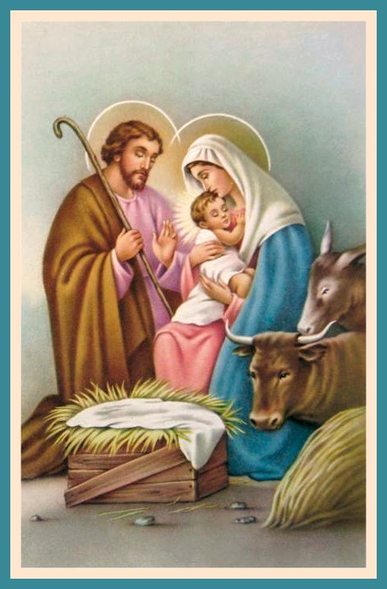
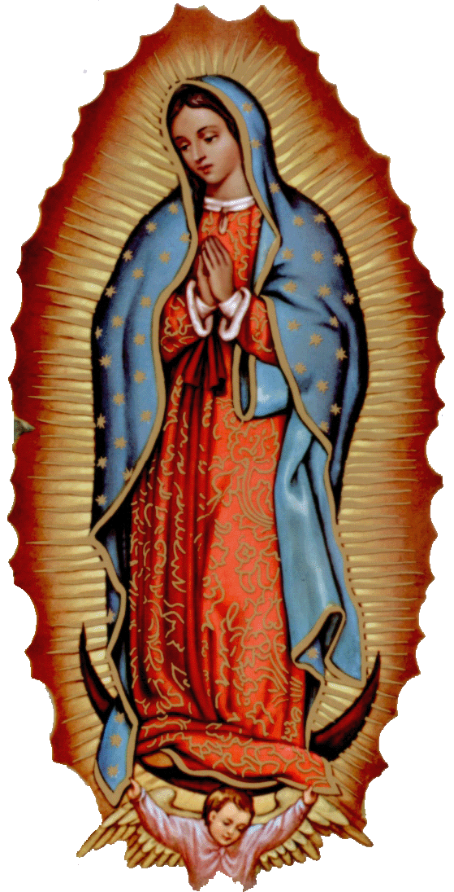

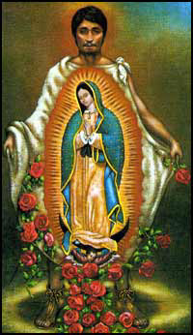

New Years Mass Schedule

Monday, Dec 31, 2018
6 p.m. Marlow

Tuesday, Jan 1, 2019
10 a.m. Duncan



Abuse of Minors Response Hotline 405-720-987 or DHS at 1-800-522-3511.
Telefóno Pastoral para Reportar Abuso de Menores 405-720-9878 o el Departamento de Servicios Humanos 1-800-522-3511.

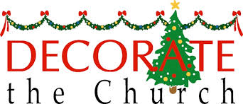

We invite all those who
would like to help with our
Christmas decorations to join us
Sunday, December 23 at 3 p.m.

Third Annual Christmas Bazaar
November 20, 21 and 22
Attention: There will be a work day on Saturday, October 10 at 10 a.m. in Gillespie Hall! We need your ideas! It will take all of us participating to make our Bazaar a success!!!

Eggrolls by Agnes, order now.
She will only make 20 dozen.
They are $40 per dozen.
Pick up will be Friday, October 16.
Place order and pay at the office.

Order Tamales by Carmen
at $25.00 per dozen.
Order and pay at the office.
Pick up will be
Saturday, Nov 14.

The profit will equally be divided between three Parishes: Walters, Duncan and Marlow for the purpose of the building fund. We need your time, talent and treasure to make this event successful.


Saint Patrick Catholic Church
THIRD AND OHIO POST OFFICE BOX 151
Walters, Oklahoma 73572
********************************
Collections:
Dec 9: Operating: $616.00
Building: $2,375.00

Immaculate Conception Church, Marlow
**************************
Collections:
Dec 9: General: $520.00
Building: $150.00

DUNCAN COLLECTIONs FOR
Dec 8-9:
Duncan: $1,396.00
Weekly Electronic Donations: $1,200.00
Building Fund: $692.00
Thank you for your generosity!!!

DUNCAN ALTAR SOCIETY
CHRISTMAS BAKE SALE

Saturday-Sunday,
December 22-23
Everyone plan to purchase your Christmas desserts and goodies!

Ladies, please make
homemade desserts to sell!

The pies and cakes will be ready for pick up on
Friday-Saturday,
Dec 21-22.

