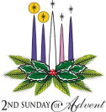
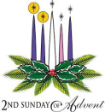
Second Sunday of Advent
December 9, 2018

CHRISTMAS SCHEDULE
Monday, December 24
4 p.m. Ryan 4 p.m. Marlow
6 p.m. Duncan, 6 p.m. Walters
Midnight Mass in Duncan

Tuesday, December 25
10 a.m. Duncan

Mass Intentions / Peticiones de Misa

Sat | Dec 8 | 4:00p D | (+) Mary Leigh
 |  | 6:00p R
Sun | Dec 9 | 8:00a M | (+) Mary Leigh
 |  | 10:00a D | (+) Pedro Martinez
 |  | 12:00a W | (+) Ron Wedman
 |  | 2:00p D
Mon | Dec 10 | 12:10p D | (+) Patrick Judson
Tues | Dec 11 | 12:10p D | Happy Birthday Blessings for  Anna Fitts
 |  | 12:00a D
Wed | Dec 12 | 12:10p D
Thur | Dec 13 | 12:10p D
Fri | Dec 14 | 12:10p D | (+) Don Trostle and Jake Seratte
Sat | Dec 15 | 4:00p D | (+) Kenneth Barron  We want to thank everyone who helped with our Annual Christmas Bazaar.  We made $22,000.00!  This amount will be distributed as follows:  60% which is $13,200.00 to Duncan  30% which is $6,600.00 to Marlow  10% which is $2,200.00 to Walters.
 |  | 6:00p R
Sun | Dec 16 | 8:00a M | (+) Marvin Conway
 |  | 10:00a D
 |  | 12:00p W | (+) Ron Wedman
 |  | 2:00p D

New Years Mass Schedule
Monday, Dec 31, 2018 - 6 p.m. Marlow

Tuesday, Jan 1, 2019 - 10 a.m. Duncan
DUNCAN ALTAR SOCIETY BAKE SALE Saturday-Sunday, December 22-23
Everyone plan to purchase your Christmas desserts

Ladies, please make homemade desserts to sell!
Pre-order Coconut Meringue or Chocolate Meringue Pies
by Ann Boice, $35.00 each or
Carrot Cake by Pat Neal $40.00 each

The pies and cakes will be ready for pick up on Friday-Saturday, Dec 21-22.
Stop by the office and Pre-order your pie or cake today!

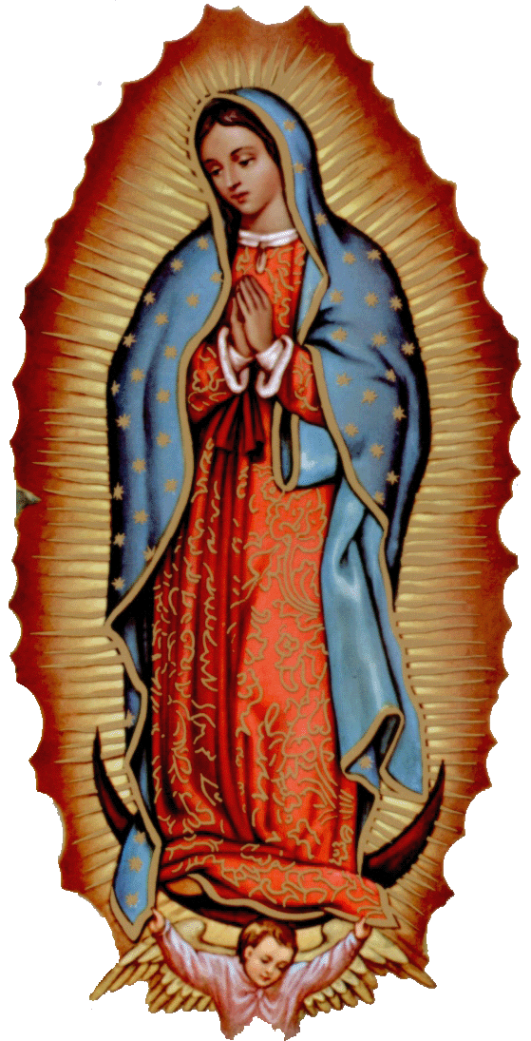

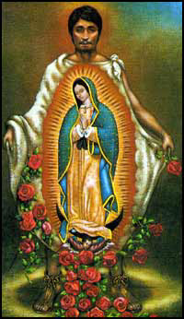

Our lady of Guadalupe celebration
Everyone is invited to the
annual celebration
of the Virgin of Guadalupe!

Sunday December 10: 7 p.m. Mass
Monday, December 11,
7 p.m. Adoration
11:00 p.m. Mananitas
Midnight Mass
Tuesday, December 12
6:00 pm ----------- Rosary
7:30pm ------------ Dinner
la fiesta de La
VIRGEN DE GUADALUPE

Todos están invitados a la celebración de la Virgen de Guadalupe
11 de Diciembre Martes:
11p.m. Mañanitas
Medianoche La Misa de la Virgen
12 de Diciembre:Miercoles
6p.m. Rosario---7:00 p.m. Cena

DUNCAN COLLECTIONs FOR
Dec 1-2:
Duncan: $1,607.50
Weekly Electronic Donations: $1,200.00
Food Bank: $322.50
St. Vincent de Paul: $22.00
Building Fund: $5.00
RYAN: $98.00
Thank you for your generosity!!!

Abuse of Minors Response Hotline 405-720-987 or DHS at 1-800-522-3511.
Telefóno Pastoral para Reportar Abuso de Menores 405-720-9878 o el Departamento de Servicios Humanos 1-800-522-3511.

Third Annual Christmas Bazaar
November 20, 21 and 22
Attention: There will be a work day on Saturday, October 10 at 10 a.m. in Gillespie Hall! We need your ideas! It will take all of us participating to make our Bazaar a success!!!

Eggrolls by Agnes, order now.
She will only make 20 dozen.
They are $40 per dozen.
Pick up will be Friday, October 16.
Place order and pay at the office.

Order Tamales by Carmen
at $25.00 per dozen.
Order and pay at the office.
Pick up will be
Saturday, Nov 14.

The profit will equally be divided between three Parishes: Walters, Duncan and Marlow for the purpose of the building fund. We need your time, talent and treasure to make this event successful.

Immaculate Conception Church, Marlow
*********************************
Collections:
Nov 25: General: $2,104.00
Building: $165.00

Saint Patrick Catholic Church
THIRD AND OHIO POST OFFICE BOX 151
Walters, Oklahoma 73572
********************************
Collections:
Nov 25: Operating: $854.00
Building: $650.00

