Thirtieth-Third Sunday in Ordinary Time
November 18, 2018

Immaculate conception
of the Blessed virgin mary,
Saturday, December 8, 2018
Is a holy day of obligation.
There will be one mass
In marlow at 9 a.m.
breakfast following mass.

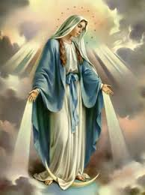
Mass Intentions / Peticiones de Misa

Sat | Nov 17 | 4:00p D | (+) Edward Weis by The Family
 |  | 6:00p R | (+) Mary Leigh
Sun | Nov 18 | 8:00a M | (+) Mary Leigh
 |  | 10:00a D | (+) Don Trostle & Jake Seratte
 |  | 12:00a W | (+) Ron Wedman
 |  | 2:00p D
Mon | Nov 19 | 12:10p D | (+) Mary Leigh
Tues | Nov 20 | 12:10p D | (+) Mary Leigh
Wed | Nov 21 | 12:10p D | (+) Mary Leigh
Thur | Nov 22 | 12:10p D | (+) Mary Leigh
Fri | Nov 23 | 12:10p D | (+) Mary Leigh
Sat | Nov 24 | 4:00p D | (+) Alice Barnes
 |  | 6:00p R | (+) Mary Leigh
Sun | Nov 25 | 8:00a M | (+) Mary Leigh
 |  | 10:00a D
 |  | 12:00p W | (+) Ron Wedman
 |  | 2:00p D

PLEASE NOTICE: The Office will be closed for Thanksgiving Holiday Tuesday-Friday, November 20-23.

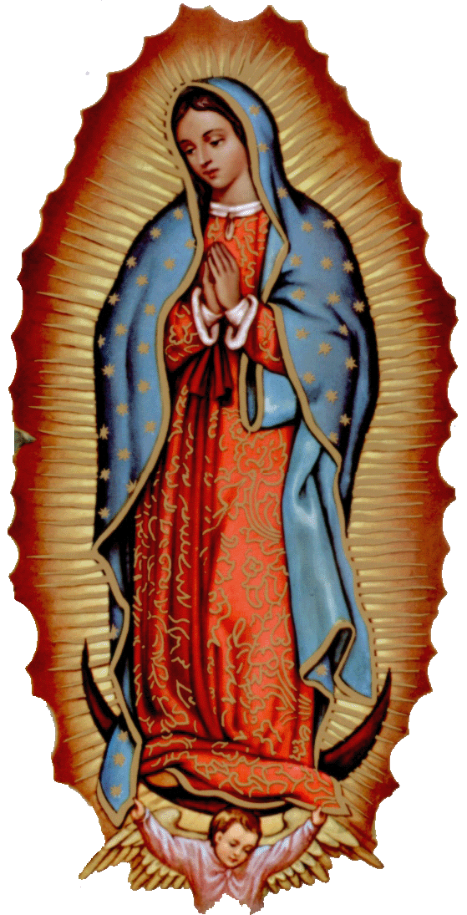
Our lady of Guadalupe celebration
Everyone is invited to the
annual celebration
of the Virgin of Guadalupe!
Tuesday, December 11,
11:00 p.m. Mananitas
Midnight Mass
Desayuno
Wednesday, December 12
6:00 pm Rosary
7:00 p.m. Dinner and Dance

la fiesta de La
VIRGEN DE GUADALUPE

Todos están invitados
a la celebración anual
de la Virgen de Guadalupe y retiro de Adviento con Padre Iden Bello!
11 de Diciembre Martes:
11p.m. Mañanitas
Medianoche La Misa de la Virgen
12 de Diciembre:Miercoles
6p.m. Rosario---7:00 p.m. Cena

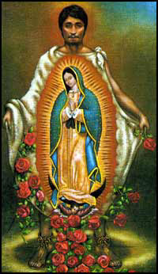

Christmas Bazaar 2018
Our Christmas Bazaar will be held this weekend November 16, 17 and 18

RAFFLE TICKETS: 1 Tkt for $20 6 Tkts for $100
1st Prize $2,000, 2nd Prize $1,000 and 3rd Prize $500.00

Drawing Sunday, Nov 18 at 5 p.m. Need not be present to win.
Credit/Debit Cards accepted!!!

Abuse of Minors Response Hotline 405-720-987 or DHS at 1-800-522-3511.
Telefóno Pastoral para Reportar Abuso de Menores 405-720-9878 o el Departamento de Servicios Humanos 1-800-522-3511.

Religious Education (RE) Families:
Sun, Nov 18 | No RE Thanksgiving
Wed, Nov 21 | No RE Thanksgiving
Sun, Nov 25 | Class
Wed, Nov 28 | Class
Sun, Dec 2 | Class
Wed, Dec 5 | Class
Sun, Dec 9 | Class
Dec 12-  Jan 2 | No Class (Christmas Break)
Sun, Jan 6 | Class
Wed, Jan 9 | Class
maria.martinez@yahoo.com or you may call the
Maria Martinez, RE Director

Mini Advent Retreat
St. Patrick Catholic Church
3rd & Ohio, walters, Ok

Sunday December 2, 2018 ~ 5 p.m.

Everyone IS WELCOME!

“New Beginings
for old traditions”
Presented by:
Deacon Mark Gildon

Refreshments served
in the parish Hall
Following the retreat

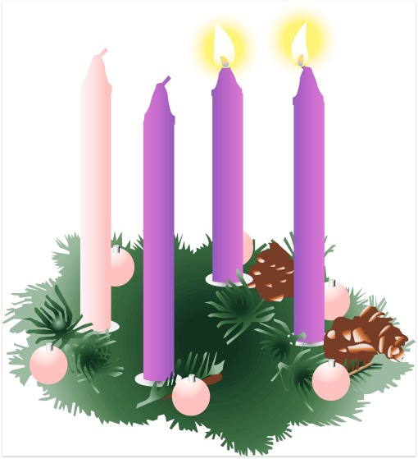
This Photo by Unknown Author is licensed under CC BY-NC-ND
Third Annual Christmas Bazaar
November 20, 21 and 22
Attention: There will be a work day on Saturday, October 10 at 10 a.m. in Gillespie Hall! We need your ideas! It will take all of us participating to make our Bazaar a success!!!

Eggrolls by Agnes, order now.
She will only make 20 dozen.
They are $40 per dozen.
Pick up will be Friday, October 16.
Place order and pay at the office.

Order Tamales by Carmen
at $25.00 per dozen.
Order and pay at the office.
Pick up will be
Saturday, Nov 14.

The profit will equally be divided between three Parishes: Walters, Duncan and Marlow for the purpose of the building fund. We need your time, talent and treasure to make this event successful.

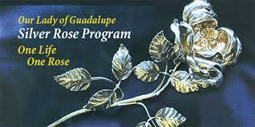

Our Lady of Guadalupe
Silver Rose Mass
The Knights of Columbus are extremely proud to have at the 4PM Mass on Saturday November 24 the Silver Rose that will be on display as it travels from K of C Councils throughout Oklahoma on its journey to The Cathedral in Mexico City for the Celebration of the feast of Our Lady of Guadalupe on December 12. A special Rosary will be said before the Mass. All Knights are asked to attend and all parishioners are invited to attend to hear the story of the Silver Rose and the events of Our Lady of Guadalupe, the Patron Saint of the Knights of Columbus.

DUNCAN COLLECTIONs FOR
Nov 10-11:
Duncan: $1,286.00
Weekly Electronic Donations: $1,200.00
Building: $225.00
Food Bank: $389.00
RYAN: $181.00
Thank you for your generosity!!!

Immaculate Conception Church, Marlow
*********************************
Collections:
Nov 11: General: $1,076.00
Building: $600.00

Catholic young adults of OKC
Open to all young adults (ages 18-39, married or single) in the archdiocese. Visit our Facebook page (Catholic Young Adults of OKC) for events and information or e-mail info@catholicyoungadultsokc.com.

Estate planning seminar
The Catholic Foundation of Oklahoma will be hosting an estate planning seminar from 8 a.m. to Noon Nov. 28 at the Catholic Pastoral Center. This year’s presenter is Douglas Stanley, partner at Bryan Cave Leighton Paisner in St. Louis, Mo. Topics covered will be “Updates on Trust Modifications,” “Non-Judicial Settlement Agreements,” and “Trust Decanting and Donor Advised Funds.” Register at www.cfook.org/estate-planning. Contact (405) 721-4115.

