Thirtieth Sunday in Ordinary Time
October 28, 2018

Christmas Bazaar 2018
Our Christmas Bazaar will be held
November 16, 17 and 18
RAFFLE TICKETS:
1 Tkt for $20
6 Tkts for $100

*1st - $2,000
*2nd - $1,000
*3rd ; $500
Please sign up to sell tickets!!! Come to the Church office and check out raffle tickets
Drawing Sunday, Nov 18 at 5 p.m.
Need not be present to win.
Credit/Debit Cards accepted!!!

Mass Intentions / Peticiones de Misa

Sat | Oct 27 | 4:00p D | (+) Dovie Jenkins
 |  | 6:00p R
Sun | Oct 28 | 8:00a M | (+) William Verde and Gabriel
 |  | 10:00a D | (+) Dovie Jenkins
 |  | 12:00a W | (+) Ron Wedman
 |  | 2:00p D | (+) Lorena Camacho
Mon | Oct 29 | 12:10p D | (+) Dovie Jenkins
Tues | Oct 30 | 12:10p D | NO MASS
Wed | Oct 31 | 12:10p D | (+) Dovie Jenkins
Thur | Nov 1 | 12:10p D | (+) Dovie Jenkins
 |  | 7:00p D | For the Parishioners
Fri | Nov 2 | 12:10p D | (+) Dovie Jenkins  (+) Bobbi Elizabeth Mullen Jester
Sat | Nov 3 | 4:00p D | Living & Deceased Members of the Atlar Society
 |  | 6:00p R
Sun | Nov 4 | 8:00a M | NO MASS
 |  | 10:00a D | (+) Jesus Rocha
 |  | 12:00p W | NO MASS
 |  | 2:00p D | NO MASS

Thanksgiving and Christmas are approaching soon; therefore, we would like to give extra food to those in need.
Beginning November 1,
All Saints Day until the last Sunday of Advent we will take a second collection for our Food Bank.
May God bless your generosity and reward
you for recognizing
Him in our poor.

ATTENTION: There will be no 12:10 p.m. Daily Masses
Monday-Friday, November 5-9
because all Priests will be on a Priestly Retreat.

You are cordially invited to Jimmy Conway’s Twentieth Year Deaconate Ordination Anniversary Mass. The Mass will take place on Sunday, November 4 at 10 a.m. in Assumption of the Blessed Virgin Mary Church. Due to this celebration we will cancel 8 a.m. Marlow, 12:00 p.m. Walters and 2 p.m. Spanish Masses.

There will only be a 10 a.m. Mass followed by a catered lunch in the R.E. Building. The lunch is free of charge; however, you must sign up to attend after weekend Masses. Do not call the office to put your name on the list.

THIS IS THE LAST WEEKEND
TO SIGN UP111

ATTENTION: NO DAILY 12:10 PM MASS ON TUESDAY

Thursday, November 1, 2018
is a Holy Day of Obligation
There will be
two Masses in Duncan:
12:10 p.m. and 7:00 p.m.

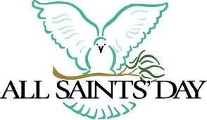

Abuse of Minors Response Hotline 405-720-987 or DHS at 1-800-522-3511.
Telefóno Pastoral para Reportar Abuso de Menores 405-720-9878 o el Departamento de Servicios Humanos 1-800-522-3511.

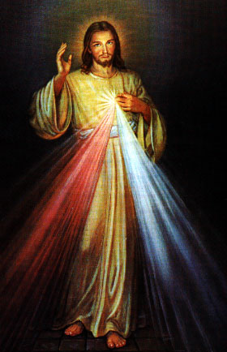
Religious Education (RE) Families:
First day of Religious Education will be Wednesday, September 12, 2018 and Sunday, September 16, 2018. Enrollment forms will be outside the office door and can be dropped off at the church office.
El primer día de Educación Religiosa empieza el miércoles, septiembre 12 y domingo, septiembre 16, 2018. Formas de Inscripciones estarán en la mesita afuera de la oficina. Puede dejar las formas en la oficina de la iglesia.
Sun, Oct 28 | Class
Wed, Oct 31 | Class
Sun, Nov 4 | NO CLASS
maria.martinez@yahoo.com or you may call the
Maria Martinez, RE Director

Knights of Columbus – Coats for Kids
A Coat for Kids drive sponsored by the K of C will be held starting October 28th and running through November 11th. Please bring any clean used or new youths coats ages 2-16 to the Churches where collection box’s will be placed. After the drive the Knights will disseminate the coats to several agencies that are looking to provide coats to needy families this winter.

Third Annual Christmas Bazaar
November 20, 21 and 22
Attention: There will be a work day on Saturday, October 10 at 10 a.m. in Gillespie Hall! We need your ideas! It will take all of us participating to make our Bazaar a success!!!

Eggrolls by Agnes, order now.
She will only make 20 dozen.
They are $40 per dozen.
Pick up will be Friday, October 16.
Place order and pay at the office.

Order Tamales by Carmen
at $25.00 per dozen.
Order and pay at the office.
Pick up will be
Saturday, Nov 14.

The profit will equally be divided between three Parishes: Walters, Duncan and Marlow for the purpose of the building fund. We need your time, talent and treasure to make this event successful.


Immaculate Conception Church, Marlow
*********************************
Collections:
Oct 21: General: $969.00
Building: $150.00

Saint Patrick Catholic Church
Walters, Oklahoma 73572
********************************
October 21:
Operating: $311.00

FALL FESTIVAL
Dear Families,
We will be having a fall festival for RE on Wednesday, October 31 from 6:00-7:00. We will be doing crafts, activities and games. The children are welcome to come dressed as a character from the bible (saints, angels, Mary, etc…)!
El miércoles, 31 de octubre de 6:00-7:00 tendremos festividades de otoño con los niños del catequices. Tendremos manualidades, actividades, y juegos para los niños. Los niños pueden vestirse como un personaje bíblico (santo, angel, Maria, etc…)!
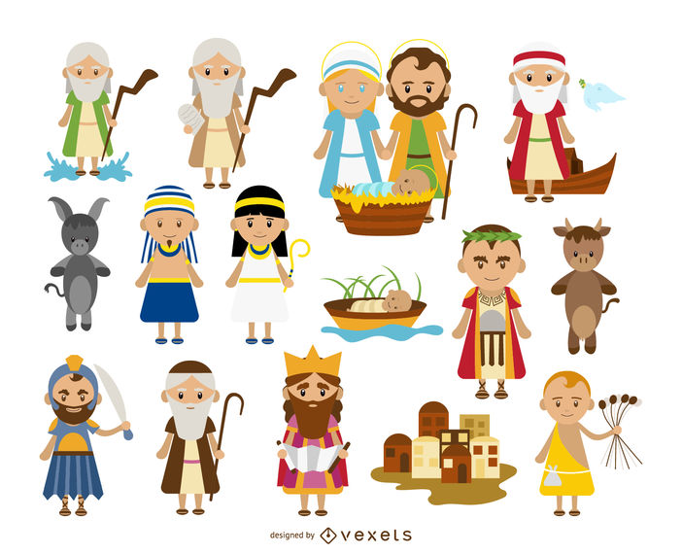
DUNCAN COLLECTIONs FOR
Oct 20-21: Duncan: $1,282.00
Weekly Electronic Donations: $1,200.00
Hurricane Relief: $743.00
Food Bank: $30.00
RYAN: $121.00
Thank you for your generosity!!!

Bingo & Spaghetti
When: Saturday
November 10, 2018
Where:Immaculate Conception
Church – Marlow.
Bingo Cost: $10 for 20 cards
for 15 Games
Prize: Each Bingo game pays $15
and several door prizes will be drawn and awarded during the games.
Knights of Columbus will host a Bingo Night along with a Spaghetti dinner
with salad.
Dinner donations accepted.
Dinner starts at 6:30PM
with Bingo to start @7PM.

Knight of Columbus will be holding a Membership Drive the weekend of October 27-28 after all Masses. Information about our Parish men’s K of C Council will be available to all interested Catholic men and families. As much good as our Council has done over the years, we could do even more with your help. Please stop by after Mass for donuts and drinks and inquire about our Charitable organization with current members.

