Twenty-Ninth Sunday in Ordinary Time
October 21, 2018

Christmas Bazaar 2018
Our Christmas Bazaar will be held
November 16, 17 and 18
RAFFLE TICKETS:
1 Tkt for $20
6 Tkts for $100

*1st - $2,000
*2nd - $1,000
*3rd ; $500
Please sign up to sell tickets!!! Come to the Church office and check out raffle tickets
Drawing Sunday, Nov 18 at 5 p.m.
Need not be present to win.
Credit/Debit Cards accepted!!!

Mass Intentions / Peticiones de Misa

Sat | Oct 20 | 4:00p D | (+) Dovie Jenkins
 |  | 6:00p R
Sun | Oct 21 | 8:00a M
 |  | 10:00a D | For the Parishioners
 |  | 12:00a W | (+) Ron Wedman
 |  | 2:00p D | (+) Dovie Jenkins
Mon | Oct 22 | 12:10p D | NO MASS
Tues | Oct 23 | 12:10p D | NO MASS
Wed | Oct 24 | 12:10p D | (+) Alice Barnes & David Dick  (+) Dovie Jenkins
Thur | Oct 25 | 12:10p D | (+) Dovie Jenkins
Fri | Oct 26 | 12:10p D | (+) Dovie Jenkins
Sat | Oct 27 | 4:00p D | (+) Dovie Jenkins
 |  | 6:00p R
Sun | Oct 28 | 8:00a M
 |  | 10:00a D | (+) Dovie Jenkins
 |  | 12:00p W | (+) Ron Wedman
 |  | 2:00p D | (+) Lorena Camacho

ATTENTION: No Daily 12:10 p.m. Masses
Monday or Tuesday, because of Clergy Days!
Thanksgiving and Christmas are approaching soon; therefore, we would like to give extra food to those in need.
Beginning November 1,
All Saints Day until the last Sunday of Advent we will take a second collection for our Food Bank.
May God bless your generosity and reward
you for recognizing
Him in our poor.

It’s BUNCO time again!
Don’t Miss out on the fun.
All Parish ladies are invited.
MONDAY, OCTOBER 22 AT 6:30 P.M
Immaculate Conception, Marlow
Only $5 per person for fun & fellowship
Must RSVP by Friday, October 19!!!
Call or text: 580-251-0956



You are cordially invited to Jimmy Conway’s Twentieth Year Deaconate Ordination Anniversary Mass. The Mass will take place on Sunday, November 4 at 10 a.m. in Assumption of the Blessed Virgin Mary Church. Due to this celebration we will cancel 8 a.m. Marlow, 12:00 p.m. Walters and 2 p.m. Spanish Masses.

There will only be a 10 a.m. Mass followed by a catered lunch in the R.E. Building. The lunch is free of charge; however, you must sign up to attend after weekend Masses. Do not call the office to put you name on the list. The last day for sign up is Sunday, October 28.

Thursday, November 1, 2017
is a Holy Day of Obligation
There will be
two Masses in Duncan:
12:10 p.m. and 7:00 p.m.

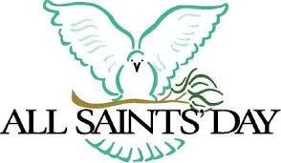

Abuse of Minors Response Hotline 405-720-987 or DHS at 1-800-522-3511.
Telefóno Pastoral para Reportar Abuso de Menores 405-720-9878 o el Departamento de Servicios Humanos 1-800-522-3511.

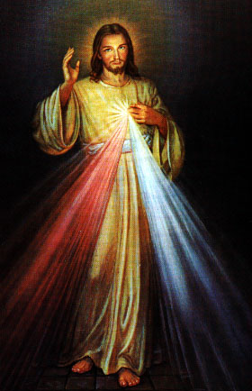

Knights of Columbus – Coats for Kids
A Coat for Kids drive sponsored by the K of C will be held starting October 28th and running through November 11th. Please bring any clean used or new youths coats ages 2-16 to the Churches where collection box’s will be placed. After the drive the Knights will disseminate the coats to several agencies that are looking to provide coats to needy families this winter.

Religious Education (RE) Families:
First day of Religious Education will be Wednesday, September 12, 2018 and Sunday, September 16, 2018. Enrollment forms will be outside the office door and can be dropped off at the church office.
El primer día de Educación Religiosa empieza el miércoles, septiembre 12 y domingo, septiembre 16, 2018. Formas de Inscripciones estarán en la mesita afuera de la oficina. Puede dejar las formas en la oficina de la iglesia.
Sun, Oct 21 | No Class Fall Break
Wed, Oct 24 | No Class Fall Break
Sun, Oct 28 | Class
Wed, Oct 31 | Class
Sun, Nov 4 | NO CLASS
For any questions or concerns regarding Religious Education you may reach me at maria.martinez@yahoo.com or you may call the church office and leave a message.
Maria Martinez, RE Director

Third Annual Christmas Bazaar
November 20, 21 and 22
Attention: There will be a work day on Saturday, October 10 at 10 a.m. in Gillespie Hall! We need your ideas! It will take all of us participating to make our Bazaar a success!!!

Eggrolls by Agnes, order now.
She will only make 20 dozen.
They are $40 per dozen.
Pick up will be Friday, October 16.
Place order and pay at the office.

Order Tamales by Carmen
at $25.00 per dozen.
Order and pay at the office.
Pick up will be
Saturday, Nov 14.

The profit will equally be divided between three Parishes: Walters, Duncan and Marlow for the purpose of the building fund. We need your time, talent and treasure to make this event successful.

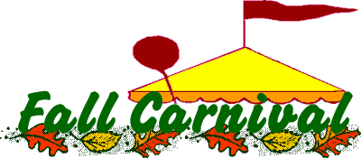
Learn About Your Faith!
We are starting a series on “What Catholics Believe” beginning on Oct. 3 at 6:30 pm every Wednesday in the Nave of the Marlow church (that’s where the pews are). There are 13 lessons with a 30 minute video & discussion at the end. Sessions should be over by 7:45 pm. Volunteers for snacks will be sought at the first lesson. Come learn & enjoy some fellowship. We will take off at Thanksgiving, Christmas & New Years. We will be finished by mid January. We cover Jesus to the Eucharist to Mary to Purgatory. Each lesson is a stand alone, attend one or all. Call Fran Gildon at 580-658-7007 with questions or leave a message. Hope you will make plans to attend “What Catholics Believe”!!!

Saint Patrick Catholic Church
Walters, Oklahoma 73572
********************************
Collections: September 30:
Operating $930.00/Building $420.00
October 14:
Operating: $930.00/Building: $420.00

Immaculate Conception Church, Marlow
*********************************
Collections:
Sep 30: General $862.72/Building $150.00
Oct 7: General: $811.00/Building: $170.00
Oct 14: General: $640.00/$150.00

DUNCAN COLLECTIONs FOR
Sep 30: Duncan: $1,467.00
Weekly Electronic Donations: $1,200.00
Food Bank: $115.00/ Building: $75.00
RYAN: $80.00
Oct 7: Duncan: 3,105.00
Food Bank: $40.00/St. Vincent de Paul: $15.00
Building: $136.00
Ryan: $136.00
Oct 14: Duncan $2,010.00
Food Bank: $31.00/St. Vincent de Paul: $40.00
Building: $256.00
Ryan: $189.00
Thank you for your generosity!!!

Carnival, Sunday, October 28
We invite everyone to participate in our yearly Carnival which will take place Sunday, Oct 28 from 11-4 p.m. We will have a variety of children’s activities, games, food and other attractions. The profits from this Event will go for the Feast of our Lady of Guadalupe flowers. Thank you for your support.

Todos invitados al Carnaval annual, que sera el 8 de Oct de las 11am alas 4 pm. Habra: Juegos y antojitos maxicanos lo recavdado sera par alas Flores de la Virge de Guadalupe Bienvenidos! Gracias!

Knight of Columbus will be holding a Membership Drive the weekend of October 27-28 after all Masses. Information about our Parish men’s K of C Council will be available to all interested Catholic men and families. As much good as our Council has done over the years, we could do even more with your help. Please stop by after Mass for donuts and drinks and inquire about our Charitable organization with current members.

