Twenty-Eighth Sunday in Ordinary Time
October 14, 2018

Mass Intentions / Peticiones de Misa

Sat | Oct 13 | 4:00p D | (+) Dovie Jenkins
 |  | 6:00p R
Sun | Oct 14 | 8:00a M
 |  | 10:00a D | (+) Don Trostle and Jake Seratte
 |  | 12:00a W
 |  | 2:00p D | (+) Dovie Jenkins
Mon | Oct 15 | 12:10p D | (+) Dovie Jenkins
Tues | Oct 16 | 12:10p D | (+) Dovie Jenkins
Wed | Oct 17 | 7:00p D | (+) Dovie Jenkins
Thur | Oct 18 | 12:10p D | (+) Dovie Jenkins
Fri | Oct 19 | 12:10p D | (+) Dovie Jenkins
Sat | Oct 20 | 4:00p D | (+) Dovie Jenkins
 |  | 6:00p R
Sun | Oct 21 | 8:00a M
 |  | 10:00a D
 |  | 12:00p W
 |  | 2:00p D | (+) Dovie Jenkins
Christmas Bazaar 2018

Our Christmas Bazaar
will be held
November 16, 17 and 18

RAFFLE TICKETS:
1 Tkt for $20
6 Tkts for $100


*1st - $2,000
*2nd - $1,000
*3rd ; $500
Please sign up to sell tickets!!! Come to the Church office and check out raffle tickets
Drawing Sunday, Nov 18 at 5 p.m.
Need not be present to win.

Credit/Debit Cards accepted!!!

You are cordially invited to Jimmy Conway’s Twentieth Year Deaconate Ordination Anniversary Mass. The Mass will take place on Sunday, November 4 at 10 a.m. in Assumption of the Blessed Virgin Mary Church. Due to this celebration we will cancel 8 a.m. Marlow, 12:00 p.m. Walters and 2 p.m. Spanish Masses.

There will only be a 10 a.m. Mass followed by a catered lunch in the R.E. Building. The lunch is free of charge; however, you must sign up to attend after weekend Masses. Do not call the office to put you name on the list. The last day for sign up is Sunday, October 28.

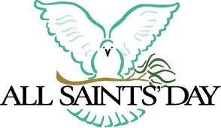

Thursday, November 1, 2017

is All Saints Day and a
Holy Day of Obligation

There will be
two Masses in Duncan:

12:10 p.m. and 7:00 p.m.

Abuse of Minors Response Hotline 405-720-987 or DHS at 1-800-522-3511.
Telefóno Pastoral para Reportar Abuso de Menores 405-720-9878 o el Departamento de Servicios Humanos 1-800-522-3511.

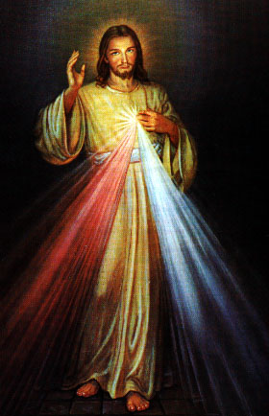

Religious Education (RE) Families:
First day of Religious Education will be Wednesday, September 12, 2018 and Sunday, September 16, 2018. Enrollment forms will be outside the office door and can be dropped off at the church office.
El primer día de Educación Religiosa empieza el miércoles, septiembre 12 y domingo, septiembre 16, 2018. Formas de Inscripciones estarán en la mesita afuera de la oficina. Puede dejar las formas en la oficina de la iglesia.
Sun, Oct 14 | Class
Wed, Oct 17 | Class
Sun, Oct 21 | No Class Fall Break
Wed, Oct 24 | No Class Fall Break
Class times are as follows:
Grades 1-6 meet on Wednesday from 6:00pm-7:30pm
Grades 7-12 meet on Sunday from 11:00pm-12:30pm
Please drop the children off on time and pick up promptly!
Por favor de dejar y levantar a su hijo(a) a tiempo!
For any questions or concerns regarding Religious Education you may reach me at maria.martinez@yahoo.com or you may call the church office and leave a message.
Maria Martinez, RE Director

Beginning RCIA Classes – 2018-2019
RCIA (The Rite of Christian Initiation for Adults) is a vibrant informative program for adults who are interested in joining the Catholic Church. If you are interested or know of someone who is interested in learning about our Catholic Faith, RCIA Inquiry one hour sessions will be starting SUNDAY, September 9, 2018 after the 10AM Mass in Duncan. An open invitation is also extended to current Catholics that want to know and learn more about our faith as well as Catholic Adults interested in becoming Catechist (Teachers) or Sponsors. For additional information on these RCIA Inquiry sessions, please contact Mike or Lucy Radtke at 606-0283 or 656-7582 or email mikelucy@live.com

Third Annual Christmas Bazaar
November 20, 21 and 22
Attention: There will be a work day on Saturday, October 10 at 10 a.m. in Gillespie Hall! We need your ideas! It will take all of us participating to make our Bazaar a success!!!

Eggrolls by Agnes, order now.
She will only make 20 dozen.
They are $40 per dozen.
Pick up will be Friday, October 16.
Place order and pay at the office.

Order Tamales by Carmen
at $25.00 per dozen.
Order and pay at the office.
Pick up will be
Saturday, Nov 14.

The profit will equally be divided between three Parishes: Walters, Duncan and Marlow for the purpose of the building fund. We need your time, talent and treasure to make this event successful.

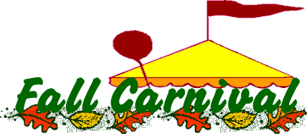
Learn About Your Faith!
We are starting a series on “What Catholics Believe” beginning on Oct. 3 at 6:30 pm every Wednesday in the Nave of the Marlow church (that’s where the pews are). There are 13 lessons with a 30 minute video & discussion at the end. Sessions should be over by 7:45 pm. Volunteers for snacks will be sought at the first lesson. Come learn & enjoy some fellowship. We will take off at Thanksgiving, Christmas & New Years. We will be finished by mid January. We cover Jesus to the Eucharist to Mary to Purgatory. Each lesson is a stand alone, attend one or all. Call Fran Gildon at 580-658-7007 with questions or leave a message. Hope you will make plans to attend “What Catholics Believe”!!!

Did you know?. . .The Altar Society prays the Divine Mercy Chaplet and Rosary week days at 11:45 a.m., Saturday at 3:30 p.m. and Sundays at 9:30 a.m. Everyone is invited to spend time with Jesus and come together as a community.

Did you know?
You can have a Mass said in memory of a loved one. What a wonderful gift! A Gregorian Mass is a set of thirty Masses said for the repose of the soul of a deceased love one. Stop by the office to reserve your date(s).

Carnival, Sunday, October 28
We invite everyone to participate in our yearly Carnival which will take place Sunday, Oct 28 from 11-4 p.m. We will have a variety of children’s activities, games, food and other attractions. The profits from this Event will go for the Feast of our Lady of Guadalupe flowers. Thank you for your support.

Todos invitados al Carnaval annual, que sera el 8 de Oct de las 11am alas 4 pm. Habra: Juegos y antojitos maxicanos lo recavdado sera par alas Flores de la Virge de Guadalupe Bienvenidos! Gracias!

