Twenty-Second Sunday in Ordinary Time
September 2, 2018

Mass Intentions / Peticiones de Misa

Sat | Sep 1 | 4:00p D
 |  | 6:00p R
Sun | Sep 2 | 8:00a M | (+) Mary Leigh
 |  | 10:00a D | (+) Howard Doerr
 |  | 12:00a W
 |  | 2:00p D
Mon | Sep 3 | 12:10p D
Tues | Sep 4 | 12:10p D
Wed | Sep 5 | 7:00p D
Thur | Sep 6 | 12:10p D
Fri | Sep 7 | 12:10p D | (+) Al Bernal in Memory
Sat | Sep 8 | 4:00p D
 |  | 6:00p R
Sun | Sep 9 | 8:00a M | (+) Mary Leigh
 |  | 10:00a D
 |  | 12:00p W
 |  | 2:00p D
Beginning RCIA Classes – 2018-2019
RCIA (The Rite of Christian Initiation for Adults) is a vibrant informative program for adults who are interested in joining the Catholic Church. If you are interested or know of someone who is interested in learning about our Catholic Faith, RCIA Inquiry one hour sessions will be starting SUNDAY, September 9, 2018 after the 10AM Mass in Duncan. An open invitation is also extended to current Catholics that want to know and learn more about our faith as well as Catholic Adults interested in becoming Catechist (Teachers) or Sponsors. For additional information on these RCIA Inquiry sessions, please contact Mike or Lucy Radtke at 606-0283 or 656-7582 or email mikelucy@live.com

DUNCAN ALTAR SOCIETY
There will be a Duncan Altar Society Meeting on Wednesday, September 12 after the 12:10pm Mass. Please bring a dish to share for our Potluck Lunch.

Special Collection for Property and Liability Insurance BALANCE TO COLLECT: $2,000.00
Every Sunday we will be having a Second Collection
for our Property and Liability Insurance for the year
2018/2019 which is around $19,000.00.
Therefore, we request that you help $17,000.00
us to raise money for this necessary expenditure.
Please write checks to
Assumption/Building Fund. $5,000.00
Thank you for your generosity.
May God Bless You, Fr. Peter $2,000.00

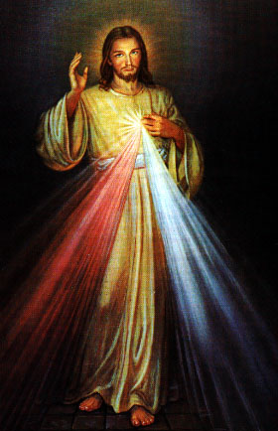
Abuse of Minors Response Hotline 405-720-987 or DHS at 1-800-522-3511.
Telefóno Pastoral para Reportar Abuso de Menores 405-720-9878 o el Departamento de Servicios Humanos 1-800-522-3511.

Third Annual Christmas Bazaar
November 20, 21 and 22
Attention: There will be a work day on Saturday, October 10 at 10 a.m. in Gillespie Hall! We need your ideas! It will take all of us participating to make our Bazaar a success!!!

Eggrolls by Agnes, order now.
She will only make 20 dozen.
They are $40 per dozen.
Pick up will be Friday, October 16.
Place order and pay at the office.

Order Tamales by Carmen
at $25.00 per dozen.
Order and pay at the office.
Pick up will be
Saturday, Nov 14.

The profit will equally be divided between three Parishes: Walters, Duncan and Marlow for the purpose of the building fund. We need your time, talent and treasure to make this event successful.

