Eighteenth Sunday in Ordinary Time
August 5, 2018

Mass Intentions / Peticiones de Misa

Sat | Aug 4 | 4:00p D
 |  | 6:00p R
Sun | Aug 5 | 8:00a M
 |  | 10:00a D | (+) Howard Doerr
 |  | 12:00a W
 |  | 2:00p D | NO SPANISH MASS
Mon | Aug 6 | 12:10p D | For the Parishioners
Tues | Aug 7 | 12:10p D
Wed | Aug 8 | 12:10p D | For the Parishioners
Thur | Aug 9 | 12:10p D
Fri | Aug 10 | 12:10p D | For the Parishioners
Sat | Aug 11 | 4:00p D
 |  | 6:00p R
Sun | Aug 12 | 8:00a M
 |  | 10:00a D | (+) Brenda Lee Plumlee  by Pat Cook
 |  | 12:00p W
 |  | 2:00p D | NO SPANISH MASS
Immaculate Conception Church
Marlow
*********************************
Collections:
July 15: General $519.00/Building $50.00
July 22: General $712.00/Building $50.00

Saint Patrick Catholic Church
Walters, Oklahoma 73572
********************************
Collections:
July 15: Operating $586.52/Building: $41.00
July 22: Operating $/Building: $

DUNCAN COLLECTIONs FOR
july 14-15:
Duncan: $1,639.60
Weekly Electronic Donations: $1,200.00
Building Fund: $522.00
Food Bank: $52.00
St. Vincent de Paul: $374.00
San Jose: $139.00
JULY 21-22:
Duncan: $1,405.00
Building Fund: $653.00
Thank you for your generosity!!!

Did you Know: You can always donate via automatic withdrawal directly to our church's account. It is easy, simple and at the end of the fiscal year you will receive a tax letter acknowledging your donations. For more information stop by the office after each Mass.
Thank you for your support.

Special Collection for Property and Liability Insurance BALANCE TO COLLECT: $4,000.00
Every Sunday we will be having a Second Collection
for our Property and Liability Insurance for the year
2018/2019 which is around $19,000.00.
Therefore, we request that you help $15,000.00
us to raise money for this necessary expenditure.
Please write checks to
Assumption/Building Fund. $5,000.00
Thank you for your generosity.
May God Bless You, Fr. Peter $2,000.00

Abuse of Minors Response Hotline 405-720-987 or DHS at 1-800-522-3511.
Telefóno Pastoral para Reportar Abuso de Menores 405-720-9878 o el Departamento de Servicios Humanos 1-800-522-3511.

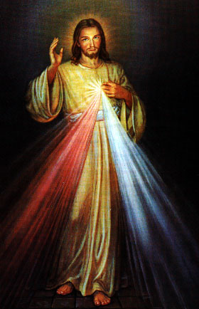
Third Annual Christmas Bazaar
November 20, 21 and 22
Attention: There will be a work day on Saturday, October 10 at 10 a.m. in Gillespie Hall! We need your ideas! It will take all of us participating to make our Bazaar a success!!!

Eggrolls by Agnes, order now.
She will only make 20 dozen.
They are $40 per dozen.
Pick up will be Friday, October 16.
Place order and pay at the office.

Order Tamales by Carmen
at $25.00 per dozen.
Order and pay at the office.
Pick up will be
Saturday, Nov 14.

The profit will equally be divided between three Parishes: Walters, Duncan and Marlow for the purpose of the building fund. We need your time, talent and treasure to make this event successful.

