Seventeenth Sunday in Ordinary time
July 29, 2018

Mass Intentions / Peticiones de Misa

Sat | July 28 | 4:00p D
 |  | 6:00p R
Sun | July 29 | 8:00a M
 |  | 10:00a D | (+) Mary Douchinsky
 |  | 12:00a W
 |  | 2:00p D | NO SPANISH MASS
Mon | July 30 | 12:10p D | For the Parishioners
Tues | July 31 | 12:10p D
Wed | Aug 1 | 12:10p D | For the Parishioners
Thur | Aug 2 | 12:10p D
Fri | Aug 3 | 12:10p D | For the Parishioners
Sat | Aug 4 | 4:00p D
 |  | 6:00p R
Sun | Aug 5 | 8:00a M
 |  | 10:00a D | (+) Howard Doerr
 |  | 12:00p W
 |  | 2:00p D | NO SPANISH MASS

Platicas del Sacramento de Bautizmo
en Español
Agosto 18, Noviembre 10, Son a la 7 p.m. en La capilla.
Para mas informacioń llame
Carmen Garcia 580-255-6337
Gracias

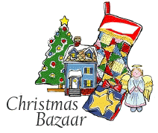
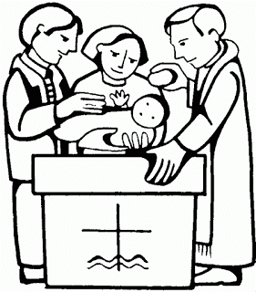

Everyone is invited to a Christmas Bazaar organizational meeting on TUESDAY, AUGUST 21
at 7 p.m. in Gillespie Hall

ATTENTION: There will be NO 2 pm Spanish Masses
Sundays, July 29-Aug 19

The Parish Feast of the
Assumption of the
Blessed Virgin Mary is Wednesday, August 15, 2018. at 7 p.m.
In Duncan only one Mass.
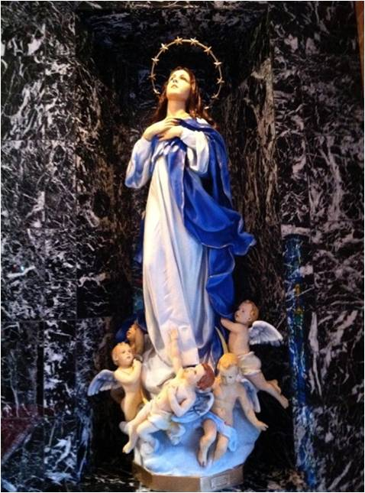

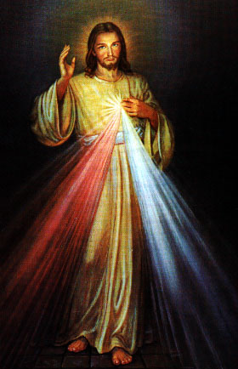
Third Annual Christmas Bazaar
November 20, 21 and 22
Attention: There will be a work day on Saturday, October 10 at 10 a.m. in Gillespie Hall! We need your ideas! It will take all of us participating to make our Bazaar a success!!!

Eggrolls by Agnes, order now.
She will only make 20 dozen.
They are $40 per dozen.
Pick up will be Friday, October 16.
Place order and pay at the office.

Order Tamales by Carmen
at $25.00 per dozen.
Order and pay at the office.
Pick up will be
Saturday, Nov 14.

The profit will equally be divided between three Parishes: Walters, Duncan and Marlow for the purpose of the building fund. We need your time, talent and treasure to make this event successful.

Archbishop’s Dinner 2018
Join Archbishop Coakley, clergy and seminarians from the Archdiocese of Oklahoma City at the 2018 Archbishop’s Dinner in support of seminarian education at 6 p.m. Aug. 7 at the Oklahoma City Golf and Country Club. Contact the Catholic Foundation of Oklahoma at (405) 709-2745 or go online to cfook.org/dinner.

Mark your calendar for Catholic Foundation’s presentation on wills and trusts. This will be held on Monday, October 24 at 7 p.m. at Assumption Catholic Church Gillespie Hall. Come and learn how to take care of those you love.
You can have a Mass said for someone's intentions at their birthday, wedding, baptism, or in memory of your deceased loved ones. Contact he office for days and times that you wish to have the Mass celebrated. What a precious gift!

