Sixteenth Sunday in Ordinary time
July 22, 2018



Did you know?
You can have a Mass said in memory of a loved one. What a wonderful gift! A Gregorian Mass is a set of thirty Masses said for the repose of the soul of a deceased love one. Stop by the office to reserve your date(s).

Mass Intentions / Peticiones de Misa

Sat | July 21 | 4:00p D
 |  | 6:00p R
Sun | July 22 | 8:00a M | (+) Joe Delk by Susan Evans
 |  | 10:00a D | For Victoria on her Birthday
 |  | 12:00a W
 |  | 2:00p D | (+) Humberto Campos
Mon | July 23 | 12:10p D | (+) Alice Barnes
Tues | July 24 | 12:10p D | NO MASS
Wed | July 25 | 12:10p D | (+) Henry Renschen
Thur | July 26 | 12:10p D
Fri | July 27 | 12:10p D
Sat | July 28 | 4:00p D
 |  | 6:00p R
Sun | July 29 | 8:00a M
 |  | 10:00a D
 |  | 12:00p W
 |  | 2:00p D

Immaculate Conception Church
Marlow
*********************************
Collections:
July 1: General $777.00
Building $215.00
July 8: General $980.00
Building $560.00

Archbishop’s Dinner 2018
Join Archbishop Coakley, clergy and seminarians from the Archdiocese of Oklahoma City at the 2018 Archbishop’s Dinner in support of seminarian education at 6 p.m. Aug. 7 at the Oklahoma City Golf and Country Club. Contact the Catholic Foundation of Oklahoma, (405) 709-2745, cfook.org/dinner.

There will be NO
12:10 p.m. Daily Mass on
Tuesday, July 24.

Did you Know: You can always donate via automatic withdrawal directly to our church's account. It is easy, simple and at the end of the fiscal year you will receive a tax letter acknowledging your donations. For more information stop by the office after each Mass.
Thank you for your support.

Saint Patrick Catholic Church
Walters, Oklahoma 73572
********************************
Collections:
July 1: Operating $547.00
Building: $603.00
July 8: Operating $441.01
Building: $125.00

DUNCAN COLLECTIONs FOR
June 30-july 1:
Duncan: $2,062.00
Weekly Electronic Donations: $1,200.00
Building Fund: $447.00
Peter’s Pence: $24.00
Food Bank: $53.00
St. Vincent de Paul: $35.00
San Jose: $140.00
JULY 7-8:
Duncan: $1,015.00
Building Fund: $773.00
Food Bank: $20.00
Thank you for your generosity!!!

We have daily adoration
and pray the
Chaplet of Divine Mercy
and the Rosary
Monday through
Friday at
11:30 a.m.
before the 12:10 Mass.
Everyone is invited
to participate and
spend time with Jesus
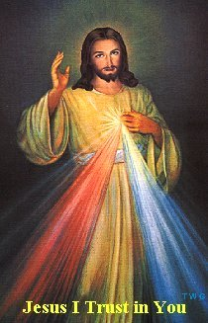
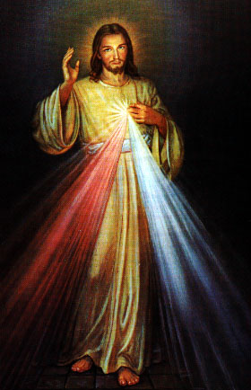
Third Annual Christmas Bazaar
November 20, 21 and 22
Attention: There will be a work day on Saturday, October 10 at 10 a.m. in Gillespie Hall! We need your ideas! It will take all of us participating to make our Bazaar a success!!!

Eggrolls by Agnes, order now.
She will only make 20 dozen.
They are $40 per dozen.
Pick up will be Friday, October 16.
Place order and pay at the office.

Order Tamales by Carmen
at $25.00 per dozen.
Order and pay at the office.
Pick up will be
Saturday, Nov 14.

The profit will equally be divided between three Parishes: Walters, Duncan and Marlow for the purpose of the building fund. We need your time, talent and treasure to make this event successful.

Mark your calendar for Catholic Foundation’s presentation on wills and trusts. This will be held on Monday, October 24 at 7 p.m. at Assumption Catholic Church Gillespie Hall. Come and learn how to take care of those you love.
You can have a Mass said for someone's intentions at their birthday, wedding, baptism, or in memory of your deceased loved ones. Contact he office for days and times that you wish to have the Mass celebrated. What a precious gift!

