The Nativity of St. John the Baptist
June 24, 2018

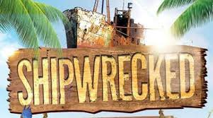
Vacation Bible School
Supplies Needed

If you would like to
donate any of the
following items for
Vacation Bible School
please drop the items off starting
this Monday at the office
10:00-11:30am or 1:00-3:00pm
or the auditorium between 5-8 p.m.
You can also make a cash donation please drop it at the office.
Thank you for your generosity.
10 plastic blue tablecloths
10 plastic white tablecloths
15 pool noodles
5 beach balls
4 blue art/craft paint
4 brown art/craft paint
Beach items/toys
5 rolls blue plastic
3 rolls of duct tape
Mass Intentions / Peticiones de Misa

Sat | June 23 | 4:00p D | (+) Jack Geurkink
 |  | 6:00p R | For the Parishioners
Sun | June 24 | 8:00a M | (+) Jason Muller
 |  | 10:00a D | (+) Alice Barnes
 |  | 12:00a W
 |  | 2:00p D | (+) Jack Geurkink
Mon | June 25 | 12:10p D | (+) Jack Geurkink
Tues | June 26 | 12:10p D | (+) Jack Geurkink
Wed | June 27 | 12:10p D | (+) Jack Geurkink
Thur | June 28 | 12:10p D | (+) Jack Geurkink
Fri | June 29 | 12:10p D | (+) Jack Geurkink
Sat | June 30 | 4:00p D | (+)Jack Geurkink
 |  | 6:00p R
Sun | July 1 | 8:00a M | (+) Jason Muller
 |  | 10:00a D | (+) Jack Geurkink
 |  | 12:00p W
 |  | 2:00p D | God’s blessings for Martha



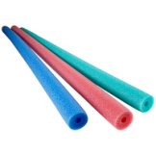

Special Collection for Property and Liability Insurance
BALANCE TO COLLECT: $4,000.00
Every Sunday we will be having a Second Collection
for our Property and Liability Insurance for the year
2018/2019 which is around $19,000.00.
Therefore, we request that you help $15,000.00
us to raise money for this necessary expenditure.
Please write checks to
Assumption/Building Fund. $5,000.00
Thank you for your generosity.
May God Bless You, Fr. Peter $2,000.00

Abuse of Minors Response Hotline 405-720-987 or DHS at 1-800-522-3511.
Telefóno Pastoral para Reportar Abuso de Menores 405-720-9878 o el Departamento de Servicios Humanos 1-800-522-3511.

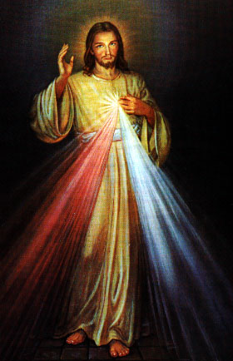
Third Annual Christmas Bazaar
November 20, 21 and 22
Attention: There will be a work day on Saturday, October 10 at 10 a.m. in Gillespie Hall! We need your ideas! It will take all of us participating to make our Bazaar a success!!!

Eggrolls by Agnes, order now.
She will only make 20 dozen.
They are $40 per dozen.
Pick up will be Friday, October 16.
Place order and pay at the office.

Order Tamales by Carmen
at $25.00 per dozen.
Order and pay at the office.
Pick up will be
Saturday, Nov 14.

The profit will equally be divided between three Parishes: Walters, Duncan and Marlow for the purpose of the building fund. We need your time, talent and treasure to make this event successful.

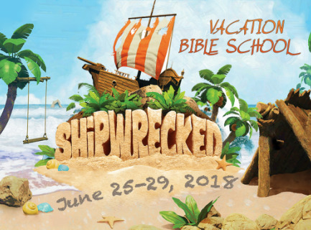

We are excited to begin VBS! This year the theme will be shipwrecked and it will begin on Monday, June 25-29. Registration will begin on June 9th. Below is the daily scheduled time:

Estamos contentos por empezar la escuela bíblica de verano! Este año el tema será Shipwrecked y empezaremos el lunes, junio 25-29. Inscripción empezara el 9 de junio. Abajo está el horario de cada día de la semana:

5:00pm- meal/cena
5:30pm- VBS begins/empezamos
6:00pm- Station Rotations/rotación de estaciones
7:45pm- VBS ends/terminamos

We would love for you to help us decorate or as stations leaders during VBS. Please complete a volunteer form and attend a team meeting on June 12th at 4:00pm. You may also contact Maria Martinez at 580-467-0184 or Veronica Ibarra at 580-606-8226.

Nos gustaría que nos ayudaran decorar o ser líderes durante VBS. Por favor de llenar la forma de voluntario y asista a una junta el 12 de junio a las 4:00pm. Pueden comunicarse con María Martínez al 580-467-0184 o Verónica Ibarra al 580-606-8226.

Mark your calendar for Catholic Foundation’s presentation on wills and trusts. This will be held on Monday, October 24 at 7 p.m. at Assumption Catholic Church Gillespie Hall. Come and learn how to take care of those you love.
You can have a Mass said for someone's intentions at their birthday, wedding, baptism, or in memory of your deceased loved ones. Contact he office for days and times that you wish to have the Mass celebrated. What a precious gift!

Summer EBT for Children Apply Now!
STUDENTS RECEIVING FREE AND REDUCED SCHOOL MEALS MAY QUALIFY FOR FREE FOOD THIS SUMMER!
To apply online, go to www.Chickasaw.net/SummerEBT.
To apply over the phone, call (580) 272-1178 or (844) 256-3467
(8 a.m. to 5 p.m., Monday-Friday).
This federally-funded program is open to both Native American and Non-Native students. Qualifying families will receive an EBT card (works like a debit card) that allows you to purchase healthy food for the summer. To qualify for Summer EBT for Children, your child must meet the following requirements: • Be enrolled in a participating ublic school district in grades pre-K (4 year old program)–12th grade for the 2017-18 school year • Be eligible to receive free or reduced meals at school - Participation in this program will not impact any government assistance you and your child currently receive. - Information provided by you on the consent form, or any records obtained for this program, will be kept confidential as allowed by law, and will be used only for this project.
- Once approved, Summer EBT cards will be mailed to the address you provided, along with a list of participating stores and a food card shopping list that will help you identify approved food items.
To learn more, call (580) 272-1178 or (844) 256-3467 between 8 a.m. and 5 p.m., Monday through Friday. Summer EBT for Children is an initiative of the Chickasaw Nation. This institution is an equal opportunity provider. This material is based upon work that is supported by the Food and Nutrition Service, U.S. Department of Agriculture.
Saint Patrick Catholic Church
Walters, Oklahoma 73572
********************************
Collections:
June 17: Operating $490.00
Building: $650.00

Immaculate Conception Church
Marlow
*********************************
Collections:
June 17: General-$678.00

DUNCAN COLLECTIONs FOR
June 16-17:
Duncan: $1,438.00
Weekly Electronic Donations: $1,200.00
Building Fund: $486.00
Thank you for your generosity!!!

