Seventeenth Sunday in Ordinary Time
July 30, 2017

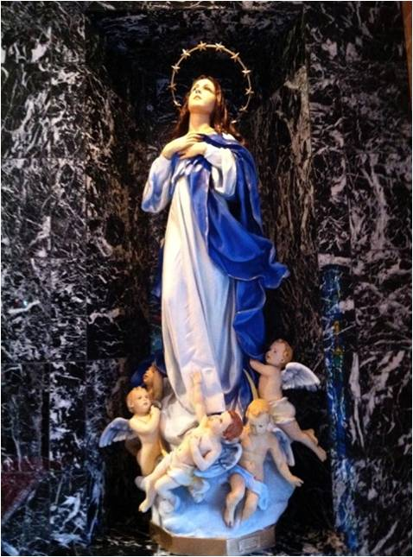

The Parish Feast of the
Assumption of the
Blessed Virgin Mary is Tuesday, August 15, 2017. at 7 p.m.
In Duncan only one Mass.
Mass Intentions / Peticiones de Misa

Sat | Ju1 29 | 4:00p D | (+) Jo Ann Hebert
 |  | 6:00p R
Sun | Jul 30 | 8:00a M
 |  | 10:00a D
 |  | 12:00p W
 |  | 2:00p D | (+) Florencia Cadena
Mon | Jul 31 | 12:10p D | For the Parishioners
Tues | Aug 1 | 12:10p D | (+) Esteban Perez , Gregorian
Wed | Aug 2 | 12:10p D | (+) Esteban Perez , Gregorian
Thur | Aug 3 | 12:10p D | (+) Esteban Perez , Gregorian
Fri | Aug 4 | 12:10p D | (+) Esteban Perez , Gregorian
Sat | Aug 5 | 4:00p D | Happy Birthday Steve Neal
 |  | 6:00p R | (+) Esteban Perez , Gregorian
Sun | Aug 6 | 8:00a M | For the Parishioners
 |  | 10:00a D | (+) Br Ray
 |  | 12:00p W | Int of Howard Doerr by The Wolfgang-Deeg Family
 |  | 2:00p D | (+) Esteban Perez , Gregorian
Our Catholic Food Bank was able to assist 4,124 people during the first six months of this year. Please remember whoever knocks on our Food Bank door is not turned away.

Annual Church Garage Sale
Saturday, August 12, 2017
8 a.m. – 2 p.m.

Assumption Church Auditorium
Beat the heat! Inside Sale!

Homemade Burritos and Drinks for sale
Starting at 10 a.m.

Donations: (furniture, shoes décor, etc.)
Accepted until Thursday, August 10
Call Carmen Garcia at 255-6337

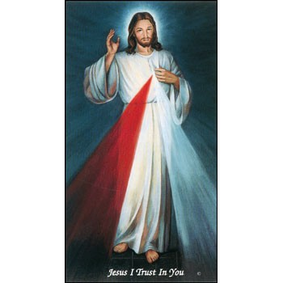


Come and join us every week day for Adoration of the Blessed Sacrament and recitation of The Divine Mercy Chaplet and Rosary at 11:30 a.m. followed by our daily Mass at 12:10 p.m.

Les invitamos todos los días a la adoración del Santísimo a las 11:30 a.m. antes de nuestra misa diaria 12:10 p.m.

Third Annual Christmas Bazaar
November 20, 21 and 22
Attention: There will be a work day on Saturday, October 10 at 10 a.m. in Gillespie Hall! We need your ideas! It will take all of us participating to make our Bazaar a success!!!

Eggrolls by Agnes, order now.
She will only make 20 dozen.
They are $40 per dozen.
Pick up will be Friday, October 16.
Place order and pay at the office.

Order Tamales by Carmen
at $25.00 per dozen.
Order and pay at the office.
Pick up will be
Saturday, Nov 14.

The profit will equally be divided between three Parishes: Walters, Duncan and Marlow for the purpose of the building fund. We need your time, talent and treasure to make this event successful.

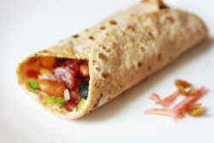

Abuse of Minors Response Hotline 405-720-987 or DHS at 1-800-522-3511.
Telefóno Pastoral para Reportar Abuso de Menores 405-720-9878 o el Departamento de Servicios Humanos 1-800-522-3511.

Mark your calendar for Catholic Foundation’s presentation on wills and trusts. This will be held on Monday, October 24 at 7 p.m. at Assumption Catholic Church Gillespie Hall. Come and learn how to take care of those you love.
You can have a Mass said for someone's intentions at their birthday, wedding, baptism, or in memory of your deceased loved ones. Contact he office for days and times that you wish to have the Mass celebrated. What a precious gift!

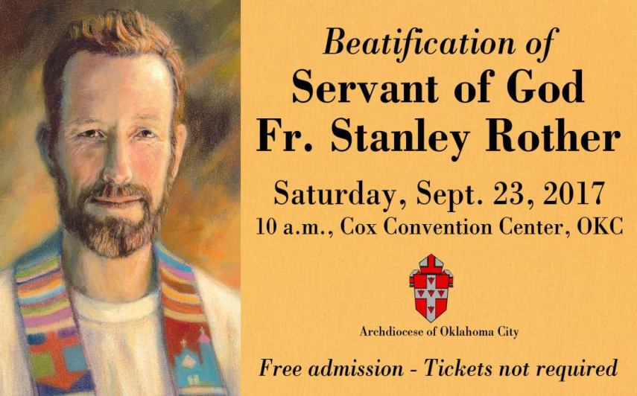
Women of Faith/Women of Action
Luncheon 2017
Saturday, August 19, 2017
At the Catholic Pastoral Center
Special Guest: Archbishop Paul S. Coakley
Luncheon 12-1:30 p.m.
Registration to attend $25.00

A buffet luncheon will be served
A Donation will be made to Catholic Relief Services

Call/Mail or E-mail to: Mary Ann Schmitt,
405-650-9674, sgmaschm@aol.com

Beautification of
Fr. Stanley Rother

Marlow is taking a bus to the Beatification of Fr. Stanley Rother on Saturday, September 23, 2017. Anyone wanting to ride the bus from Duncan, Walters or Marlow needs to sign up no later than Thursday, August 31, 2017. A Donation for the transportation will be taken on the day of travel. The bus will leave Marlow @ 7:00 a.m. on Saturday, September 23.

To sign up, call Kathi Havron 641-1867, or Bill Havron 512-6867. This is a chance of a lifetime! The bus can hold 56 people, and first come, first serve!

We will have the bus all day, so we can eat afterwards. With this bus there is no hassle with parking.

Website for
Fr. Rother Beatification
For everything you need to know about Father Rother’s beatification, go online to stanleyrother.org. Father Rother’s beatification is Sept. 23 at the Cox Convention Center. No tickets required.

Immaculate Conception Church
4th & Comanche, Marlow
**********************************
Collections:
July 23: Operating: $356.00
Building: $150.00

Saint Patrick Catholic Church
THIRD AND OHIO
POST OFFICE BOX 151
Walters, Oklahoma 73572
********************************
Collections:
Jul 23: Operating $656.00
Building: $145.00

DUNCAN COLLECTIONs FOR
July 22-23:
Duncan: $1,601.00
Weekly Electronic Donations: $1,000.00
Second Collection: $209.00
Building Fund: $50.00
Ryan: $176.00
Thank you for your generosity!!!

Rother Heritage Gallery
adds weekend hours

The Heritage Gallery at the Catholic Pastoral Center, 7501 Northwest Expressway, is presenting “The Shepherd Cannot Run: A retrospective on the life of Father Stanley Rother.” The exhibit is open 9 a.m. - 4 p.m. Monday-Friday, and on the following Saturdays from 9 a.m. to Noon: July 29 and Aug. 19. The exhibit is free. Special tours arranged by calling (405) 721-5651, Ext. 141.

