Sixteenth Sunday in Ordinary Time
July 23, 2017

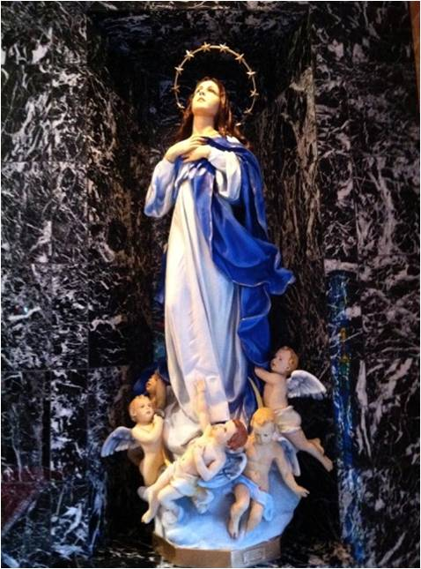

The Parish Feast of the
Assumption of the
Blessed Virgin Mary is Tuesday, August 15, 2017. at 7 p.m.
In Duncan only one Mass.
Mass Intentions / Peticiones de Misa

Sat | Ju1 22 | 4:00p D | For Victoria on her Birthday
 |  | 6:00p R
Sun | Jul 23 | 8:00a M | (+) Joanne Lowe  by Fr. Peter
 |  | 10:00a D
 |  | 12:00p W
 |  | 2:00p D | (+) Esteban Perez  By Maria Jones & Lee Jones
Mon | Jul 24 | 12:10p D | (+) Alice Barnes by Family
Tues | Jul 25 | 12:10p D | (+) Mary Mansaker
Wed | Jul 26 | 12:10p D | (+) Vangie & Bill Mullen
Thur | Jul 27 | 12:10p D | For the Parishioners
Fri | Jul 28 | 12:10p D | (+) George E. Coughlin
Sat | Jul 29 | 4:00p D | (+) Jo Ann Hebert
 |  | 6:00p R
Sun | Jul 30 | 8:00a M
 |  | 10:00a D
 |  | 12:00p W
 |  | 2:00p D | (+) Florencia Cadena
Our Catholic Food Bank was able to assist 4,124 people during the first six months of this year. Please remember whoever knocks on our Food Bank door is not turned away.

Beautification of Fr. Stanley Rother

Marlow is taking a bus to the Beatification of Fr. Stanley Rother on Saturday, September 23, 2017. Anyone wanting to ride the bus from Duncan, Walters or Marlow needs to sign up no later than Sunday, July 30, 2017. A Donation for the transportation will be taken on the day of travel. The bus will leave Marlow @ 7:00 a.m. on Saturday, September 23.

To sign up, call Kathi Havron 641-1867, or Bill Havron 512-6867. This is a chance of a lifetime! The bus can hold 56 people, and first come first serve, and no reservations after Sunday, July 30, 2017.

We will have the bus all day, so we can eat afterwards. With this bus there is no hassle with parking.

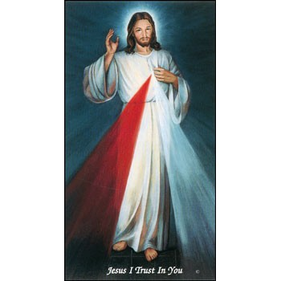

Come and join us every week day for Adoration of the Blessed Sacrament and recitation of The Divine Mercy Chaplet and Rosary at 11:30 a.m. followed by our daily Mass at 12:10 p.m.

Les invitamos todos los días a la adoración del Santísimo a las 11:30 a.m. antes de nuestra misa diaria 12:10 p.m.

Third Annual Christmas Bazaar
November 20, 21 and 22
Attention: There will be a work day on Saturday, October 10 at 10 a.m. in Gillespie Hall! We need your ideas! It will take all of us participating to make our Bazaar a success!!!

Eggrolls by Agnes, order now.
She will only make 20 dozen.
They are $40 per dozen.
Pick up will be Friday, October 16.
Place order and pay at the office.

Order Tamales by Carmen
at $25.00 per dozen.
Order and pay at the office.
Pick up will be
Saturday, Nov 14.

The profit will equally be divided between three Parishes: Walters, Duncan and Marlow for the purpose of the building fund. We need your time, talent and treasure to make this event successful.

Abuse of Minors Response Hotline 405-720-987 or DHS at 1-800-522-3511.
Telefóno Pastoral para Reportar Abuso de Menores 405-720-9878 o el Departamento de Servicios Humanos 1-800-522-3511.

Mark your calendar for Catholic Foundation’s presentation on wills and trusts. This will be held on Monday, October 24 at 7 p.m. at Assumption Catholic Church Gillespie Hall. Come and learn how to take care of those you love.
You can have a Mass said for someone's intentions at their birthday, wedding, baptism, or in memory of your deceased loved ones. Contact he office for days and times that you wish to have the Mass celebrated. What a precious gift!

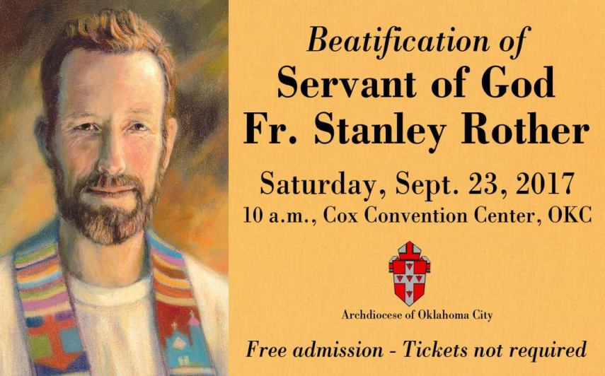
Rother Prayer Service
A prayer service recognizing the 36th anniversary of the martyrdom of The Venerable Servant of God Stanley Rother will be at 6:30 p.m. Friday, July 28 at St. Eugene, 2400 W. Hefner Rd., OKC. Personal reflections shared by Fr. Don Wolf, pastor at St. Eugene and cousin of Fr. Rother.

Website for
Fr. Rother Beatification
For everything you need to know about Father Rother’s beatification, go online to stanleyrother.org. Father Rother’s beatification is Sept. 23 at the Cox Convention Center. No tickets required.

Quo Vadis Days Retreat
A four-day discernment retreat at Our Lady of Guadalupe Catholic Youth Camp is for young men in high school and college who want to learn more about listening to God’s call in their lives, and to help determine if their vocation may be the priesthood. The retreat begins with Sunday Mass with Archbishop Coakley for the retreatants and their families on Sun., July 30, and ends on Wednesday, Aug. 2. Visit qvdays.org/register/archdiocese-oklahoma-city. Complete online registration by July 24. $20 registration fee. Call (405) 721-9351.

Worldwide Marriage Encounter Weekend
September 15-17, 2017
Married Couples: All the busy activities of summer tend to add stress in marriages. Take time for a Marriage Encounter Weekend to relax and fortify your sacrament at the Catholic Pastorial Center on Sep 15-17. Apply by Fri, Aug 18 at http://meoklahoma.org, and receive a 25% off the $100 application fee (promo code: EarlySept). For more info, contact Rick & Bev Feller at (405)323-9119, rbfeller@gmail.com.
Rother Heritage Gallery
adds weekend hours

The Heritage Gallery at the Catholic Pastoral Center, 7501 Northwest Expressway, is presenting “The Shepherd Cannot Run: A retrospective on the life of Father Stanley Rother.” The exhibit is open 9 a.m. - 4 p.m. Monday-Friday, and on the following Saturdays from 9 a.m. to Noon: July 29 and Aug. 19. The exhibit is free. Special tours arranged by calling (405) 721-5651, Ext. 141.

Catholic Women:
Living the Joy of the Gospel
Catholic women are invited to the National Council of Catholic Women 2017 Convention Sept. 7-9 at the Hilton Anatole in Dallas. Celebrate Living the Joy of the Gospel through liturgies, devotions and guest speakers. Contact Becky VanPool, (405) 834-3782 or visit www.nccw.org/2017AnnualConvention.

Saint Patrick Catholic Church
THIRD AND OHIO
POST OFFICE BOX 151
Walters, Oklahoma 73572
********************************
Collections:
Jul 16: Operating $654.00

Immaculate Conception Church
4th & Comanche, Marlow
**********************************
Collections:
July 16: Operating: $439.00
Building: $150.00

DUNCAN COLLECTIONs FOR
July 15-16:
Duncan: $1,454.00
Weekly Electronic Donations: $1,000.00
Second Collection: $208.00
Building Fund: $100.00
St. Vincent de Paul: $55.00
Food Bank: $32.00
Scholarship Fund: $20.00
Ryan: $160.00
Thank you for your generosity!!!

