Fifteenth Sunday in Ordinary Time
July 16, 2017

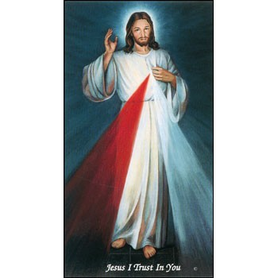

Come and join us every week day for Adoration of the Blessed Sacrament and recitation of The Divine Mercy Chaplet and Rosary at 11:30 a.m. followed by our daily Mass at 12:10 p.m.

Les invitamos todos los días a la adoración del Santísimo a las 11:30 a.m. antes de nuestra misa diaria 12:10 p.m.

Mass Intentions / Peticiones de Misa

Sat | Ju1 15 | 4:00p D | (+) Elizabeth Pickrel
 |  | 6:00p R
Sun | Jul 16 | 8:00a M | For the Parishioners
 |  | 10:00a D | (+) Helen James  by CeCe and Annette
 |  | 12:00p W | (+) Br. Ray
 |  | 2:00p D
Mon | Jul 17 | 12:10p D | (+) Richard Dixon
Tues | Jul 18 | 12:10p D | (+) Don Dowhower
Wed | Jul 19 | 12:10p D | (+) Bill & Jo Ann McCoy
Thur | Jul 20 | 12:10p D | (+) Leon Fitts
Fri | Jul 21 | 12:10p D | (+) Mable & Joe Hanson
Sat | Jul 22 | 4:00p D | For Victoria on her Birthday
 |  | 6:00p R
Sun | Jul 23 | 8:00a M | (+) Joanne Lowe  by Fr. Peter
 |  | 10:00a D
 |  | 12:00p W
 |  | 2:00p D | (+) Esteban Perez  By Maria Jones & Lee Jones
The Parish Feast of the
Assumption of the
Blessed Virgin Mary is Tuesday, August 15, 2017. at 7 p.m.
In Duncan only one Mass.

Beautification of Fr. Stanley Rother

Marlow is taking a bus to the Beatification of Fr. Stanley Rother on Saturday, September 23, 2017. Anyone wanting to ride the bus from Duncan, Walters or Marlow needs to sign up no later than Sunday, July 30, 2017. A Donation for the transportation will be taken on the day of travel. The bus will leave Marlow @ 7:00 a.m. on Saturday, September 23.

To sign up, call Kathi Havron 641-1867, or Bill Havron 512-6867. This is a chance of a lifetime! The bus can hold 56 people, and first come first serve, and no reservations after Sunday, July 30, 2017.

We will have the bus all day, so we can eat afterwards. With this bus there is no hassle with parking.

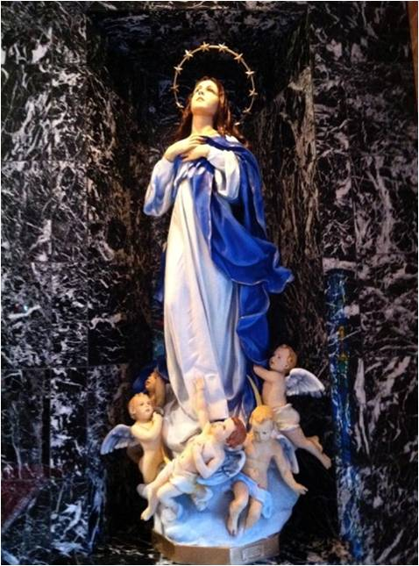

Third Annual Christmas Bazaar
November 20, 21 and 22
Attention: There will be a work day on Saturday, October 10 at 10 a.m. in Gillespie Hall! We need your ideas! It will take all of us participating to make our Bazaar a success!!!

Eggrolls by Agnes, order now.
She will only make 20 dozen.
They are $40 per dozen.
Pick up will be Friday, October 16.
Place order and pay at the office.

Order Tamales by Carmen
at $25.00 per dozen.
Order and pay at the office.
Pick up will be
Saturday, Nov 14.

The profit will equally be divided between three Parishes: Walters, Duncan and Marlow for the purpose of the building fund. We need your time, talent and treasure to make this event successful.

Abuse of Minors Response Hotline 405-720-987 or DHS at 1-800-522-3511.
Telefóno Pastoral para Reportar Abuso de Menores 405-720-9878 o el Departamento de Servicios Humanos 1-800-522-3511.

Mark your calendar for Catholic Foundation’s presentation on wills and trusts. This will be held on Monday, October 24 at 7 p.m. at Assumption Catholic Church Gillespie Hall. Come and learn how to take care of those you love.
You can have a Mass said for someone's intentions at their birthday, wedding, baptism, or in memory of your deceased loved ones. Contact he office for days and times that you wish to have the Mass celebrated. What a precious gift!

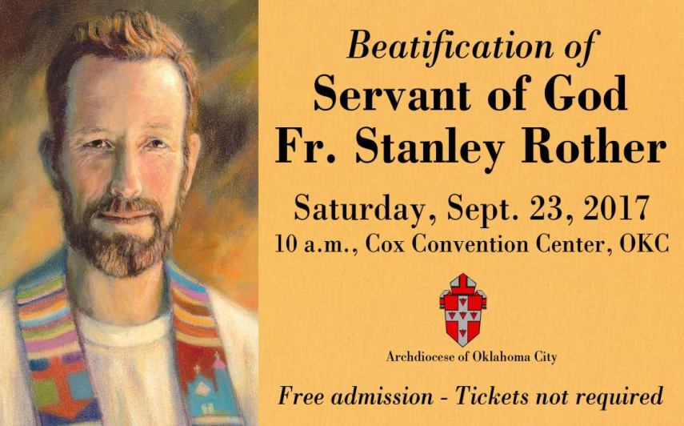
Catholic Women:
Living the Joy of the Gospel
Catholic women are invited to the National Council of Catholic Women 2017 Convention Sept. 7 – 9 at the Hilton Anatole in Dallas. Celebrate Living the Joy of the Gospel through liturgies, devotions and guest speakers. Contact Becky VanPool, (405) 834-3782 or visit https://www.nccw.org/2017AnnualConvention.

Website for
Fr. Rother Beatification
For everything you need to know about Father Rother’s beatification, go online to stanleyrother.org. Father Rother’s beatification is Sept. 23 at the Cox Convention Center. No tickets required.

Relationship Communication Workshop
Considering different perceptions and discovering solutions increases the likelihood of building stronger relationships and reducing conflicts. During the workshop, participants will explore the origins of communication, recognize the value of improving skills, and discern the nature of conflict in various settings. The workshop is 9 a.m. – 3 p.m. Sat., July 29, at the Catholic Pastoral Center, 7501 Northwest Expressway. Lunch provided. Michelle Morris, an instructor for the U.S. Air Force and a college professor, will facilitate. Call the Office of Family Life, (405) 721-8944. Space is limited.

Immaculate Conception Church
4th & Comanche, Marlow
**********************************
Collections:
July 9: Operating: $459.00
Building: $650.00

DUNCAN COLLECTIONs FOR
July 8-9:
Duncan: $1,673.03
Weekly Electronic Donations: $1,000.00
Second Collection: $230.67
Food Bank: $13.00
Thank you for your generosity!!!

Saint Patrick Catholic Church
THIRD AND OHIO
POST OFFICE BOX 151
Walters, Oklahoma 73572
********************************
Collections:
Jul 2: Operating $344.00, Building: $350.00
Jul 9: Operating $525.00, Building: $20.00

Quo Vadis Days Retreat
A four-day discernment retreat at Our Lady of Guadalupe Catholic Youth Camp is for young men in high school and college who want to learn more about listening to God’s call in their lives, and to help determine if their vocation may be the priesthood. The retreat begins with Sunday Mass with Archbishop Coakley for the retreatants and their families on Sun., July 30, and ends on Wednesday, Aug. 2. Visit qvdays.org/register/archdiocese-oklahoma-city. Complete online registration by July 24. $20 registration fee. Call (405) 721-9351.

Archbishop’s Dinner 2017
Archbishop Coakley and the board of directors of the Catholic Foundation of Oklahoma invite you to attend the 2017 Archbishop’s Dinner at 7 p.m. Aug. 8 at the Oklahoma City Golf and Country Club, 7000 N.W. Grand Blvd. in Nichols Hills. Individual tickets $250. Proceeds benefit the Saint John Vianney Fund, a permanent endowment supporting seminarian education for the Archdiocese of Oklahoma City. Call (405) 721-4115, cfookc.org/dinner.

Fr. Rother Documentary Trailer
The official trailers for the Fr. Rother documentary in English and Spanish can be found at stanleyrother.org.

Rother Heritage Gallery
adds weekend hours

The Heritage Gallery at the Catholic Pastoral Center, 7501 Northwest Expressway, is presenting “The Shepherd Cannot Run: A retrospective on the life of Father Stanley Rother.” The exhibit is open 9 a.m. - 4 p.m. Monday-Friday, and on the following Saturdays from 9 a.m. to Noon: July 29 and Aug. 19. The exhibit is free. Special tours arranged by calling (405) 721-5651, Ext. 141.

