Thirteenth Sunday in Ordinary Time
July 2, 2017

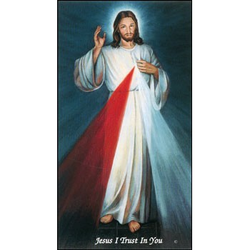

The office will be closed on
Monday-Tuesday,
July 3-4
in observance of
Independence Day;
however, we will celebrate
12:10 p.m. Daily Mass.
Adoration of the Blessed Sacrament at 11:30 a.m. with the
Chaplet of Divine Mercy
and Rosary.

Mass Intentions / Peticiones de Misa

Sat | Ju1 1 | 4:00p D | (+) Jack Geurkink, Gregorian Mass
 |  | 6:00p R
Sun | Jul 2 | 8:00a M
 |  | 10:00a D | (+) Jack Geurkink,  Gregorian Mass
 |  | 12:00p W | (+) Dorothy Hennessee  by Doris Renschen
 |  | 2:00p D | (+) Br. Ray
Mon | Jul 3 | 12:10p D | (+) Jack Geurkink,  Gregorian Mass
Tues | Jul 4 | 12:10p D | (+) Jack Geurkink,  Gregorian Mass
Wed | Jul 5 | 12:10p D | (+) Jack Geurkink,  Gregorian Mass
Thur | Jul 6 | 12:10p D | (+) Jack Geurkink,  Gregorian Mass
Fri | Jul 7 | 12:10p D | (+) Jack Geurkink,  Gregorian Mass
Sat | Jul 8 | 4:00p D | (+) Jack Geurkink,  Gregorian Mass
 |  | 6:00p D
Sun | Jul 9 | 8:00a M
 |  | 10:00a D | (+) Jack Geurkink,  Gregorian Mass
 |  | 12:00p W
 |  | 2:00p D

The Knights of Columbus ‘Garage Sale’. Friday (7am-6 pm)-Saturday (7 am-2 pm), July 14-15 at Immaculate Conception Church in Marlow. Proceeds from the sale will benefit Assumption’s Food Bank and other Knights of Columbus charitable activities. Contact Mike Radtke 606-0283 if you need items picked up or leave at Duncan or Marlow’s Church before Friday, July 7, 2017.

The Parish Feast of the
Assumption of the Blessed Virgin Mary is Tuesday, August 15, 2017. at 7 p.m.
In Duncan only one Mass.

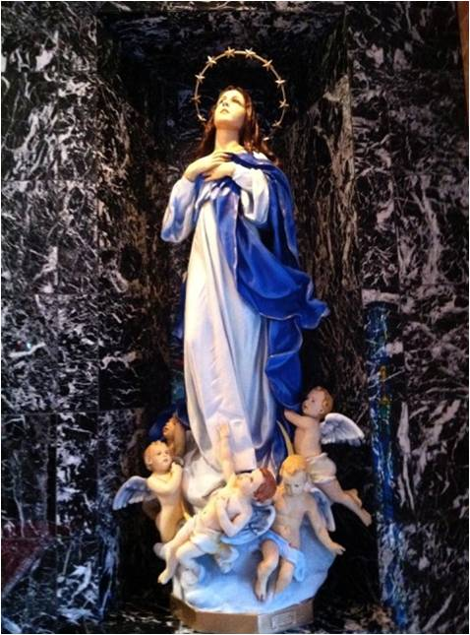

Third Annual Christmas Bazaar
November 20, 21 and 22
Attention: There will be a work day on Saturday, October 10 at 10 a.m. in Gillespie Hall! We need your ideas! It will take all of us participating to make our Bazaar a success!!!

Eggrolls by Agnes, order now.
She will only make 20 dozen.
They are $40 per dozen.
Pick up will be Friday, October 16.
Place order and pay at the office.

Order Tamales by Carmen
at $25.00 per dozen.
Order and pay at the office.
Pick up will be
Saturday, Nov 14.

The profit will equally be divided between three Parishes: Walters, Duncan and Marlow for the purpose of the building fund. We need your time, talent and treasure to make this event successful.

Abuse of Minors Response Hotline 405-720-987 or DHS at 1-800-522-3511.
Telefóno Pastoral para Reportar Abuso de Menores 405-720-9878 o el Departamento de Servicios Humanos 1-800-522-3511.

Mark your calendar for Catholic Foundation’s presentation on wills and trusts. This will be held on Monday, October 24 at 7 p.m. at Assumption Catholic Church Gillespie Hall. Come and learn how to take care of those you love.
You can have a Mass said for someone's intentions at their birthday, wedding, baptism, or in memory of your deceased loved ones. Contact he office for days and times that you wish to have the Mass celebrated. What a precious gift!

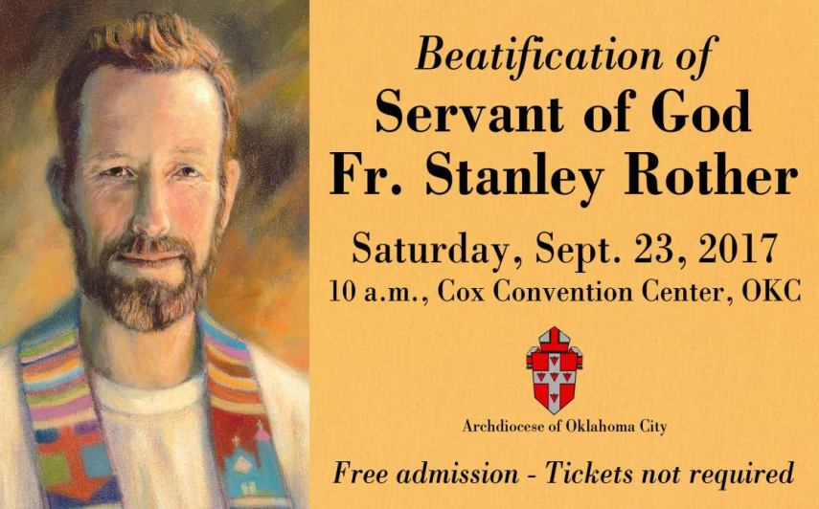
Catholic Women:
Living the Joy of the Gospel
Catholic women are invited to the National Council of Catholic Women 2017 Convention Sept. 7 – 9 at the Hilton Anatole in Dallas. Celebrate Living the Joy of the Gospel through liturgies, devotions and guest speakers. Contact Becky VanPool, (405) 834-3782 or visit https://www.nccw.org/2017AnnualConvention.

Website for
Fr. Rother Beatification
For everything you need to know about Father Rother’s beatification, go online to stanleyrother.org. Father Rother’s beatification is Sept. 23 at the Cox Convention Center. No tickets required.

Fr. Rother Documentary Trailer
The official trailers for the Fr. Rother documentary in English and Spanish can be found at stanleyrother.org.

DUNCAN COLLECTIONs FOR
June 24-25:
Duncan: $1,506.80
Weekly Electronic Donations: $1,000.00
Second Collection: $249.00
Food Bank: $34.00
St. Vincent de Paul: $5.00
Ryan: $158.00
Thank you for your generosity!!!

Immaculate Conception Collection
4th & Comanche, Marlow
*************************************
Collections:
June 25: Operating: $416.00
Building: $100.00

Pastoral Ministry Program
The fall 2017 schedule begins in August and includes “Theology and Methods of Ministry,” “Theology of Church” and “The Prophets.” Cost is $200 plus textbooks; personal enrichment/audit: $100 plus textbooks; and graduates of the program-continuing education (no credit given): $80 plus textbooks. Classes held at the Catholic Pastoral Center and video conferencing sites. To register, contact the Pastoral Ministry Office, (405) 721-4208, (800) 721-5651, Ext. 131, cgrimes@archokc.org or dkoorie@archokc.org. Visit www.archokc.org/office-of-pastoral-ministry/home.

Saint Patrick Catholic Church
THIRD AND OHIO
POST OFFICE BOX 151
Walters, Oklahoma 73572
********************************
Collections:
June 18: Operating $420.00
Building: $145.00

Archbishop’s Dinner 2017
Archbishop Coakley and the board of directors of the Catholic Foundation of Oklahoma invite you to attend the 2017 Archbishop’s Dinner at 7 p.m. Aug. 8 at the Oklahoma City Golf and Country Club, 7000 N.W. Grand Blvd. in Nichols Hills. Individual tickets $250. Proceeds benefit the Saint John Vianney Fund, a permanent endowment supporting seminarian education for the Archdiocese of Oklahoma City. Call (405) 721-4115, cfookc.org/dinner.

Rother Heritage Gallery
adds weekend hours

The Heritage Gallery at the Catholic Pastoral Center, 7501 Northwest Expressway, is presenting “The Shepherd Cannot Run: A retrospective on the life of Father Stanley Rother.” The exhibit is open 9 a.m. - 4 p.m. Monday-Friday, and on the following Saturdays from 9 a.m. to Noon: July 29 and Aug. 19. The exhibit is free. Special tours arranged by calling (405) 721-5651, Ext. 141.

