The Most Holy Body and Blood of Jesus Christ
June 18, 2017

Rother Heritage Gallery
adds weekend hours

The Heritage Gallery at the Catholic Pastoral Center, 7501 Northwest Expressway, is presenting “The Shepherd Cannot Run: A retrospective on the life of Father Stanley Rother.” The exhibit is open 9 a.m. - 4 p.m. Monday-Friday, and on the following Saturdays from 9 a.m. to Noon: July 29 and Aug. 19. The exhibit is free. Special tours arranged by calling (405) 721-5651, Ext. 141.

Mass Intentions / Peticiones de Misa

Sat | Jun 17 | 4:00p D | (+) Jack Geurkink, Gregorian Mass
 |  | 6:00p R | For the Parishioners
Sun | Jun 18 | 8:00a M | (+) Joann Lowe  by Phil & Louise
 |  | 10:00a D | (+) Jack Geurkink,  Gregorian Mass
 |  | 12:00p W | (+) Dorothy Hennessee  by Doris Renschen
 |  | 2:00p D | NO MASS
Mon | Jun 19 | 12:10p D | (+) Jack Geurkink,  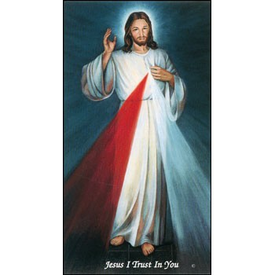  Gregorian Mass  Come and join us every week day for Adoration of the Blessed Sacrament and recitation of The Divine Mercy Chaplet and Rosary at 11:30 a.m. followed by our daily Mass at 12:10 p.m.  Les invitamos todos los días a la adoración del Santísimo a las 11:30 a.m. antes de nuestra misa diaria 12:10 p.m.
Tues | Jun 20 | 4:00p D | (+) Jack Geurkink,  Gregorian Mass
Wed | Jun 21 | 12:10p D | (+) Jack Geurkink,  Gregorian Mass
Thur | Jun 22 | 12:10p D | (+) Jack Geurkink,  Gregorian Mass
Fri | Jun 23 | 12:10p D | (+) Jack Geurkink,  Gregorian Mass
Sat | Jun 24 | 4:00p D | (+) Jack Geurkink,  Gregorian Mass
 |  | 6:00p D
Sun | Jun 25 | 8:00a M
 |  | 10:00a D | (+) Jack Geurkink,  Gregorian Mass
 |  | 12:00p W | (+) Dorothy Hennessee  by Doris Renschen
 |  | 2:00p D | For the Parishioners
The Parish Feast of the
Assumption of the Blessed Virgin Mary is Tuesday, August 15, 2016. at 7 p.m.
In Duncan only one Mass.

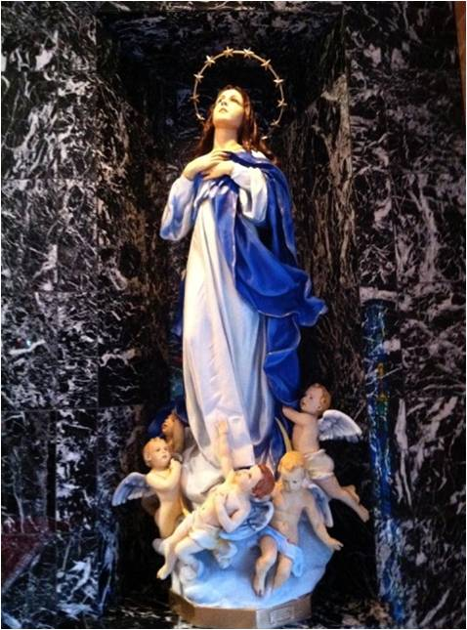

ATTENTION:
The Daily Mass on
Tuesday, June 20
will be celebrated at 4 p.m.!!!
Third Annual Christmas Bazaar
November 20, 21 and 22
Attention: There will be a work day on Saturday, October 10 at 10 a.m. in Gillespie Hall! We need your ideas! It will take all of us participating to make our Bazaar a success!!!

Eggrolls by Agnes, order now.
She will only make 20 dozen.
They are $40 per dozen.
Pick up will be Friday, October 16.
Place order and pay at the office.

Order Tamales by Carmen
at $25.00 per dozen.
Order and pay at the office.
Pick up will be
Saturday, Nov 14.

The profit will equally be divided between three Parishes: Walters, Duncan and Marlow for the purpose of the building fund. We need your time, talent and treasure to make this event successful.

Thank you to the Knights of Columbus for their generous sponsorship of our Vacation Bible School. We also wish to thank all the volunteers who made this event possible and enjoyable.

Abuse of Minors Response Hotline 405-720-987 or DHS at 1-800-522-3511.
Telefóno Pastoral para Reportar Abuso de Menores 405-720-9878 o el Departamento de Servicios Humanos 1-800-522-3511.

Mark your calendar for Catholic Foundation’s presentation on wills and trusts. This will be held on Monday, October 24 at 7 p.m. at Assumption Catholic Church Gillespie Hall. Come and learn how to take care of those you love.
You can have a Mass said for someone's intentions at their birthday, wedding, baptism, or in memory of your deceased loved ones. Contact he office for days and times that you wish to have the Mass celebrated. What a precious gift!

Certification in Catechetics
Summer Program
St. Gregory’s University is enrolling for the Certificate in Catechetics summer program June 23-24. Students can attend three weekend courses, or sequentially over a three-year period. Cost is $50 per weekend or $150 for all three weekends. Tuition includes registration, a wine and cheese social, and continental breakfast and lunch on Saturday. Campus housing available for fee. Course credits transferable to degree programming. Register at www.stgregorys.edu/catechetics or call (405) 878-5100.

South Region ACCW Meeting
Tuesday, June 27, 2017 –
9 a.m. to 11 a.m.
(we will go out for lunch)
Blessed Sacrament Parish Hall –
Lawton
Rosary at 9:15 a.m.
Business meeting - plan for NCCW
National Convention in Dallas
& our South Region plans for the fall
RSVP - Sharon Stephen, President
at 580 585 7119

Congratulations to our
Jesse Wayne Moore
Scholarship Recipients:

Chase Minden
Brooklyn Minden
Christian York
Gilberto Diaz
Alexandra Cassidy

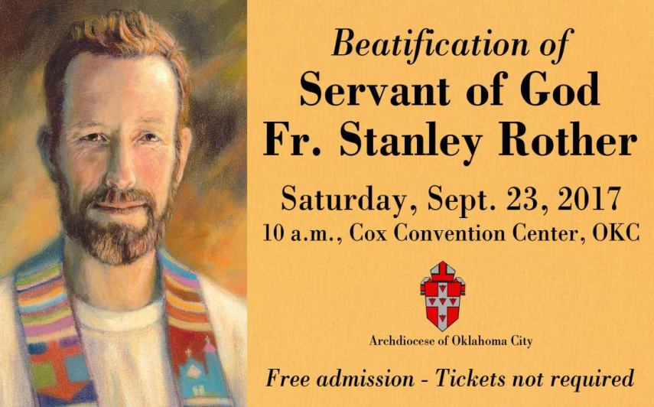
Website for
Fr. Rother Beatification
For everything you need to know about Father Rother’s beatification, go online to stanleyrother.org. Father Rother’s beatification is Sept. 23 at the Cox Convention Center. No tickets required.

Fr. Rother Documentary Trailer
The official trailers for the Fr. Rother documentary in English and Spanish can be found at stanleyrother.org.

Our Lady of Fatima centennial tour
The International Pilgrim Virgin Statue will be in Oklahoma as part of the world Apostolate of Fatima U.S. Tour for Peace. The historic tour marks the 100th anniversary of the apparition of Our Lady of Fatima, Portugal. The tour will be at the Shrine of Our Lady of Fatima/St. Joseph, Bison, Oct. 13; St. Mary, Guthrie, Oct. 14; St. Monica, Edmond, Oct. 15; St. Damien, Edmond, Oct. 16; St. Paul the Apostle, Del City, Oct. 17; and Prince of Peace, Altus, Oct. 18.

Saint Patrick Catholic Church
THIRD AND OHIO
POST OFFICE BOX 151
Walters, Oklahoma 73572
********************************
Collections:
June 11: Operating $650.22
Building: $125.00

DUNCAN COLLECTIONs FOR
June 10-11:
Duncan: $1,739.00
Weekly Electronic Donations: $1,000.00
Building Fund: $150.00
Food Bank: $26.00
Scholarship: $20.00
Second Collection: $23
Ryan: $166.00
Thank you for your generosity!!!

