Fifth Sunday of Easter
May 14, 2017

Happy Mothers Day.
May God Bless you!
Mass Intentions / Peticiones de Misa

Sat | May 13 | 4:00p D | For the Parishioners
 |  | 6:00p R | (+) John Charles Matousek
Sun | May 14 | 8:00a M | 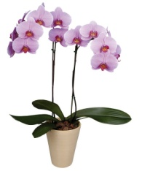      (+) Joe Lockvich by Cheryl  The Easter flowers will be for sale after all Masses this weekend! The orchids and ferns are $15.00 each. Please talk to the Altar Society ladies after Mass to make your purchase. The water feature is also for sale. The cost is $1,600 installed!
 |  | 10:00a D | Int. of Howard Doerr by The  Wolfgang-Deeg Family
 |  | 12:00p W | (+) John Charles Matousek
 |  | 2:00p R | (+) Don Trostle
Mon | May 15 | 12:10p D | (+) John Charles Matousek
Tues | May 16 | 7:00 am | (+) John Charles Matousek
Wed | May 17 | 12:10p D | NO MASS
Thur | May 18 | 12:10p D | NO MASS
Fri | May 19 | 12:10p D | NO MASS
Sat | May 20 | 4:00p D | (+) George E. Coughlin
 |  | 6:00p R | (+) John Charles Matousek
Sun | May 21 | 8:00 a M | (+) Joe & Ada Duesman | Come and join us every week day for Adoration of the Blessed Sacrament and recitation of The Divine Mercy Chaplet and Rosary at 11:30 a.m. followed by our daily Mass at 12:10 p.m.  Les invitamos todos los días a la adoración del Santísimo a las 11:30 a.m. antes de nuestra misa diaria 12:10 p.m.
 |  | 10:00a D | Pat Neal Blessing | 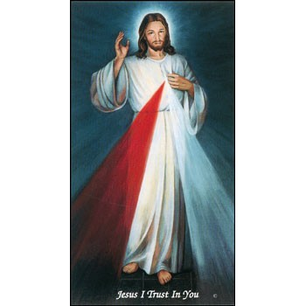
 |  | 12:00p W | (+) John Charles Matousek | Our Second Collection will be for the Food Bank and Christmas Decorations. There are envelopes in the pews. Thank you for your generosity!
 |  | 2:00p D | For all Mothers
ATTENTION: The Daily Mass on Tuesday, will be at 7 a.m.!
THERE WILL BE NO 12:10 pm
DAILY MASSES Wednesday,
Thursday or Friday, May 17-18-19.

Attention all Lectors from Duncan, Marlow, Ryan and Walters: There will be a mandatory meeting/training for all Lectors and those who wish to become Lectors on Tuesday, May 23 at 7 p.m. at Assumption Church.

Archdiocesan Campaign
Planning Study e-survey
This is an exciting time in the Archdiocese of Oklahoma City. After a great deal of prayer and consultation, Archbishop Coakley has begun planning for the first major fundraising campaign in the history of the Archdiocese. As part of the planning process, a campaign planning study is underway and we want your input and opinions. Please take a few minutes to go online and complete a 5-minute e-Survey giving your feedback on plans for the future. The survey can be found at www.archokc.org/survey. Thank you!

Atención a todos los Lectores de Duncan, Marlow, Ryan y Walters; El miércoles, 24 de mayo a las 7pm, tendremos una junta/entrenamiento mandatorio en la iglesia de Asunción en Duncan. Gracias
Third Annual Christmas Bazaar
November 20, 21 and 22
Attention: There will be a work day on Saturday, October 10 at 10 a.m. in Gillespie Hall! We need your ideas! It will take all of us participating to make our Bazaar a success!!!

Eggrolls by Agnes, order now.
She will only make 20 dozen.
They are $40 per dozen.
Pick up will be Friday, October 16.
Place order and pay at the office.

Order Tamales by Carmen
at $25.00 per dozen.
Order and pay at the office.
Pick up will be
Saturday, Nov 14.

The profit will equally be divided between three Parishes: Walters, Duncan and Marlow for the purpose of the building fund. We need your time, talent and treasure to make this event successful.

Abuse of Minors Response Hotline 405-720-987 or DHS at 1-800-522-3511.
Telefóno Pastoral para Reportar Abuso de Menores 405-720-9878 o el Departamento de Servicios Humanos 1-800-522-3511.

Mark your calendar for Catholic Foundation’s presentation on wills and trusts. This will be held on Monday, October 24 at 7 p.m. at Assumption Catholic Church Gillespie Hall. Come and learn how to take care of those you love.
You can have a Mass said for someone's intentions at their birthday, wedding, baptism, or in memory of your deceased loved ones. Contact he office for days and times that you wish to have the Mass celebrated. What a precious gift!

We are exploring the possibility of constructing a permanent columbarium for the ashes of our loved ones. This columbarium will be located in our church at the main entrance. Therefore, we are asking those who are interested in this project to take a five question survey at the following link: https://www.surveymonkey.com/r/F2W9VDW
You can also go to our web page and follow the link!
Thank you for your input. Fr. Peter

We are taking orders for home-made burritos.

Bean and cheese, Fajita Chicken, Beef and potato

The burritos are $25.00 per dozen and can be preordered and prepaid by
Monday, May 15, for pick up on Saturday, May 20.

Stop by the office and order your burritos today!

Burritos will be for sale after weekend Masses
Saturday-Sunday, May 20-21 for $2.50 each!

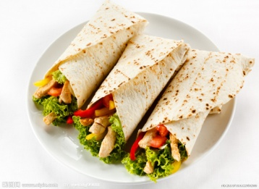

DUNCAN COLLECTIONs FOR
May 6-7:
Duncan: $3,967.00
Weekly Electronic Donations: $1,000.00
Second Collection: $257.00
Food Bank: $60.00
St. Vincent de Paul: $157.00
Ryan: $182.00
Thank you for your generosity!!!

