Fourth Sunday of Easter
May 7, 2017

Mass Intentions / Peticiones de Misa

Sat | May 6 | 4:00p D |       (+) John Charles Matousek  The Easter flowers will be for sale after all Masses this weekend! The orchids and ferns are $15.00 each. Please talk to the Altar Society ladies after Mass to make your purchase. The water feature is also for sale. The cost is $1,600 installed!
 |  | 6:00p R | For the Parishioners
Sun | May 7 | 8:00a M | (+) Ronney Koch
 |  | 10:00a D | (+) Molly Bernal By Suzanne
 |  | 12:00p W | (+) John Charles Matousek
 |  | 2:00p R
Mon | May 8 | 12:10p D | (+) John Charles Matousek
Tues | May 9 | 12:10p D | (+) John Charles Matousek
Wed | May 10 | 12:10p D | (+) John Charles Matousek
Thur | May 11 | 12:10p D | (+) John Charles Matousek
Fri | May 12 | 12:10p D | (+) John Charles Matousek
Sat | May 13 | 4:00p D | For the Parishioners
 |  | 6:00p R | (+) John Charles Matousek
Sun | May 14 | 8:00 a M
 |  | 10:00a D | Intentions of Howard Doerr by the Wolfgang-Deeg Family
 |  | 12:00p W | (+) John Charles Matousek | Our Second Collection will be for the Food Bank and Christmas Decorations. There are envelopes in the pews. Thank you for your generosity!
 |  | 2:00p D
Attention all Lectors from Duncan, Marlow, Ryan and Walters: There will be a mandatory meeting/training for all Lectors and those who wish to become Lectors on Tuesday, May 23 at 7 p.m. at Assumption Church.
Duncan Altar Society Meeting on Wednesday, May 10
after the 12:10 pm Mass.
We will have a pot luck lunch.
So bring a dish to share!

DID YOU KNOW:
A Gregorian Mass is for the
faithfully departed.
The Holy Mass is celebrated daily
for thirty days.
Call the office for more information.

Atención a todos los Lectores de Duncan, Marlow, Ryan y Walters; El miércoles, 24 de mayo a las 7pm, tendremos una junta/entrenamiento mandatorio en la iglesia de Asunción en Duncan. Gracias
Archdiocesan Campaign Planning Study e-survey
This is an exciting time in the Archdiocese of Oklahoma City. After a great deal of prayer and consultation, Archbishop Coakley has begun planning for the first major fundraising campaign in the history of the Archdiocese. As part of the planning process, a campaign planning study is underway and we want your input and opinions. Please take a few minutes to go online and complete a 5-minute e-Survey giving your feedback on plans for the future. The survey can be found at www.archokc.org/survey. Thank you!

Third Annual Christmas Bazaar
November 20, 21 and 22
Attention: There will be a work day on Saturday, October 10 at 10 a.m. in Gillespie Hall! We need your ideas! It will take all of us participating to make our Bazaar a success!!!

Eggrolls by Agnes, order now.
She will only make 20 dozen.
They are $40 per dozen.
Pick up will be Friday, October 16.
Place order and pay at the office.

Order Tamales by Carmen
at $25.00 per dozen.
Order and pay at the office.
Pick up will be
Saturday, Nov 14.

The profit will equally be divided between three Parishes: Walters, Duncan and Marlow for the purpose of the building fund. We need your time, talent and treasure to make this event successful.

Abuse of Minors Response Hotline 405-720-987 or DHS at 1-800-522-3511.
Telefóno Pastoral para Reportar Abuso de Menores 405-720-9878 o el Departamento de Servicios Humanos 1-800-522-3511.

Mark your calendar for Catholic Foundation’s presentation on wills and trusts. This will be held on Monday, October 24 at 7 p.m. at Assumption Catholic Church Gillespie Hall. Come and learn how to take care of those you love.
You can have a Mass said for someone's intentions at their birthday, wedding, baptism, or in memory of your deceased loved ones. Contact he office for days and times that you wish to have the Mass celebrated. What a precious gift!

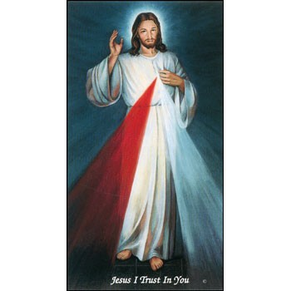
We are taking orders for
home-made burritos.

Bean and cheese
Fajita Chicken
Beef and potato

The burritos are $25.00 per dozen and can be preordered and prepaid by
Monday, May 15
for pick up on
Saturday, May 20.

Stop by the office and
order your burritos today!

Burritos will be for sale after weekend Masses Saturday-Sunday, May 20-21
for $2.50 each!

Come and join us every week day for Adoration of the Blessed Sacrament and recitation of The Divine Mercy Chaplet and Rosary at 11:30 a.m. followed by our daily Mass at 12:10 p.m.

Les invitamos todos los días a la adoración del Santísimo a las 11:30 a.m. antes de nuestra misa diaria 12:10 p.m.

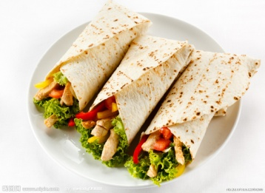

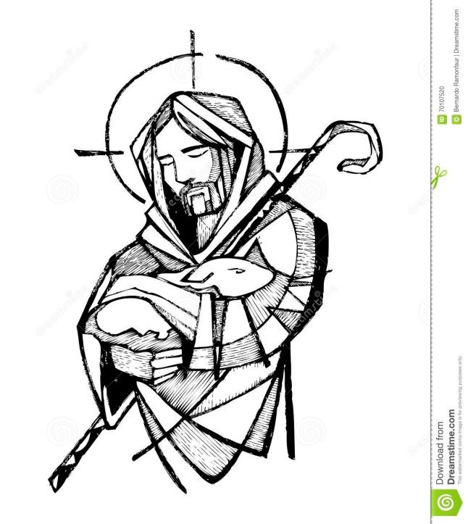
God our Father, we thank you for calling
Men and women to serve in your Son’s
Kingdom as priests, deacons, religious, and
consecrated persons.

Send your Holy Spirit to
help us respond generously and courageously to your call.
May our community of faith
support vocations of
sacrificial love in our youth.

We ask this through our Lord Jesus
Christ, who lives and reigns with you and
the Holy Spirit, one God, forever and ever.
Amen.

World Day of Prayer for Vocations
World Day of Prayer for Vocations will be observed on Sunday, May 7, also known as "Good Shepherd Sunday." The purpose of this day is to publicly fulfill the Lord's instruction to, "Pray the Lord of the harvest to send laborers into his harvest" (Mt 9:38; Lk 10:2). Please pray that young men and women hear and respond generously to the Lord's call to the priesthood, diaconate, religious life, and societies of apostolic life or secular institutes. Find resources at www.usccb.org/vocations or www.archokc.org/vocations/home.

DUNCAN COLLECTIONs FOR
April 29-30:
Duncan: $2,051.00
Weekly Electronic Donations: $1,000.00
Second Collection: $226.81
Food Bank: $15.00
St. Vincent de Paul: $15.00
Ryan: $170.00
Thank you for your generosity!!!

