Palm Sunday of the Passion of the Lord
April 9, 2017

Mass Intentions / Peticiones de Misa

ATTENTION: Help decorate our Parish for Easter. We will begin decorating after the Good Friday Service. Please come and make our church beautiful!

Sat | Apr 8 | 4:00p D | (+) Kaleb Eiser by  Shannon & Bennie Wilson
 |  | 6:00p R | For the Parishioners
Sun | Apr 9 | 8:00a M
 |  | 10:00a D | 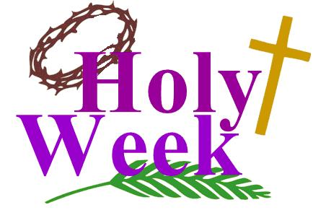  Good Health for Jeremy Couvillion by Couvillon Family  Assumption Parish  Holy Thursday, April 13, 7 p.m.  Good Friday, April 14, 7 p.m.  Holy Saturday, April 15, 7 p.m.
 |  | 12:00p W | (+) Dorothy Hennessee by Doris Renschen
 |  | 2:00p D
Mon | Apr 10 | 12:10p D | Intentions of Howard Doerr  By The Wolfgang-Deeg Family
Tues | Apr 11 | 12:10p D | NO MASS
Wed | Apr 12 | 12:10p D | Good Health for Frances Allen  By The Couvillion Family
Thur | Apr 13 | 7:00p D | HOLY THURSDAY
Fri | Apr 14 | 7:00p D | GOOD FRIDAY
Sat | Apr 15 | 7:00p D | HOLY SATURDAY
Sun | Apr 16 | 8:00 a M | For the Parishioners | Our Easter  Sunday Schedule  Marlow 8 a.m.  Duncan 10 a.m.  Walters 10 a.m.  No tenemos la misa en español a las 2 p.m.
 |  | 10:00a D | (+) Paul
 |  | 12:00p W | (+) Dorothy Hennessee by Doris Renschen | Our Second Collection will be for the Food Bank and Christmas Decorations. There are envelopes in the pews. Thank you for your generosity!
 |  | 2:00p D | NO MASS
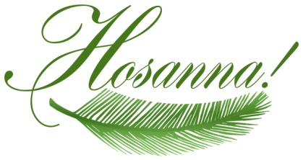

DUNCAN ALTAR SOCIETY NEWS

There is an Easter Bake Sale this weekend after all Masses.

Attention all Ladies:
Please make items to sell for the bake sale.

Attention all Parishioners: Please make your purchase of home-made goodies for Easter to support our Altar Society.


ATTENTION CHILDREN:
On Easter Sunday, April 16 after Assumption’s 10 a.m. Mass there will be an EASTER EGG HUNT sponsored by the
Knights of Columbus.

Third Annual Christmas Bazaar
November 20, 21 and 22
Attention: There will be a work day on Saturday, October 10 at 10 a.m. in Gillespie Hall! We need your ideas! It will take all of us participating to make our Bazaar a success!!!

Eggrolls by Agnes, order now.
She will only make 20 dozen.
They are $40 per dozen.
Pick up will be Friday, October 16.
Place order and pay at the office.

Order Tamales by Carmen
at $25.00 per dozen.
Order and pay at the office.
Pick up will be
Saturday, Nov 14.

The profit will equally be divided between three Parishes: Walters, Duncan and Marlow for the purpose of the building fund. We need your time, talent and treasure to make this event successful.

Abuse of Minors Response Hotline 405-720-987 or DHS at 1-800-522-3511.
Telefóno Pastoral para Reportar Abuso de Menores 405-720-9878 o el Departamento de Servicios Humanos 1-800-522-3511.

Mark your calendar for Catholic Foundation’s presentation on wills and trusts. This will be held on Monday, October 24 at 7 p.m. at Assumption Catholic Church Gillespie Hall. Come and learn how to take care of those you love.
You can have a Mass said for someone's intentions at their birthday, wedding, baptism, or in memory of your deceased loved ones. Contact he office for days and times that you wish to have the Mass celebrated. What a precious gift!

SCHOLARSHIPS!!! - IT IS THAT TIME AGAIN
ASSUMPTION CATHOLIC CHURCH and the Knights of Columbus Council No. 5168 are again accepting applications for the Jesse Wayne Moore Scholarships for the graduating seniors wishing to further their education this year. A few scholarships, from $300 to $1,500 are available. You may obtain application forms from Jim Surjaatmadja or the Assumption Church Office and submit the applications and the necessary documents ON or BEORE Monday, April 19, 2017 to the Church's office or myself. All applications will be judged on Parish activities, community activities and scholastic achievements. A note to all Parish Members: On behalf of the Knights and the graduating Seniors, we would like to thank everyone for the generous contributions that help make the Scholarship Program continue throughout the years. But, we will need your support again for the years to come. For this, again we will ask your continued generous monthly contributions. Please write your checks to Assumption Church Scholarship Fund. Thank you again for your continuing support! Jim Surjaatmadja, Scholarship Chairman, Knights of Columbus 5168.

Religious Education News!
Grades 7-12/Confirmation:
Sundays from 11-12:30

NO CLASSES: April 9, Palm Sunday
April 16, Easter Sunday
April 23, Confirmation

Last Classes:
Sunday, April 30
Wednesday, May 3

Grades 1-6:
Wednesdays from 6:00-7:00 p.m.
NO CLASS: April 12, Holy Week

Save the Dates: 10 a.m. Mass
Confirmation Sunday, April 23
First Communion, Sunday, May 7

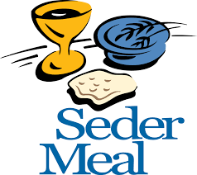
Seder Meal
Immaculate Conception
Wednesday, April 12 at 6 p.m.
Please sign up prior to
Sunday, April 9 or call
Bill Havron at 580-512-6867.
There is a list of items to bring contact
Bette Cooper at 580-641-1350.

Marriage Encounter Weekend
The next Worldwide Marriage Encounter weekend is April 28-30 at the Catholic Pastoral Center. The weekend is to renew and nourish good marriages, giving couples new ways to make their sacrament more fulfilling and stronger. Apply at www.meoklahoma.org or call Rick and Bev Feller, (405) 323-9119 or Bryan and Karen Berland, (405) 850-4274.

Catholic Family Festival
The Archdiocese presents “Discovering God Together: Catholic Family Festival,” 9 a.m. - 5 p.m., April 22, at St. Gregory’s University. Sessions for adults, youth and children. Free child care provided for ages 1-5. Special guests Greg and Lisa Popcak of More2Life Radio and speaker/musician Cooper Ray. Registration forms available in the parish office or at www.archokc.org/new-evangelization/up-coming-events.

Catholic Day with the OKC Dodgers
“Catholic Day with the Oklahoma City Dodgers” will be at 2:05 p.m. Sunday, April 23, at the Chickasaw Bricktown Ballpark, 2 S. Mickey Mantle Dr. Tickets $13 and include field seats with Catholic families, limited edition OKC Dodgers baseball hat, PlayBall! game program, inflatables, face painting and balloon animals.
Go online to: onlinehttps://oss.ticketmaster.com/aps/okcdodgers/EN/promotion/home and use the promotional code CD2017. Deadline April 7.

DUNCAN COLLECTIONs FOR
April 1-2:
Duncan: $1,789.56
Weekly Electronic Donations: $1,000.00
Second Collection: $425.21
Food Bank: $109.00
St. Vincent de Paul: $37.00

Ryan: $111.00
Thank you for your generosity!!!

Saint Patrick Catholic Church
THIRD AND OHIO POST OFFICE BOX 151
Walters, Oklahoma 73572
********************************
Collections:
April 2: Operating: $702.00
Building: $350.00

