Fourth Sunday of Lent
March 26, 2017

Our Easter
Sunday Schedule

Marlow 8 a.m.
Duncan 10 a.m.
Walters 10 a.m.

No tenemos la misa en español
a las 2 p.m.

Mass Intentions / Peticiones de Misa

Sat | Mar 25 | 4:00p D | (+) Paul
 |  | 6:00p R | (+) Jo Ann Hebert
Sun | Mar 26 | 8:00a M
 |  | 10:00a D | (+) Jo Ann Hebert
 |  | 12:00p W | For the Parishioners
 |  | 2:00p D
Mon | Mar 27 | 12:10p D | (+)Jo Ann Hebert
Tues | Mar 28 | 12:10p D | (+) Jo Ann Hebert
Wed | Mar 29 | 12:10p D | (+) Jo Ann Hebert  (+) Jack Geurkink
Thur | Mar 30 | 12:10p D | (+) Jo Ann Hebert
Fri | Mar 31 | 12:10p D | (+) Jo Ann Hebert
Sat | Apr 1 | 4:00p D | (+) Jo Ann Hebert  By Patty & Greg Winegardner | The Second Collection is for Easter flowers, decorations and musicians.
 |  | 6:00p R | (+) Jo Ann Hebert
Sun | Apr 2 | 8:00 a M | (+) Jo Ann Hebert
 |  | 10:00a D |  | 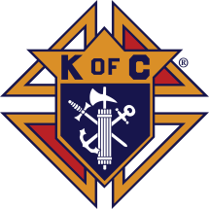  Fish Fry Fridays  Sponsored by  The Marlow/Duncan  Knights of Columbus  Fridays: March 31  April 7, 5:30-7:30 p.m.  At Immaculate Conception Church,  307 N 4th St, Marlow, OK  Carry-outs welcome 580-658-2365  Fish, fries, coleslaw, beans,  drink and dessert  $9.00 for adults and children under 8 free  STATIONS OF THE CROSS AT 6 P.M.
 |  | 12:00p W |  |   Our Second Collection will be for the Food Bank and Christmas Decorations. There are envelopes in the pews. Thank you for your generosity!
 |  | 2:00p D



Sunday, April 2, 2017, 5 p.m.
Assumption Parish
Lenten Taizé Prayers
Soup following in
Gillespie Hall

DUNCAN ALTAR SOCIETY NEWS

There is an Easter Bake Sale on Saturday and Sunday, April 8-9 after all Masses.

Attention all Ladies: Please make items to sell for the bake sale.

Attention all Parishioners: Please make your purchase of home-made goodies for Easter to support our Altar Society.
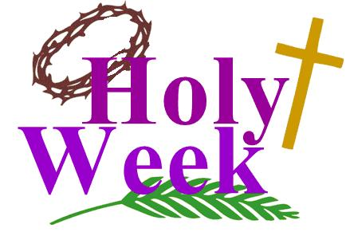

Assumption Parish
Holy Thursday, April 13, 7 p.m.
Good Friday, April 14, 7 p.m.
Holy Saturday, April 15, 7 p.m.

Third Annual Christmas Bazaar
November 20, 21 and 22
Attention: There will be a work day on Saturday, October 10 at 10 a.m. in Gillespie Hall! We need your ideas! It will take all of us participating to make our Bazaar a success!!!

Eggrolls by Agnes, order now.
She will only make 20 dozen.
They are $40 per dozen.
Pick up will be Friday, October 16.
Place order and pay at the office.

Order Tamales by Carmen
at $25.00 per dozen.
Order and pay at the office.
Pick up will be
Saturday, Nov 14.

The profit will equally be divided between three Parishes: Walters, Duncan and Marlow for the purpose of the building fund. We need your time, talent and treasure to make this event successful.

Abuse of Minors Response Hotline 405-720-987 or DHS at 1-800-522-3511.
Telefóno Pastoral para Reportar Abuso de Menores 405-720-9878 o el Departamento de Servicios Humanos 1-800-522-3511.

Mark your calendar for Catholic Foundation’s presentation on wills and trusts. This will be held on Monday, October 24 at 7 p.m. at Assumption Catholic Church Gillespie Hall. Come and learn how to take care of those you love.
You can have a Mass said for someone's intentions at their birthday, wedding, baptism, or in memory of your deceased loved ones. Contact he office for days and times that you wish to have the Mass celebrated. What a precious gift!




BINGO NIGHT
Knights of Columbus will be holding a Bingo Night starting at 7PM on Saturday, April 1, 2017 in the Immaculate Conception Church Hall. $10 Purchase for 20 cards good for 15 regular (includes horizontal, vertical, diagonal or 4 corners) bingo. Each Bingo game pays $15. Special 50/50 drawings will be played after each bingo game for table prizes and the final drawing of the event will be for the 50/50 pot. Doors open at 6:30 PM for dinner.
A spaghetti plate will also be offered for a donation!!!!
Net Proceeds from the event will go to support the Center of Family Love Group

Religious Education News!
Grades 7-12/Confirmation:
Sundays from 11-12:30

NO CLASSES: April 9, Palm Sunday
April 16, Easter Sunday
April 23, Confirmation

Last Classes:
Sunday, April 30
Wednesday, May 3

Grades 1-6:
Wednesdays from 6:00-7:00 p.m.
NO CLASS: April 12, Holy Week

Save the Dates: 10 a.m. Mass
Confirmation Sunday, April 23
First Communion, Sunday, May 7

Seder Meal
Immaculate Conception
Wednesday, April 12 at 6 p.m.
Please sign up prior to
Sunday, April 9 or call
Bill Havron at 580-512-6867.
There is a list of items
to bring contact
Bette Cooper at 580-641-1350.
SCHOLARSHIPS!!! - IT IS THAT TIME AGAIN
ASSUMPTION CATHOLIC CHURCH and the Knights of Columbus Council No. 5168 are again accepting applications for the Jesse Wayne Moore Scholarships for the graduating seniors wishing to further their education this year. A few scholarships, from $300 to $1,500 are available. You may obtain application forms from Jim Surjaatmadja or the Assumption Church Office and submit the applications and the necessary documents ON or BEORE Monday, April 19, 2017 to the Church's office or myself. All applications will be judged on Parish activities, community activities and scholastic achievements. A note to all Parish Members: On behalf of the Knights and the graduating Seniors, we would like to thank everyone for the generous contributions that help make the Scholarship Program continue throughout the years. But, we will need your support again for the years to come. For this, again we will ask your continued generous monthly contributions. Please write your checks to Assumption Church Scholarship Fund. Thank you again for your continuing support! Jim Surjaatmadja, Scholarship Chairman, Knights of Columbus 5168.

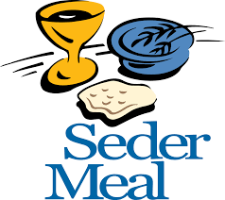

Chicken Flautas,
rice and beans
for sale $8.00
per plate
this weekend
after
Duncan
Masses.
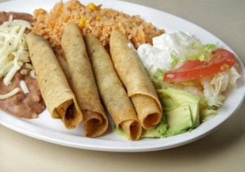

DUNCAN COLLECTIONs FOR
March 19-20:
Duncan: $2,056.79
Weekly Electronic Donations: $1,000.00
Second Collection: $267.59
Food Bank: $47.00
St. Vincent de Paul: $107.00
Ryan: $56.00
Thank you for your generosity!!!

Saint Patrick Catholic Church
THIRD AND OHIO POST OFFICE BOX 151
Walters, Oklahoma 73572
********************************
Collections:
March 19: Operating: $479.00

