Third Sunday of Lent
March 19, 2017

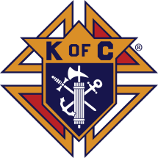
Fish Fry Fridays
Sponsored by
The Marlow/Duncan
Knights of Columbus

Fridays: March 10, 17, 24, 31
April 7, 5:30-7:30 p.m.
At Immaculate Conception Church,
307 N 4th St, Marlow, OK

Carry-outs welcome 580-658-2365
Fish, fries, coleslaw, beans,
drink and dessert

$9.00 for adults and children under 8 free

STATIONS OF THE CROSS AT 6 P.M.
Mass Intentions / Peticiones de Misa



Sat | Mar 18 | 4:00p D | (+) Michael L. Dunn  by The Bennie Wilson Family
 |  | 6:00p R | (+) Jo Ann Hebert
Sun | Mar 19 | 8:00a M | (+) Jo Ann Hebert
 |  | 10:00a D | (+) Bob Rice  By The Bennie Wilson Family
 |  | 12:00p W
 |  | 2:00p D | For the Parishioners
Mon | Mar 20 | 12:10p D | (+)Jo Ann Hebert
Tues | Mar 21 | 12:10p D | (+) Jo Ann Hebert
Wed | Mar 22 | 12:10p D | (+) Jo Ann Hebert  Int of Bill Blanton
Thur | Mar 23 | 12:10p D | (+) Jo Ann Hebert
Fri | Mar 24 | 12:10p D | (+) Jo Ann Hebert  (+) Alice Barnes  by Carolyn Trostle
Sat | Mar 25 | 4:00p D | (+) Paul | Chicken Flautas,  rice and beans  for sale $8.00 per plate  after Masses  on  Saturday-Sunday,  March 25-26.
 |  | 6:00p R | (+) Jo Ann Hebert | 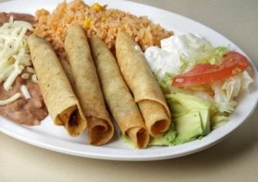
Sun | Mar 26 | 8:00 a M
 |  | 10:00a D | (+) Jo Ann Hebert
 |  | 12:00p W | For the Parishioners | Our Second Collection will be for the Food Bank and Christmas Decorations. There are envelopes in the pews. Thank you for your generosity!
 |  | 2:00p D

Sunday, April 2, 2017, 5 p.m.
Assumption Parish
Lenten Taizé Prayers
Soup following in
Gillespie Hall



Seder Meal
Immaculate Conception
Wednesday, April 12 at 6 p.m.
Please sign up prior to
Sunday, April 9 or call
Bill Havron at 580-512-6867.
There is a list of items
to bring contact
Bette Cooper at 580-641-1350.
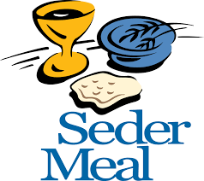

Assumption Parish
Holy Thursday, April 13, 7 p.m.
Good Friday, April 14, 7 p.m.
Holy Saturday, April 15, 7 p.m.
DUNCAN ALTAR SOCIETY NEWS

There is an Easter Bake Sale on Saturday and Sunday, April 8-9 after all Masses.

Attention all Ladies: Please make items to sell for the bake sale.

Attention all Parishioners: Please make your purchase of home-made goodies for Easter to support our Altar Society.
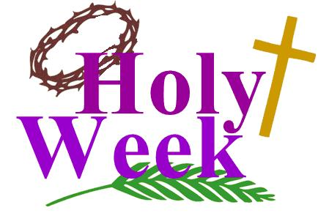

Third Annual Christmas Bazaar
November 20, 21 and 22
Attention: There will be a work day on Saturday, October 10 at 10 a.m. in Gillespie Hall! We need your ideas! It will take all of us participating to make our Bazaar a success!!!

Eggrolls by Agnes, order now.
She will only make 20 dozen.
They are $40 per dozen.
Pick up will be Friday, October 16.
Place order and pay at the office.

Order Tamales by Carmen
at $25.00 per dozen.
Order and pay at the office.
Pick up will be
Saturday, Nov 14.

The profit will equally be divided between three Parishes: Walters, Duncan and Marlow for the purpose of the building fund. We need your time, talent and treasure to make this event successful.

Abuse of Minors Response Hotline 405-720-987 or DHS at 1-800-522-3511.
Telefóno Pastoral para Reportar Abuso de Menores 405-720-9878 o el Departamento de Servicios Humanos 1-800-522-3511.

Mark your calendar for Catholic Foundation’s presentation on wills and trusts. This will be held on Monday, October 24 at 7 p.m. at Assumption Catholic Church Gillespie Hall. Come and learn how to take care of those you love.
You can have a Mass said for someone's intentions at their birthday, wedding, baptism, or in memory of your deceased loved ones. Contact he office for days and times that you wish to have the Mass celebrated. What a precious gift!

SCHOLARSHIPS!!! - IT IS THAT TIME AGAIN
ASSUMPTION CATHOLIC CHURCH and the Knights of Columbus Council No. 5168 are again accepting applications for the Jesse Wayne Moore Scholarships for the graduating seniors wishing to further their education this year. A few scholarships, from $300 to $1,500 are available. You may obtain application forms from Jim Surjaatmadja or the Assumption Church Office and submit the applications and the necessary documents ON or BEORE Monday, April 19, 2017 to the Church's office or myself. All applications will be judged on Parish activities, community activities and scholastic achievements. A note to all Parish Members: On behalf of the Knights and the graduating Seniors, we would like to thank everyone for the generous contributions that help make the Scholarship Program continue throughout the years. But, we will need your support again for the years to come. For this, again we will ask your continued generous monthly contributions. Please write your checks to Assumption Church Scholarship Fund. Thank you again for your continuing support! Jim Surjaatmadja, Scholarship Chairman, Knights of Columbus 5168.

Religious Education News!
Grades 7-12/Confirmation:
Sundays from 11-12:30

NO CLASSES: April 9, Palm Sunday
April 16, Easter Sunday
April 23, Confirmation

Last Classes:
Sunday, April 30
Wednesday, May 3

Grades 1-6:
Wednesdays from 6:00-7:00 p.m.
NO CLASS: April 12, Holy Week

Save the Dates: 10 a.m. Mass
Confirmation Sunday, April 23
First Communion, Sunday, May 7

Catholic Foundation scholarships available
The 2017-18 Catholic Foundation of Oklahoma scholarship applications are now available. The Catholic Foundation offers a $6,000 scholarship to students attending a non-Catholic college or university and a $12,000 scholarship to students attending a Catholic college or university. Additional scholarships may be available to a University of Oklahoma medical student, a nursing student at the school of their choice, students studying pastoral music, and a student attending Saint Gregory’s University. If interested, visit the Catholic Foundation website at www.cfook.org or contact (405) 721-4115,cfo-info@archokc.org. Completed applications are due by Monday, April 3.
Becas disponibles de la Fundación Católica
Las solicitudes de becas para el 2017-18 de la Fundación Católica de Oklahoma ya están disponibles. La Fundación Católica ofrece una beca de $6,000 dólares a estudiantes que asistan a colegios o universidades no-Católicas y una beca de $12,000 para estudiantes que asistan a colegios o universidades Católicas.Se podrán adquirir becas adicionales para un estudiante de medicina que asista a la Universidad de Oklahoma, para un estudiante de enfermería, para la escuela de su elección, para estudiantes que estudien música sacra, y para estudiantes que asisten a la Universidad de San Gregorio. Si le interesa favor de visitar la página de Catholic Foundation: www.cfook.org,o llamar a(405) 721-4115, o escribir a cfo-info@archokc.org. Las solicitudes se estarán recibiendo hasta el lunes de abril del 2017.

Catholic young adults of OKC
Open to all young adults (ages 18-39, married or single) in the archdiocese. Visit our Facebook page (Catholic Young Adults of OKC) for events and information or e-mail info@catholicyoungadultsokc.com.

In the Father’s Footsteps
Catholic Men’s Conference
Saturday, April 1, 2017,
9 a.m. – 4 p.m.
Norman, OK
Embassy Suites Convention Center
Catholicmen.net

DUNCAN COLLECTIONs FOR
March 11-12:
Duncan: $1,900.31
Weekly Electronic Donations: $1,000.00
Second Collection: $228.00
Food Bank: $320.00
Building Fund: $380.00
St. Vincent de Paul: $170.00
Scholarship: $25.00
Ryan: $193.00
Thank you for your generosity!!!

Saint Patrick Catholic Church
THIRD AND OHIO POST OFFICE BOX 151
Walters, Oklahoma 73572
********************************
Collections:
March 12: Operating: $316.00
Building: $125.00

