Eighteenth Sunday in Ordinary Time
August 4, 2013

The Assumption of the
Blessed Virgin Mary,
Thursday, August 15,
is a
Holy Day of Obligation
There will be
one Mass
in Duncan at 7 p.m.
Reception will follow

Mass Intentions / Peticiones de Misa

Sat | Aug 3 | 4:00p D | (+)Barbara McCartney
 |  | 6:00p R
Sun | Aug 4 | 8:00a M | Blessings for Petra Rocha on her Birthday by Maria Jones
 |  | 10:00a D | (+)Barbara McCartney
 |  | 12:00p W | Blessings for Steve Neal
 |  | 2:00p D |  | We would like to invite everyone to attend a Good-bye Party for Fr. Joseph on Sunday, June 30 at 5 p.m. in Gillespie Hall. The Knights of Columbus are providing hamburgers and hot dogs. We will have a money tree for Fr. Joseph.  We would like to invite everyone to attend a Good-bye Party for Fr. Joseph on Sunday, June 30 at 5 p.m. in Gillespie Hall. The Knights of Columbus are providing hamburgers and hot dogs. We will have a money tree for Fr. Joseph.
Mon | Aug 5 | 12:10p D | (+)Barbara McCartney
Tues | Aug 6 | 12:10p D | (+)Barbara McCartney
Wed | Aug 7 | 12:10p D | (+)Barbara McCartney
Thur | Aug 8 | 12:10p D | (+)Barbara McCartney
Fri | Aug 9 | 12:10p D | (+)Barbara McCartney
Sat | Aug 10 | 4:00p D | (+)Barbara McCartney  Attention Parishioners!  The Duncan Altar Society will be collecting flower donations for the Feast of Assumption of The Blessed Virgin Mary Celebration at the weekend Masses of August 3-4.
 |  | 6:00p R | For the Parishioners
Sun | Aug 11 | 8:00a M | (+)Mr. & Mrs. Antonio Ramirez by Maria & Lee Jones
 |  | 10:00a D | Int of Howard Doerr by Janet Wolfgang & The Deeg Family  Altar Society News:  Gift Shop and Book Store!  Many Religious Articles for sale: rosaries, prayer cards, books, tote bags, medals, etc!  Many Divine Mercy and  Blessed John Paul II items! Many gift items!  Please support your Altar Society!
 |  | 12:00p W
 |  | 2:00p D | (+)Barbara McCartney
Attention all Volunteers:
If you are a volunteer in the Church (Ushers, Eucharistic Ministers, Choir Members, etc.) please come by the office and get a Safe Environment Application. We must have a completed application for all those who volunteer in the Church! Immaculate Conception in Marlow, St. Joseph in Ryan and St. Patrick's in Walters included. Call the office and let us know how many forms you will require. It is important that we have a form for everyone who volunteers in Assumption and the Mission Churches!

Catholic Charities of Lawton will offer case management and counseling services at our Church twice a month. The counselors will be here on Thursday, August 22. In order to take advantage of their service you must make an appointment by calling the following number 580-353-1811.

New Floor Fund Project
Thank you for your generosity. We have collected $60,000
$47,000 and still need $13,000 to meet our goal.
We are taking a second collection every Sunday
for this Project. Should you wish to use an envelope,
please use the envelopes found in the pews. $47,000
Thank you for your generosity. May God Bless You. Fr. Peter
Proyecto del nuevo piso de la iglesia
Damos gracias a las personas que estaban
trabajandopara el proyecto del nuevo piso $20,000
en nuestra iglesia. Todavía necesitamos colectar
$13,000 para este objetivo. Todos los Domingos $15,000
vamos hacer la segunda colecta para este Proyecto.
Muchas Gracias a Todos. $13,000

405-720-9878 Abuse of Minors Pastoral Response Hotline 405-720-9878
You may also contact Oklahoma Department of Human Services at 1-800-522-3511.
405-720-9878 Línea Telefónica Pastoral para Reportar Abuso de Menores 405-720-9878
También puede comunicarse con el Departamento de Servicios Humanos al 1-800-522-3511.

Do you own stock which has appreciated greatly since you purchased it? By establishing a permanent Endowment Fund at the Catholic Foundation, you may be able to make a gift of the stock for the benefit of your parish or favorite Catholic ministry and receive an immediate tax benefit. Contact the Catholic Foundation for a plan that works for you at 405-721-4115 or e-mail bsemtner@archokc.org.
Red Mass - Saturday, September 21 - 5 p.m.
Cathedral of Our Lady of Perpetual Help, OKC
On September 21, 2012 a Red Mass will be celebrated at the regularly scheduled 5 p.m. Mass. Archbishop Coakley will preside. The homilist will be Bishop Weisenburger (Salina). A reception will follow in the Connor Center. In the U.S., a Red Mass for judges, attorneys and government officials is traditionally celebrated to coincide with the convening of the U.S. Supreme Court on the first Monday in October. (The Red Mass takes its name from the red vestments worn at the Mass, symbolic of the tongues of fire that descended on the Apostles at Pentecost.)
Por favor, aparten la fecha: el 21 de septiembre de 2013 se celebrara una Misa Roja en el horario regular de la Misa de las 5:00 pm en la Catedral de Nuestra Señora del Perpetuo Socorro, de Oklahoma City. Presidirá el Arzobispo Coakley. El homilista será Obispo Weisenburger, Obispo de Salina. Habrá una recepción después en el Centro Connor. En los Estados Unidos, una Misa Roja para jueces, abogados y funcionarios del gobierno es tradicionalmente celebrada coincidiendo con la celebración de la Corte Suprema de Estados Unidos en el primer lunes de octubre. (La Misa Roja toma su nombre de los ornamentos rojos utilizados ​​en la Misa, símbolo de las lenguas de fuego que descendieron sobre los Apóstoles en Pentecostés.)

Year of Faith Pilgrimage Sites
Did you know. . .
The sites of interest stop at the
Assumption of the Blessed Virgin Mary
Parish in Duncan?

When: The pilgrimage sites are open from 9:30 a.m. to noon and 1:00-3:00 p.m. weekdays June 17 through August 16. The sites will also be open on Sunday - August 18 from 11:00 a.m. to 4:00 p.m.
Why: To personally encounter Christ in the sacred spaces of the Archdiocese of Oklahoma City and to learn the history of the Church in central and western Oklahoma.
Please see the Sooner Catholic dtd June 2, back
page for more information or the bulletin board!

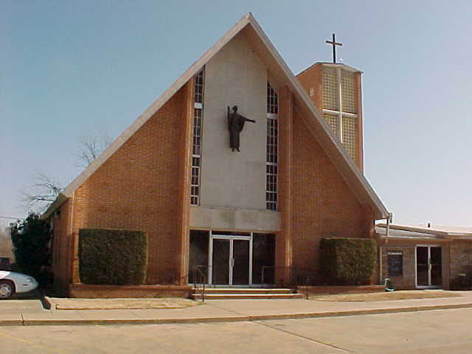

Website Sponsorships Available!
- In the weeks ahead, our parish representative from Solutio, Inc., will be setting up the advertising for our website for the year.
- Please consider participating in this effort since the revenue from the ads is what makes the website possible at no cost to the parish.
- It’s a great way to get your name in front of the families in the parish. Advertisements may be purchased for a business, family memorial, or you can sponsor an ad supporting Catholic Charities, Knights of Columbus, Vocations, etc.
- Please give these ideas some thought. We need and appreciate your help! If you are interested or just curious as to prices and want more information, please contact 580.713.0264 or Sponsorship@SolutioSoftware.com.

Go to our web page and get all the news at www.AssumptionDuncanOK.com
Thank you for sponsoring our Billboard
on Hwy 81 & 7:
August: Don & Bette Creel
September: Don & Carmie Ferland
October: In Memory of Jo Ann McCoy
November: Hispanic Cursillo Movement

Please remember you can support
your Church with automatic donations!
Sign up today to automatically donate
your Sunday offering especially during vacation times!
In order for us to process your automatic donation, we will need from you: voided check and a signed authorization form. Please come to the office after one of our weekend Masses or during the week.

Saint Patrick Catholic Church
THIRD AND OHIO POST OFFICE BOX 151
Walters, Oklahoma 73572
**************************************
Collections:
July 28: Operating: $343.00
Building: $5,125.00

DUNCAN COLLECTIONs FOR
july 28:
Duncan: $2,143.27
Building Fund: $427.00
Weekly Direct Deposit Donations: $1,100.00
Ryan $241.00

Please remember your Parish in your will.

