Sixth Sunday of Ordinary Time
February 12, 2017

2017 Annual Catholic Appeal
“God’s Light Shines Through Us”

During January, many parish families have received a letter from Archbishop Coakley asking to consider a pledge to the 2017 Annual Catholic Appeal. Please respond as generously as possible by returning your pledge in the mail. This year, the theme of the appeal is “God’s Light Shines Through Us.” We all have received God’s love. By financially supporting the ministries and services funded by the Annual Catholic Appeal, we help to extend God’s love to many, many others. As you review the mailing from Archbishop Coakley, please note the ministries and services funded by the appeal, including the ones that directly support the work of our parish. We thank you in advance for your generosity.

To learn more or to make your gift online, go to www.archokc.org/appeal.

Mass Intentions / Peticiones de Misa

Sat | Feb 11 | 4:00p D | Intentions of Howard Doerr by The Wolfgang-Deeg Family
 |  | 6:00p R | (+) Bobbi
Sun | Feb 12 | 8:00a M | (+) Bobbi
 |  | 10:00a D | Phan Pham and Family
 |  | 12:00p W | For the Parishioners
 |  | 2:00p D | (+) Angel Zamora by  Adrian Hunsucker
Mon | Feb 13 | 12:10p D | (+) Don Trostle & Jake Seratte  (+) Bobbi
Tues | Feb 14 | 12:10p D | Many Blessings for the 40th Wedding Anniversary  of Troy and Ann  (+) Bobbi
Wed | Feb 15 | 12:10p D | (+) Bobbi
Thur | Feb 16 | 12:10p D | (+) Bobbi
Fri | Feb 17 | 12:10p D | (+) Bobbi
Sat | Feb 18 | 4:00p D | (+) Bobbi
 |  | 6:00p R
Sun | Feb 19 | 8:00 a M | For the Parishioners
 |  | 10:00a D | (+) Bobbi
 |  | 12:00p W |  | Our Second Collection will be for the Food Bank and Christmas Decorations. There are envelopes in the pews. Thank you for your generosity!
 |  | 2:00p D

Platicas del Sacramento de Bautizmo
en Español
Febrero 25 Son a la 7 p.m. en La capilla.
Para mas informacioń
llame a la oficina
580-255-0590 ex 11,
o Carmen Garcia 580-255-6337 Gracias

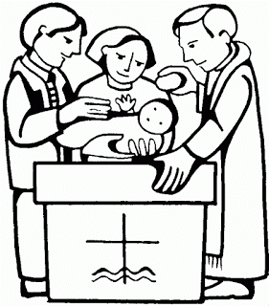

Come and join us every week day for Adoration of the Blessed Sacrament and recitation of The Divine Mercy Chaplet and Rosary at 11:30 a.m. followed by our daily Mass at 12:10 p.m.
Les invitamos todos los días a la adoración del Santísimo a las 11:30 a.m. antes de nuestra misa diaria 12:10p.m.

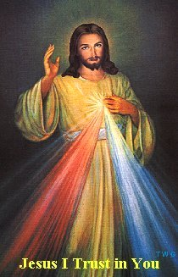

Duncan Altar Society News
Attention Ladies: There will be an Altar Society Meeting on Thursday, March 2. We will meet after the 12:10 p.m. Mass. You are invited to bring something to share for lunch.

Third Annual Christmas Bazaar
November 20, 21 and 22
Attention: There will be a work day on Saturday, October 10 at 10 a.m. in Gillespie Hall! We need your ideas! It will take all of us participating to make our Bazaar a success!!!

Eggrolls by Agnes, order now.
She will only make 20 dozen.
They are $40 per dozen.
Pick up will be Friday, October 16.
Place order and pay at the office.

Order Tamales by Carmen
at $25.00 per dozen.
Order and pay at the office.
Pick up will be
Saturday, Nov 14.

The profit will equally be divided between three Parishes: Walters, Duncan and Marlow for the purpose of the building fund. We need your time, talent and treasure to make this event successful.

Abuse of Minors Response Hotline 405-720-987 or DHS at 1-800-522-3511.
Telefóno Pastoral para Reportar Abuso de Menores 405-720-9878 o el Departamento de Servicios Humanos 1-800-522-3511.

Mark your calendar for Catholic Foundation’s presentation on wills and trusts. This will be held on Monday, October 24 at 7 p.m. at Assumption Catholic Church Gillespie Hall. Come and learn how to take care of those you love.
You can have a Mass said for someone's intentions at their birthday, wedding, baptism, or in memory of your deceased loved ones. Contact he office for days and times that you wish to have the Mass celebrated. What a precious gift!


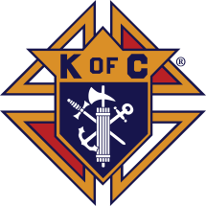

Fish Fry Fridays
Sponsored by The Marlow/Duncan Knights of Columbus

Fridays: March 3, 10, 17, 24, 31
April 7, 5:30-7:30 p.m.
At Immaculate Conception Church,
307 N 4th St
Marlow, OK

Carry-outs welcome
580-658-2365

Fish, fries, coleslaw, beans,
drink and dessert

$9.00 for adults and
children under 8 free

Stations of the Cross at 6:00 p.m.
Religious Education News!

Grades 7-12/Confirmation:
Sundays from 11-12:30
March 12 No Class, Spring Break

Grades 1-6:
Wednesdays from 6:00-7:00 p.m.
No Classes:
March 1, Ash Wednesday
March 8, Catechist Meeting
March 15, Spring Break

Save the Dates: 10 a.m. Mass
Confirmation Sunday, April 23
First Communion, Sunday,
May 7

In the Father’s Footsteps
Catholic Men’s Conference
Saturday, April 1, 2017,
9 a.m. – 4 p.m.
Norman, OK
Embassy Suites Convention Center
Catholicmen.net
Encounter with God’s Call
A seminary discernment retreat at Conception Seminary College April 1-3 for high school juniors through college-age men curious about seminary. Contact (660) 944-2886, vocations@conception.edu or go online to www.ewgc.org.

Retrouvaille
Retrouvaille helps spouses uncover or re-awaken the love, trust and commitment that originally brought them together. The program is highly successful in saving hurting marriages, even bringing reconciliation to couples who already have separated or divorced. The next weekend program is Feb. 24-26 at the Catholic Pastoral Center, 7501 Northwest Expressway.
For confidential information or to register, call (405) 443-3541 or go online to www.HelpOurMarriage.com.

Catholic young adults of OKC
Open to all young adults (ages 18-39, married or single) in the archdiocese. Visit our Facebook page (Catholic Young Adults of OKC) for events and information or e-mail info@catholicyoungadultsokc.com.

DUNCAN COLLECTIONs FOR
February 4-5:
Duncan: $1,910.94
Weekly Electronic Donations: $1,000.00
Second Collection: $218.00
Food Bank: $70.00
St. Vincent de Paul: $223.00
Ryan: $170.00
Thank you for your generosity!!!

Saint Patrick Catholic Church
THIRD AND OHIO POST OFFICE BOX 151
Walters, Oklahoma 73572
********************************
Collections:
Feb 5: Operating: 657.40
Bldg: $345.00

