Fifth Sunday of Ordinary Time
February 5, 2017

Immaculate Conception
Annual Valentines Steak Dinner

Friday, February 10, 2017
Starting at 6 p.m.
in the Church Hall,
307 N 4th Street, Marlow, OK
$25.00 per couple
Please sign up and pay no later than Sunday, February 5, 2017

Sign up sheets are in the
Church Hall or contact
Bill Havron at 580-512-6867
LAST WEEKEND TO SIGN UP!!!
Mass Intentions / Peticiones de Misa

Sat | Feb 4 | 4:00p D |   (+) Bobbi
 |  | 6:00p R
Sun | Feb 5 | 8:00a M | (+) Bobbi
 |  | 10:00a D | Phan Pham and Family
 |  | 12:00p W
 |  | 2:00p D | For the Parishioners
Mon | Feb 6 | 12:10p D | (+) Jack Geurkink  (+) Bobbi
Tues | Feb 7 | 12:10p D | (+) Jack Geurkink  (+) Bobbi
Wed | Feb 8 | 12:10p D | (+) Bobbi
Thur | Feb 9 | 12:10p D | (+) Bobbi
Fri | Feb 10 | 12:10p D | (+) Bobbi
Sat | Feb 11 | 4:00p D | Intentions of Howard Doerr by The Wolfgang-Deeg Family
 |  | 6:00p R | (+) Bobbi
Sun | Feb 12 | 8:00 a M | (+) Bobbi
 |  | 10:00a D | (+) Phan Pham and Family
 |  | 12:00p W | For the Parishioners | Our Second Collection will be for the Food Bank and Christmas Decorations. There are envelopes in the pews. Thank you for your generosity!
 |  | 2:00p D
Thank you to Don and Bette Creel who donated $470.00 to purchase the new Easter Paschal candle.
May God bless you. –Fr. Peter
2017 Annual Catholic Appeal
“God’s Light Shines Through Us”

During January, many parish families have received a letter from Archbishop Coakley asking to consider a pledge to the 2017 Annual Catholic Appeal. Please respond as generously as possible by returning your pledge in the mail. This year, the theme of the appeal is “God’s Light Shines Through Us.” We all have received God’s love. By financially supporting the ministries and services funded by the Annual Catholic Appeal, we help to extend God’s love to many, many others. As you review the mailing from Archbishop Coakley, please note the ministries and services funded by the appeal, including the ones that directly support the work of our parish. We thank you in advance for your generosity.

To learn more or to make your gift online, go to www.archokc.org/appeal.

Platicas del Sacramento de Bautizmo
en Español
Febrero 25 Son a la 7 p.m. en La capilla.
Para mas informacioń
llame a la oficina
580-255-0590 ex 11,
o Carmen Garcia 580-255-6337 Gracias

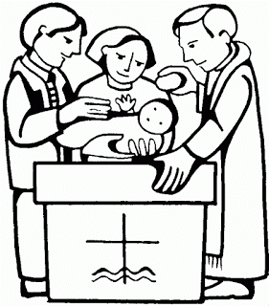

Third Annual Christmas Bazaar
November 20, 21 and 22
Attention: There will be a work day on Saturday, October 10 at 10 a.m. in Gillespie Hall! We need your ideas! It will take all of us participating to make our Bazaar a success!!!

Eggrolls by Agnes, order now.
She will only make 20 dozen.
They are $40 per dozen.
Pick up will be Friday, October 16.
Place order and pay at the office.

Order Tamales by Carmen
at $25.00 per dozen.
Order and pay at the office.
Pick up will be
Saturday, Nov 14.

The profit will equally be divided between three Parishes: Walters, Duncan and Marlow for the purpose of the building fund. We need your time, talent and treasure to make this event successful.

In the Father’s Footsteps
Catholic Men’s Conference
Saturday, April 1, 2017,
9 a.m. – 4 p.m.
Norman, OK
Embassy Suites Convention Center
Catholicmen.net

Mark your calendar for Catholic Foundation’s presentation on wills and trusts. This will be held on Monday, October 24 at 7 p.m. at Assumption Catholic Church Gillespie Hall. Come and learn how to take care of those you love.
You can have a Mass said for someone's intentions at their birthday, wedding, baptism, or in memory of your deceased loved ones. Contact he office for days and times that you wish to have the Mass celebrated. What a precious gift!

Abuse of Minors Response Hotline 405-720-987 or DHS at 1-800-522-3511.
Telefóno Pastoral para Reportar Abuso de Menores 405-720-9878 o el Departamento de Servicios Humanos 1-800-522-3511.

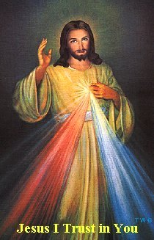

Come and join us every week day for Adoration of the Blessed Sacrament and recitation of The Divine Mercy Chaplet and Rosary at 11:30 a.m. followed by our daily Mass at 12:10 p.m.
Les invitamos todos los días a la adoración del Santísimo a las 11:30 a.m. antes de nuestra misa diaria 12:10p.m.

Religious Education News!

Grades 7-12/Confirmation:
Sundays from 11-12:30
March 12 No Class, Spring Break

Grades 1-6:
Wednesdays from 6:00-7:00 p.m.
No Classes:
March 1, Ash Wednesday
March 8, Catechist Meeting
March 15, Spring Break

South Region ACCW
Third Quarterly Meeting
Presentation of Award
“Women of Faith in Action”

Saturday, February 11, 2017
Holy Family, Lawton, OK, 9:30 a.m.

RSVP: Sharon Stephen at
580-585-7119

Don’t forget to bring an item
for the silent auction!

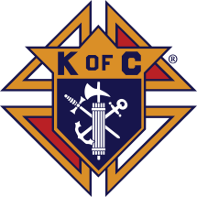


Fish Fry Fridays
Sponsored by The Marlow/Duncan Knights of Columbus

Fridays: March 3, 10, 17, 24, 31
April 7, 5:30-7:30 p.m.
At Immaculate Conception Church,
307 N 4th St
Marlow, OK

Carry-outs welcome
580-658-2365

Fish, fries, coleslaw, beans,
drink and dessert

$9.00 for adults and
children under 8 free

Stations of the Cross at 6:00 p.m.

Catholic young adults of OKC
Open to all young adults (ages 18-39, married or single) in the archdiocese. Visit our Facebook page (Catholic Young Adults of OKC) for events and information or e-mail info@catholicyoungadultsokc.com.

DUNCAN COLLECTIONs FOR
January 28-29:
Duncan: $2,589.54
Weekly Electronic Donations: $1,200.00
Second Collection: $303.56
Food Bank: $71.00
St. Vincent de Paul: $26.71
Building Fund: $155.00
Ryan: $176.00
Thank you for your generosity!!!

Saint Patrick Catholic Church
THIRD AND OHIO POST OFFICE BOX 151
Walters, Oklahoma 73572
********************************
Collections:
Jan 22: Operating: $305.00
Jan 29: Operating: 355.00
Bldg: $125.00

