The Epiphany of the Lord
January 8, 2017

Mass Intentions / Peticiones de Misa

Sat | Jan 7 | 4:00p D | Church Donation Envelopes  The Church Donation Envelopes are here! You can pick them up in Gillespie Hall.  Please Note: You can always donate via automatic withdrawal directly to our church's account. It is easy, simple and at the end of the fiscal year you will receive a tax letter acknowledging your donations. For more information stop by the office after each Mass.  Thank you for your support.
 |  | 6:00p R
Sun | Jan 8 | 8:00a M
 |  | 10:00a D |   (+) Phan Pham and the Family
 |  | 12:00P W
 |  | 2:00p D | (+) Fernando Contreras  By Fr. Peter
Mon | Jan 9 | 12:10p D
Tues | Jan 10 | 12:10p D
Wed | Jan 11 | 12:10p D | Intentions of Howard Doerr  By The Wolfgang-Deeg Family
Thur | Jan 12 | 12:10p D
Fri | Jan 13 | 12:10p D
Sat | Jan 14 | 4:00p D
 |  | 6:00p R
Sun | Jan 15 | 8:00 a M
 |  | 10:00a D | (+) Phan Pham and the Family
 |  | 12:00p W |  | Our Second Collection will be for the Food Bank and Christmas Decorations. There are envelopes in the pews. Thank you for your generosity!
 |  | 2:00p D | (+) Linda Salazar by Fr. Peter

Come and join us every week day for Adoration of the Blessed Sacrament at 11:30 a.m. The Divine Mercy Chaplet and Rosary will begin at 11:40 a.m. followed by our daily Mass at 12:10 p.m.

Les invitamos todos los días a la adoración del Santísimo a las 11:30 a.m. antes de nuestra misa diaria 12:10p.m.

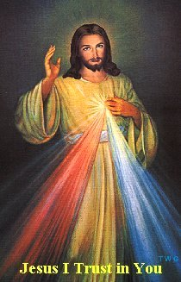

IMPORTANT I.R.S. NOTICE
If you require a 2016 tax letter for IRS stating your donations to Assumption Parish or other Missions please contact the office directly. We will NOT mail these statements unless you request them. Please make sure to leave your correct name and address while making your request. If you made cash donations, you're not entitled to receive this letter. Thank you.

Third Annual Christmas Bazaar
November 20, 21 and 22
Attention: There will be a work day on Saturday, October 10 at 10 a.m. in Gillespie Hall! We need your ideas! It will take all of us participating to make our Bazaar a success!!!

Eggrolls by Agnes, order now.
She will only make 20 dozen.
They are $40 per dozen.
Pick up will be Friday, October 16.
Place order and pay at the office.

Order Tamales by Carmen
at $25.00 per dozen.
Order and pay at the office.
Pick up will be
Saturday, Nov 14.

The profit will equally be divided between three Parishes: Walters, Duncan and Marlow for the purpose of the building fund. We need your time, talent and treasure to make this event successful.

Mark your calendar for Catholic Foundation’s presentation on wills and trusts. This will be held on Monday, October 24 at 7 p.m. at Assumption Catholic Church Gillespie Hall. Come and learn how to take care of those you love.
You can have a Mass said for someone's intentions at their birthday, wedding, baptism, or in memory of your deceased loved ones. Contact he office for days and times that you wish to have the Mass celebrated. What a precious gift!

Abuse of Minors Response Hotline 405-720-987 or DHS at 1-800-522-3511.
Telefóno Pastoral para Reportar Abuso de Menores 405-720-9878 o el Departamento de Servicios Humanos 1-800-522-3511.


Religious Education News!
Grades 7-12/Confirmation:
Sundays from 11-12:30
Jan 8, 2017:
No Class Catechist Meeting
January 15, 2017: Return to Class

Grades 1-6:
Wednesdays from 6:00-7:00 p.m.
January 11, 2017: Return to Class

PARISH BINGO NIGHT

The Knights of Columbus will be holding a Bingo Night starting at 7 pm on Saturday, January 14, 2017 in the Assumption Church RE Auditorium. A $10 Purchase for 20 cards good for 15 regular (includes horizontal, vertical, diagonal or 4 corners) bingo games. Each Bingo game pays $15. Special 50/50 drawings will be played after each bingo game for table prizes and the final drawing of the event will be for the 50/50 pot.

A spaghetti plate dinner will be available for voluntary donations starting at 6:30PM. Please come and have an enjoyable evening of food, bingo and social time.

Proceeds from this event will go to The Knights of Columbus Charitable Programs.

ATTENTION PLEASE:

You can have a Mass offered for someone's intentions on their birthday, wedding, baptism, or in memory of your deceased loved ones. Contact the office for days and times that you wish to have the Mass celebrated.
What a wonderful spiritual gift!

A Gregorian Mass is for the
faithfully departed.
The Holy Mass is said daily
for thirty days.



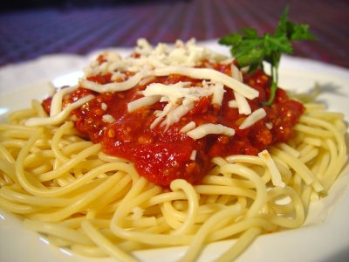

Catholic young adults of OKC
Open to all young adults (ages 18-39, married or single) in the archdiocese. Visit our Facebook page (Catholic Young Adults of OKC) for events and information or e-mail info@catholicyoungadultsokc.com.

Saint Patrick Catholic Church
THIRD AND OHIO POST OFFICE BOX 151
Walters, Oklahoma 73572
********************************
Collections:
Jan 1: Operating: $375.00
Building: $170.00

DUNCAN COLLECTIONs FOR
December 31-Jan 1:
Duncan: $1,225.70
Weekly Electronic Donations: $1,200.00
Christmas Decorations: $96.66
Ryan: No Mass
Thank you for your generosity!!!

