The Nativity of the Lord
December 25, 2016

Mass Intentions / Peticiones de Misa

Sat | Dec 24 | 4:00p W | NEW YEAR’S MASS SCHEDULE:  New Year’s Eve,  December 31, 2016  4:00 p.m. Duncan  6:00 p.m. Ryan  New Year’s Day,  January 1, 2017  8:00 a.m. Marlow  10:00 a.m. Duncan  12:00 p.m. Walters  NO SPANISH MASS
 |  | 4:00p R
 |  | 6:00p D | (+) Paul
 | Midnight | 12:00a D | (+) Paul
Sun | Dec 25 | 8:00a M | (+) Paul
 |  | 10:00a D | (+) Phan Pham and the Family
 |  | 2:00p D | NO MASS
Mon | Dec 26 | 12:10p D | NO MASS
Tues | Dec 27 | 12:10p D | NO MASS
Wed | Dec 28 | 12:10p D | NO MASS
Thur | Dec 29 | 12:10p D | NO MASS
Fri | Dec 30 | 12:10p D | NO MASS
Sat | Dec 31 | 4:00p W | (+) Lity Estrada
 |  | 6:00p D
Sun | Jan 1 | 8:00 a M
 |  | 10:00a D | (+) Phan Pham and the Family
 |  | 12:00p W |  | Our Second Collection will be for the Food Bank and Christmas Decorations. There are envelopes in the pews. Thank you for your generosity!
 |  | 2:00p D | NO MASS
ATTENTION: THERE WILL BE NO
12:10 P.M. DAILY MASSES
MONDAY-FRIDAY, DECEMBER 26-30.

May the newly born Christ be always present in your heart and bring you peace and joy!
Fr. Peter and Fr. David

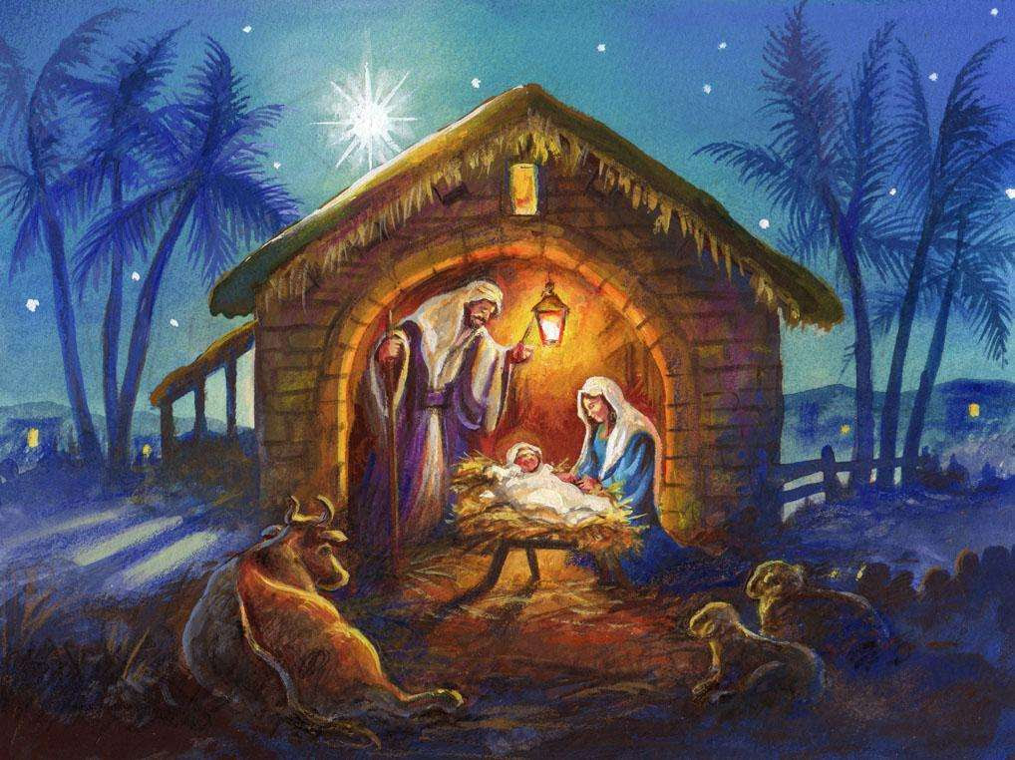

Third Annual Christmas Bazaar
November 20, 21 and 22
Attention: There will be a work day on Saturday, October 10 at 10 a.m. in Gillespie Hall! We need your ideas! It will take all of us participating to make our Bazaar a success!!!

Eggrolls by Agnes, order now.
She will only make 20 dozen.
They are $40 per dozen.
Pick up will be Friday, October 16.
Place order and pay at the office.

Order Tamales by Carmen
at $25.00 per dozen.
Order and pay at the office.
Pick up will be
Saturday, Nov 14.

The profit will equally be divided between three Parishes: Walters, Duncan and Marlow for the purpose of the building fund. We need your time, talent and treasure to make this event successful.

Mark your calendar for Catholic Foundation’s presentation on wills and trusts. This will be held on Monday, October 24 at 7 p.m. at Assumption Catholic Church Gillespie Hall. Come and learn how to take care of those you love.
You can have a Mass said for someone's intentions at their birthday, wedding, baptism, or in memory of your deceased loved ones. Contact he office for days and times that you wish to have the Mass celebrated. What a precious gift!

Abuse of Minors Response Hotline 405-720-987 or DHS at 1-800-522-3511.
Telefóno Pastoral para Reportar Abuso de Menores 405-720-9878 o el Departamento de Servicios Humanos 1-800-522-3511.

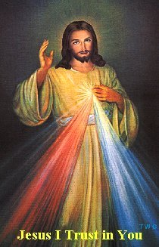

Come and join us every week day for Adoration of the Blessed Sacrament at 11:30 a.m. The Divine Mercy Chaplet and Rosary will begin at 11:40 a.m. followed by our daily Mass at 12:10 p.m.

Les invitamos todos los días a la adoración del Santísimo a las 11:30 a.m. antes de nuestra misa diaria 12:10p.m.

CHRISTMAS DONATIONS
There are Envelopes in the pews for donations for our Christmas flowers, decorations, and music.
Thank you for your generosity.

donaciones para de navidad
Hay Sobres en las bancas para donaciones para las Flores y Decoraciones de Navidad.
Gracias por su generosidad.



ATTENTION PLEASE:
You can have a Mass offered for someone's intentions on their birthday, wedding, baptism, or in memory of your deceased loved ones. Contact the office for days and times that you wish to have the Mass celebrated.
What a wonderful spiritual gift!

A Gregorian Mass is for the
faithfully departed.
The Holy Mass is said daily
for thirty days.

Attention:
The office will be closed
Monday, December 19 through Monday, January 2.
The office will re-open on Tuesday, January 3, 2017!

Please Note: You can always donate via automatic withdrawal directly to our church's account. It is easy, simple and at the end of the fiscal year you will receive a tax letter acknowledging your donations. For more information stop by the office after each Mass!
Thank you for your support.

Catholic young adults of OKC
Open to all young adults (ages 18-39, married or single) in the archdiocese. Visit our Facebook page (Catholic Young Adults of OKC) for events and information or e-mail info@catholicyoungadultsokc.com.

DUNCAN COLLECTIONs FOR
December 17-18:
Duncan: $2,082.21
Weekly Electronic Donations: $1,200.00
St Vincent de Paul: $66.00
Food Bank: $230.00
Christmas Decorations: $555.00
Ryan: No Mass
Thank you for your generosity!!!

Saint Patrick Catholic Church
THIRD AND OHIO POST OFFICE BOX 151
Walters, Oklahoma 73572
********************************
Collections:
Dec 18: Operating: $457.00
Building: $125.00

