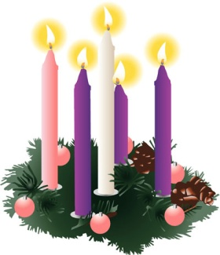
Fourth Sunday of Advent
December 18, 2016

Mass Intentions / Peticiones de Misa

Sat | Dec 17 | 4:00p D | (+) Phan Pham and the Family  CHRISTMAS MASS SCHEDULE:  Christmas Eve, December 24  4 p.m. Walters  4 p.m. Ryan  6 p.m. Duncan  12 Midnight Duncan  Christmas Day, December 25  8 a.m. Marlow  10:00 a.m. Duncan  NO SPANISH MASS
 |  | 6:00p R | (+) Paul
Sun | Dec 18 | 8:00a M | (+) Paul
 |  | 10:00a D | (+) Phan Pham and the Family
 |  | 12:00p W | (+) Don Trostle & Jake Seratte
 |  | 2:00p D | (+) Leticia Sanchez
Mon | Dec 19 | 12:10p D | (+) Alice Barnes  (+) Paul
Tues | Dec 20 | 12:10p D | (+) Paul
Wed | Dec 21 | 12:10p D | (+) Paul
Thur | Dec 22 | 12:10p D | (+) Paul
Fri | Dec 23 | 12:10p D | (+) Paul
Sat | Dec 24 | 4:00p W
 |  | 4:00p R
 |  | 6:00p D | (+) Paul
Sun | Dec 25 | Midnight | (+) Paul
 |  | 8:00 a M | (+) Paul
 |  | 10:00a D | (+) Phan Pham and the Family | Our Second Collection will be for the Food Bank and Christmas Decorations. There are envelopes in the pews. Thank you for your generosity!
 |  | 2:00 p D | NO MASS

Duncan Altar Society
Christmas Bake Sale
Saturday and Sunday,
THIS WEEKEND
after all weekend Masses

Bring your items for sale and
plan to purchase wonderful baked
goods for Christmas.
Thank you all!

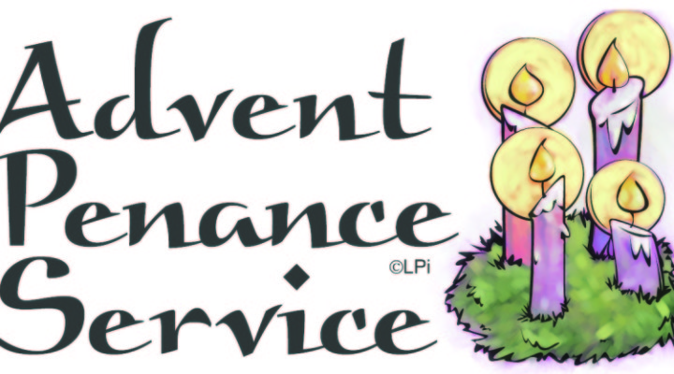
ATTENTION:
THERE WILL BE A
PENANCE SERVICE ON MONDAY, DECEMBER 19 AT 7 P.M.
AT ASSUMPTION PARISH.
ALL ARE INVITED.

Third Annual Christmas Bazaar
November 20, 21 and 22
Attention: There will be a work day on Saturday, October 10 at 10 a.m. in Gillespie Hall! We need your ideas! It will take all of us participating to make our Bazaar a success!!!

Eggrolls by Agnes, order now.
She will only make 20 dozen.
They are $40 per dozen.
Pick up will be Friday, October 16.
Place order and pay at the office.

Order Tamales by Carmen
at $25.00 per dozen.
Order and pay at the office.
Pick up will be
Saturday, Nov 14.

The profit will equally be divided between three Parishes: Walters, Duncan and Marlow for the purpose of the building fund. We need your time, talent and treasure to make this event successful.

Mark your calendar for Catholic Foundation’s presentation on wills and trusts. This will be held on Monday, October 24 at 7 p.m. at Assumption Catholic Church Gillespie Hall. Come and learn how to take care of those you love.
You can have a Mass said for someone's intentions at their birthday, wedding, baptism, or in memory of your deceased loved ones. Contact he office for days and times that you wish to have the Mass celebrated. What a precious gift!

Abuse of Minors Response Hotline 405-720-987 or DHS at 1-800-522-3511.
Telefóno Pastoral para Reportar Abuso de Menores 405-720-9878 o el Departamento de Servicios Humanos 1-800-522-3511.

CHRISTMAS DONATIONS
There are Envelopes in the pews for donations for our Christmas flowers, decorations, and music.
Thank you for your generosity.

donaciones para de navidad
Hay Sobres en las bancas para donaciones para las Flores y Decoraciones de Navidad.
Gracias por su generosidad.

Christmas Choir Rehearsals:
Please Join our Choir!!

Sunday, December 18, 11:00 a.m.
Friday, December 23, 4:30-6:00.m.



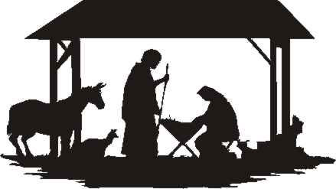

Attention:
The office will be closed
Monday, December 19 through Monday, January 2.
The office will re-open on Tuesday, January 3, 2017!
Vocations Retreat for
Young Men
The Vocations Office’s “Advent Day of Recollection” is open to young men in high school and college. It will be held Dec. 22 from 8 a.m. to 3 p.m. at the Catholic Pastoral Center. RSVP by Dec. 20 at (405)721-9351 or vocations@archokc.org.

Catholic young adults of OKC
Open to all young adults (ages 18-39, married or single) in the archdiocese. Visit our Facebook page (Catholic Young Adults of OKC) for events and information or e-mail info@catholicyoungadultsokc.com.

Please Note: You can always donate via automatic withdrawal directly to our church's account. It is easy, simple and at the end of the fiscal year you will receive a tax letter acknowledging your donations. For more information stop by the office after each Mass. Thank you for your support.

DUNCAN COLLECTIONs FOR
December 10-11:
Duncan: $1,676.20
Weekly Electronic Donations: $1,200.00
Retirement for Religious: $20.00
Scholarship Fund: $15.00
Food Bank: $822.96
Lady of Guadalupe: $544.00
Christmas Decorations: $442.00
Ryan: $256.00
Thank you for your generosity!!!

Saint Patrick Catholic Church
THIRD AND OHIO POST OFFICE BOX 151
Walters, Oklahoma 73572
********************************
Collections:
Dec 11: Operating: $1,623.00
Building: $5,165.00

