Third Sunday of Advent
December 11, 2016

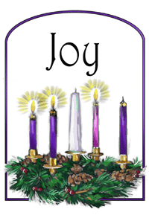
Mass Intentions / Peticiones de Misa

Sat | Dec 10 | 4:00p D | (+) Phan Pham and the Family
 |  | 6:00p R | (+) Paul  CHRISTMAS MASS SCHEDULE:  Christmas Eve, December 24  4 p.m. Walters  4 p.m. Ryan  6 p.m. Duncan  12 Midnight Duncan  Christmas Day, December 25  8 a.m. Marlow  10:00 a.m. Duncan  NO SPANISH MASS
Sun | Dec 11 | 8:00a M | (+) Paul
 |  | 10:00a D | Happy Birthday and Special Blessings to Anna Fitts
 |  | 12:00p W
 |  | 2:00p D | (+) Linda Salazar by Fr. Peter
Mon | Dec 12 | 7:00p D | (+) Intentions of Howard Doerr by the  Wolfgang-Deeg Family  (+) Paul
Tues | Dec 13 | 12:10p D | (+) Paul
Wed | Dec 14 | 12:10p D | NO MASS
Thur | Dec 15 | 12:10p D | (+) Paul
Fri | Dec 16 | 12:10p D | (+) Paul
Sat | Dec 17 | 4:00p D | (+) Phan Pham and the Family
 |  | 6:00p R | (+) Paul
Sun | Dec 18 | 8:00a M | (+) Paul
 |  | 10:00a D | (+) Phan Pham and the Family
 |  | 12:00p W |  | Our Second Collection will be for the Food Bank and Christmas Decorations. There are envelopes in the pews. Thank you for your generosity!
 |  | 2:00p D | (+) Linda Salazar by Fr. Peter

la fiesta de La
VIRGEN DE GUADALUPE

Todos están invitados a la celebración anual
de la Virgen de Guadalupe!

El Lunes, 12 de diciembre
5:00 pm ---------------------- El Rosario
7:00pm ---------------------- La Misa
Después de Misa ----------- La Cena
Después de Cena ----------- Matachines
Bailables

Our lady of Guadalupe celebration

Everyone is invited to the
annual celebration
of the Virgin of Guadalupe!

Monday, December 12
5:00 pm ------------------------ Rosary
7:00pm ------------------------ Mass
After Mass -------------------- Dinner
After Dinner ------------------ Matachines
Folkloric Dances

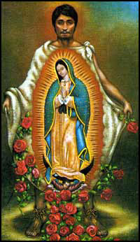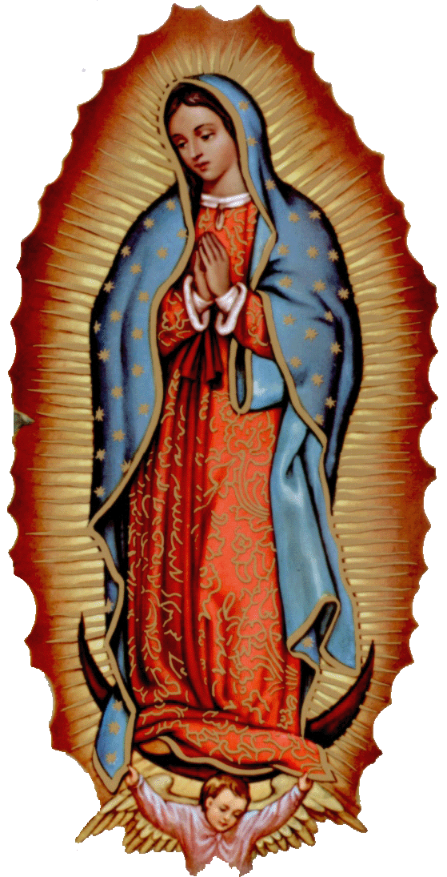

Thank you to the
Knights of Columbus for the
2017 Parochial Calendars!
Thanks to everyone our Christmas Bazaar was a success. We received $20,000 and the funds will be split $10,000 to Assumption, $5,000 to Immaculate Conception and $5,000 to St Patrick. Thank you for your gift of time, talent and treasure. --Fr. Peter
Third Annual Christmas Bazaar
November 20, 21 and 22
Attention: There will be a work day on Saturday, October 10 at 10 a.m. in Gillespie Hall! We need your ideas! It will take all of us participating to make our Bazaar a success!!!

Eggrolls by Agnes, order now.
She will only make 20 dozen.
They are $40 per dozen.
Pick up will be Friday, October 16.
Place order and pay at the office.

Order Tamales by Carmen
at $25.00 per dozen.
Order and pay at the office.
Pick up will be
Saturday, Nov 14.

The profit will equally be divided between three Parishes: Walters, Duncan and Marlow for the purpose of the building fund. We need your time, talent and treasure to make this event successful.

Mark your calendar for Catholic Foundation’s presentation on wills and trusts. This will be held on Monday, October 24 at 7 p.m. at Assumption Catholic Church Gillespie Hall. Come and learn how to take care of those you love.
You can have a Mass said for someone's intentions at their birthday, wedding, baptism, or in memory of your deceased loved ones. Contact he office for days and times that you wish to have the Mass celebrated. What a precious gift!

Abuse of Minors Response Hotline 405-720-987 or DHS at 1-800-522-3511.
Telefóno Pastoral para Reportar Abuso de Menores 405-720-9878 o el Departamento de Servicios Humanos 1-800-522-3511.

Duncan Altar Society
Christmas Bake Sale
Saturday and Sunday,
December 17-18
after all weekend Masses

Bring your items for sale and
plan to purchase wonderful baked
goods for Christmas.
Thank you all!

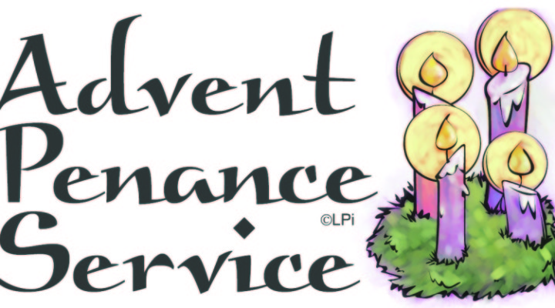
ATTENTION:
THERE WILL BE A
PENANCE SERVICE ON MONDAY, DECEMBER 19 AT 7 P.M.
AT ASSUMPTION PARISH.
ALL ARE INVITED.

Vocations Retreat for
Young Men
The Vocations Office’s “Advent Day of Recollection” is open to young men in high school and college. It will be held Dec. 22 from 8 a.m. to 3 p.m. at the Catholic Pastoral Center. RSVP by Dec. 20 at (405)721-9351 or vocations@archokc.org.

Christmas Choir Rehearsals:
Please Join our Choir!!

Sunday, December 11, 11:00 a.m.
Wednesday, December 14, 7:00-8:30 p.m.
Sunday, December 18, 11:00 a.m.
Wednesday, December 21, 7:00-8:30 p.m.



Catholic young adults of OKC
Open to all young adults (ages 18-39, married or single) in the archdiocese. Visit our Facebook page (Catholic Young Adults of OKC) for events and information or e-mail info@catholicyoungadultsokc.com.

DUNCAN COLLECTIONs FOR
December 3-4:
Duncan: $2,712.45
Weekly Electronic Donations: $1,200.00
Building Fund: $100.00
Food Bank: $229.00
St. Vincent de Paul: $150.00
Christmas Decorations: $316.33
Ryan: $149.00
Thank you for your generosity!!!

Saint Patrick Catholic Church
THIRD AND OHIO POST OFFICE BOX 151
Walters, Oklahoma 73572
********************************
Collections:
Dec 4: Operating: $405.00
Building: $345.00

