Second Sunday of Advent
December 4, 2016


Mass Intentions / Peticiones de Misa

Sat | Dec 3 | 4:00p D | (+) Paul
 |  | 6:00p R
Sun | Dec 4 | 8:00a M | (+) Dennis Wilde    By Susan Evans  CHRISTMAS MASS SCHEDULE:  Christmas Eve, December 24  4 p.m. Walters  6 p.m. Duncan  12 Midnight Duncan  Christmas Day, December 25  8 a.m. Marlow  10:00 a.m. Duncan  NO SPANISH MASS
 |  | 10:00a D | (+) Paul
 |  | 12:00p W
 |  | 2:00p D
Mon | Dec 5 | 12:10p D | (+) Jack Geurkink  (+) Paul
Tues | Dec 6 | 12:10p D | (+) Jack Geurkink  (+) Paul
Wed | Dec 7 | 12:10p D | (+) Paul
Thur | Dec 8 | 7:00p D | (+) Paul  (+) Pedro Martinez
Fri | Dec 9 | 12:10p D | (+) Paul  (+) Pedro Martinez
Sat | Dec 10 | 4:00p D | (+) Phan Pham and the Family
 |  | 6:00p R | (+) Paul
Sun | Dec 11 | 8:00a M | (+) Paul
 |  | 10:00a D | Happy Birthday and Special Blessings to Anna Fitts
 |  | 12:00p W |  | Our Second Collection will be for the Food Bank and Christmas Decorations. There are envelopes in the pews. Thank you for your generosity!
 |  | 2:00p D

Our lady of Guadalupe celebration

Everyone is invited to the
annual celebration
of the Virgin of Guadalupe!

Monday, December 12
5:00 pm ------------------------ Rosary
7:00pm ------------------------ Mass
After Mass -------------------- Dinner
After Dinner ------------------ Matachines
Folkloric Dances

la fiesta de La
VIRGEN DE GUADALUPE

Todos están invitados a la celebración anual
de la Virgen de Guadalupe!

El Lunes, 12 de diciembre
5:00 pm ---------------------- El Rosario
7:00pm ---------------------- La Misa
Después de Misa ----------- La Cena
Después de Cena ----------- Matachines
Bailables

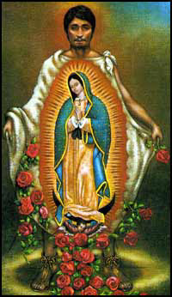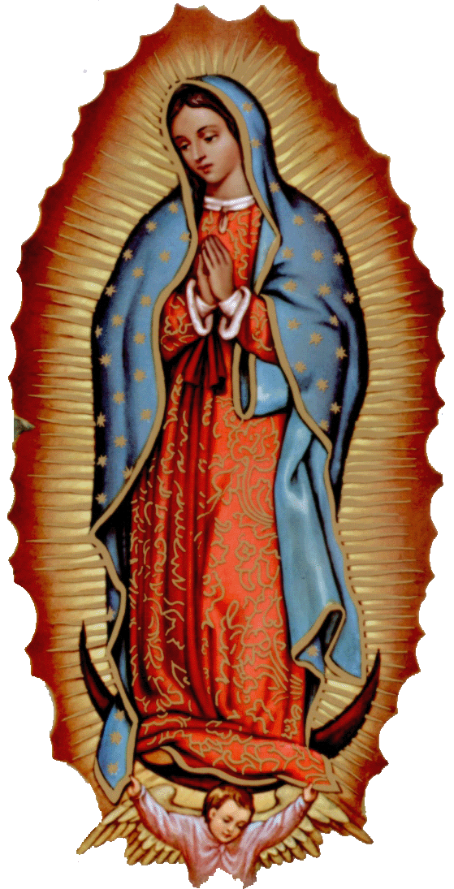

A collection will be taken up on
Thursday, December 8 for the
Immaculate Conception Mass at 7 p.m.
and the funds will go to the Food Bank.
Third Annual Christmas Bazaar
November 20, 21 and 22
Attention: There will be a work day on Saturday, October 10 at 10 a.m. in Gillespie Hall! We need your ideas! It will take all of us participating to make our Bazaar a success!!!

Eggrolls by Agnes, order now.
She will only make 20 dozen.
They are $40 per dozen.
Pick up will be Friday, October 16.
Place order and pay at the office.

Order Tamales by Carmen
at $25.00 per dozen.
Order and pay at the office.
Pick up will be
Saturday, Nov 14.

The profit will equally be divided between three Parishes: Walters, Duncan and Marlow for the purpose of the building fund. We need your time, talent and treasure to make this event successful.

Mark your calendar for Catholic Foundation’s presentation on wills and trusts. This will be held on Monday, October 24 at 7 p.m. at Assumption Catholic Church Gillespie Hall. Come and learn how to take care of those you love.
You can have a Mass said for someone's intentions at their birthday, wedding, baptism, or in memory of your deceased loved ones. Contact he office for days and times that you wish to have the Mass celebrated. What a precious gift!

Abuse of Minors Response Hotline 405-720-987 or DHS at 1-800-522-3511.
Telefóno Pastoral para Reportar Abuso de Menores 405-720-9878 o el Departamento de Servicios Humanos 1-800-522-3511.

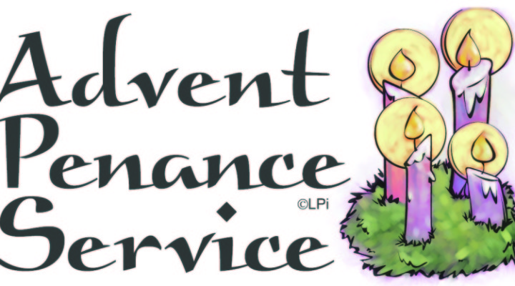
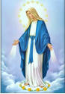

ATTENTION:
THERE WILL BE A
PENANCE SERVICE ON MONDAY, DECEMBER 19 AT 7 P.M.
AT ASSUMPTION PARISH.
ALL ARE INVITED.

The Solemnity of the
Immaculate Conception,
the patronal feast of the United States,
is a Holy Day of Obligation.

There will be one Mass at Assumption Parish at 7 p.m.,
Thursday, December 8
Archbishop Coakley will celebrate.

Immaculate Conception will have refreshments after the Mass in Gillespie Hall.

Duncan Altar Society
Christmas Bake Sale
Saturday and Sunday,
December 17-18
after all weekend Masses

Bring your items for sale and
plan to purchase wonderful baked
goods for Christmas.
Thank you all!

Christmas is Coming Soon
Join Us For Choir Rehearsals!
Saturday at 3:30 p.m.,
Sundays at
8:45 a.m. and 11:00 a.m.

Dear friends in Christ, Christmas is now less than two months away! Santa is practically waiting in Walmart and soon the trees will be covered in lights. We here at Assumption must do our part to prepare for the birth of Christ our King. St. Augustine once said that “he who sings prays twice.” I am asking all choir members to begin joining us for rehearsals as we get ready for this exciting season.
--Sam Backman



DUNCAN COLLECTIONs FOR
November 26-27:
Duncan: $2,224.01
Weekly Electronic Donations: $1,200.00
Building Fund: $20.00
Food Bank: $446.00
St. Vincent de Paul: $83.00
Christmas Decorations: $106.00
Scholarship: $15.00
Ryan: $144.00
Thank you for your generosity!!!

Saint Patrick Catholic Church
THIRD AND OHIO POST OFFICE BOX 151
Walters, Oklahoma 73572
********************************
Collections:
Nov 27: Operating: $307.00 Building: $125.00

