Our Lord Jesus Christ, King of the Universe
November 20, 2016

Mass Intentions / Peticiones de Misa

Christmas Bazaar
Our Christmas Bazaar
will be held
November 18, 19 and 20.
We hope everyone is making
beautiful items for sale.
There will also be a raffle for
three Visa cards:
$1,000, $500 and $250!
The raffle tickets are for sale now!
They are $5.00 each or five for $20.00! Please buy tickets and
also check them out to sell.
Let’s come together and
work hard to make this a
successful event!
Sat | Nov 19 | 4:00p D
 |  | 6:00p R | 
Sun | Nov 20 | 8:00a M | (+) Benjamin Ryan Gildon
 |  | 10:00a D
 |  | 12:00p W
 |  | 2:00p D | (+) Pedro Molina
Mon | Nov 21 | 12:10p D
Tues | Nov 22 | 12:10p D | (+) Alice J. Barnes  By The Trostle Family
Wed | Nov 23 | 12:10p D | NO MASS
Thur | Nov 24 | 12:10p D | NO MASS
Fri | Nov 25 | 12:10p D | NO MASS
Sat | Nov 26 | 4:00p D | (+) Paul
 |  | 6:00p R
Sun | Nov 27 | 8:00a M | (+)Benjamin Ryan Gildon
 |  | 10:00a D | Living & Deceased Members of The Altar Society
 |  | 12:00p W | 
 |  | 2:00p D | (+) Paul

ATTENTION:
The office will be closed Monday-Friday, November 21-25.
There will be no 12:10 p.m. Daily Masses,
Wednesday-Friday, November 23-25!

Diciembre 4-6, 2016

Mision de adviento 2016

Invitado Especial: Padre Iden Bello, J.C.L

Rector de la Catedral de San Agustin.

Laredo, Texas.

Domingo 4/12/2016 Misa 2 PM
Lunes 5/12/2016 7 PM
Martes 6/12/2016 7 PM

Este será un Nuevo Adviento, un Nuevo paso del Señor Jesús por tu vida!

El adviento es un periodo de tiempo privilegiado para los cristianos ya se nos invita a recordar el pasado, vivir el presente y preparar el futuro.

Our Second Collection will be for the Food Bank and Christmas Decorations. There are envelopes in the pews. Thank you for your generosity!

We would like to thank all those who participated in our Guadalupe fundraiser on October 16, 2016. Through your participation and generosity we have raised $2,398.20 which will allow us to purchase flowers for the Feast of Our Lady of Guadalupe. Thank you.

Muchas gracias a las personas que nos comprarón en la kermes el 16 de Oct salió $2,398.20. Ya tenamos para las Flores! Gracias

Third Annual Christmas Bazaar
November 20, 21 and 22
Attention: There will be a work day on Saturday, October 10 at 10 a.m. in Gillespie Hall! We need your ideas! It will take all of us participating to make our Bazaar a success!!!

Eggrolls by Agnes, order now.
She will only make 20 dozen.
They are $40 per dozen.
Pick up will be Friday, October 16.
Place order and pay at the office.

Order Tamales by Carmen
at $25.00 per dozen.
Order and pay at the office.
Pick up will be
Saturday, Nov 14.

The profit will equally be divided between three Parishes: Walters, Duncan and Marlow for the purpose of the building fund. We need your time, talent and treasure to make this event successful.

Mark your calendar for Catholic Foundation’s presentation on wills and trusts. This will be held on Monday, October 24 at 7 p.m. at Assumption Catholic Church Gillespie Hall. Come and learn how to take care of those you love.
You can have a Mass said for someone's intentions at their birthday, wedding, baptism, or in memory of your deceased loved ones. Contact he office for days and times that you wish to have the Mass celebrated. What a precious gift!

Abuse of Minors Response Hotline 405-720-987 or DHS at 1-800-522-3511.
Telefóno Pastoral para Reportar Abuso de Menores 405-720-9878 o el Departamento de Servicios Humanos 1-800-522-3511.

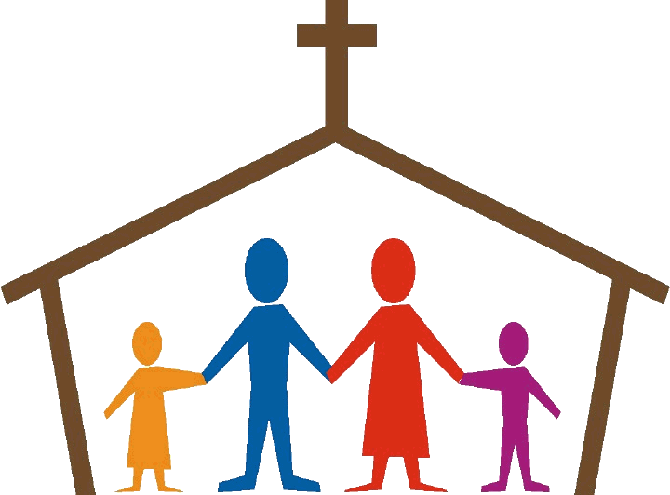
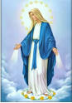
Religious Education News!

Grades 7-12/Confirmation:
Sundays from 11-12:30

Grades 1-6:
Wednesdays from 6:00-7:00 p.m.

No Classes:
Sundays: Nov 20 (Thanksgiving)
Dec 18 & 25
Jan 1, 2017
Jan 8, 2017 (Catechist Meeting)

Wednesdays: Nov 23 (Thanksgiving)
Nov 30 (Catechist Meeting)
Dec 21 & 28
Jan 4, 2017

The Solemnity of the
Immaculate Conception,
the patronal feast of the United States,
is a Holy Day of Obligation.

There will be one Mass at Assumption Parish at 7 p.m.,
Thursday, December 8
Archbishop Coakley will celebrate.

Immaculate Conception will have refreshments after the Mass
in Gillespie Hall.

Christmas is Coming Soon
Join Us For Choir Rehearsals!
Saturday at 3:30 p.m.,
Sundays at
8:45 a.m. and 11:00 a.m.

Dear friends in Christ, Christmas is now less than two months away! Santa is practically waiting in Walmart and soon the trees will be covered in lights. We here at Assumption must do our part to prepare for the birth of Christ our King. St. Augustine once said that “he who sings prays twice.” I am asking all choir members to begin joining us for rehearsals as we get ready for this exciting season.
--Sam Backman
Marriage workshop
On Saturday, Dec. 3, at the Catholic Pastoral Center, the Office of Family Life is partnering with the Oklahoma Marriage Initiative to present a Spanish language workshop, Real y Para Siempre, that is designed to help in areas such as speaker/listener technique, problem solving, ground rules for handling conflict and other pertinent issues that can aid in honing our communication skills. Begins at 9:30 a.m. with sign-in. Program is 10 a.m. to 4 p.m. No cost. Don’t miss this opportunity to enhance your relationship, whether married, single or as a continuation of marriage preparation. Call Lisa at (405) 709-2709.
Real y para siempre
La Oficina de la Vida Familiar se ha asociado con la Iniciativa Matrimonial de Oklahoma para presentar un taller Real y Para Siempre el sábado, 3 de diciembre en el Centro Pastoral Católico, 7501 Northwest Expressway, OKC. Este programa está diseñado para ayudar en la comunicación: Técnica de locutor/oyente, resolución de problemas, reglas para el manejo de conflictos y otros temas pertinentes que pueden ayudar a perfeccionar nuestras habilidades de comunicación. El día comienza a las 9:30 a.m. con inscripción y la primera sesión a las 10 a.m. – 4 p.m. No te pierdas esta oportunidad de mejorar su relación con tu pareja, o como una continuación de preparación matrimonial. Llame a Lisa en (405) 709-2709. Es todo en español y la entrada es gratuita.



DUNCAN COLLECTIONs FOR
October Nov 12-13:
Duncan: $2,035.46
Weekly Electronic Donations: $1,200.00
Building Fund: $962.88
Food Bank: $46.00
Ryan: $225.00
Thank you for your generosity!!!

