Fifteenth Sunday in Ordinary Time
July 10, 2016

Mass Intentions / Peticiones de Misa

We have daily adoration
and pray the
Chaplet of Divine Mercy
and the Rosary
Monday through
Friday at
11:30 a.m.
before the 12:10 Mass.
Everyone is invited
to participate and
spend time with Jesus!

Sat | July 9 | 4:00p D | (+) Bill Mullen
 |  | 6:00p R | Living & Deceased Members  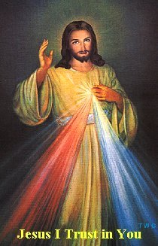Of the Altar Society
Sun | July 10 | 8:00a M
 |  | 10:00a D | Int of Howard Doerr by The Wolfgang-Deeg Family
 |  | 12:00p W
 |  | 2:00p D | (+) Bill Mullen
Mon | July 11 | 12:10p D | (+) Bill Mullen
Tues | July 12 | 12:10p D | (+) Bill Mullen
Wed | July 13 | 12:10p D | (+) Bill Mullen
Thur | July 14 | 12:10p D | (+) Don Trostle & Jake Seratte and (+) Bill Mullen
Fri | July 15 | 12:10p D | (+) Bill Mullen
Sat | July 16 | 4:00p D | (+) Bill Mullen
 |  | 6:00p R | For the Parishioners
Sun | July 17 | 8:00a M
 |  | 10:00a D | (+) Bill Mullen
 |  | 12:00p W
 |  | 2:00p D
July 5-August 15th the Office Hours are 10:00 a.m. to 3:00 p.m.
St Vincent de Paul is closed for July and August!

The Parish Feast of the
Assumption of the Blessed Virgin Mary
is Monday, August 15, 2016.
We will celebrate Mass at 6 p.m.
with a Pot Lunch Dinner to follow.

The Church will provide the
plates, drinks and also the meat.

So that we may have an assortment of food,
we ask that you bring a dish following this list:

Last Names beginning with:
A – I Salad or Vegetable
J – R Meat Casserole
S – Z Dessert/Fruit

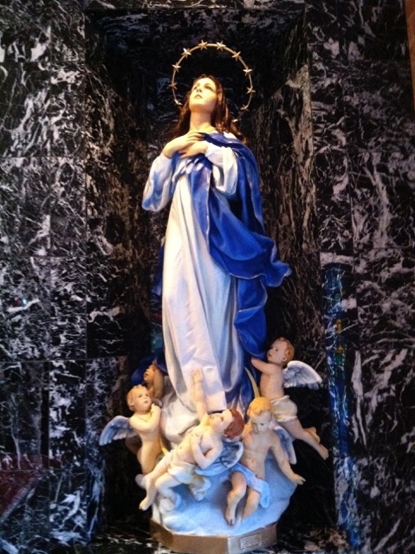

Third Annual Christmas Bazaar
November 20, 21 and 22
Attention: There will be a work day on Saturday, October 10 at 10 a.m. in Gillespie Hall! We need your ideas! It will take all of us participating to make our Bazaar a success!!!

Eggrolls by Agnes, order now.
She will only make 20 dozen.
They are $40 per dozen.
Pick up will be Friday, October 16.
Place order and pay at the office.

Order Tamales by Carmen
at $25.00 per dozen.
Order and pay at the office.
Pick up will be
Saturday, Nov 14.

The profit will equally be divided between three Parishes: Walters, Duncan and Marlow for the purpose of the building fund. We need your time, talent and treasure to make this event successful.

You can have a Mass said for someone's intentions at their birthday, wedding, baptism, or in memory of your deceased loved ones. Contact he office for days and times that you wish to have the Mass celebrated. What a precious gift!

Abuse of Minors Response Hotline 405-720-987 or DHS at 1-800-522-3511.
Telefóno Pastoral para Reportar Abuso de Menores 405-720-9878 o el Departamento de Servicios Humanos 1-800-522-3511.

Pre-Cana classes
Pre-Cana is a day for couples preparing for the Sacrament of Marriage. A specially prepared team of married couples and a priest share their experience and information with the intention of enabling engaged couples to be more aware of the privileges and responsibilities of marriage. Class is held at the Catholic Pastoral Center, 7501 Northwest Expressway. Spanish classes are Aug. 20, Oct. 1 or Nov. 12. English classesare Aug. 20 or Oct. 15. Registration begins at 8:15 a.m. and the program starts at 8:45 a.m., ending at 4 pm. Call (405)721-8944.Download registration form online at www.archokc.org.


Summer Parish Church Dinner & Bingo Night – Friday, July 15.

Immaculate Conception Church in Marlow will be hosting a Parish BBQ Dinner (donations will be accepted) on Friday, July 15 starting at 6 pm. To insure we have enough food we must have a head count. Please sign up by contacting Bill Havron (512-6867) or Tracey Forsythe (641-1988). Deadline for sign up is Monday July 11. Following Dinner we will hold a Free Fun Bingo event with 50/50 chances available.

Emmaus Days
Emmaus Days is for young men in high school or who recently graduated who are interested in discerning a call to the priesthood. Emmaus Days is Aug. 3-5 at Our Lady of Guadalupe Catholic Youth Camp in Arcadia. To register, contact (405) 721-9351,vocations@archokc.org or go online to http://archokc.org/vocations/home.

Communication Workshop
The Office of Family Life is presenting a free workshop, “Communicating with Yourself-What Messages are You Sending?,” that will give practical tools to improve communication, from 9 a.m. to Noon July 23 at the Catholic Pastoral Center, 7501 Northwest Expressway. Michelle Morris, an instructor for the Air Force, will facilitate. Call (405) 721-8944 to register.

Catholic young adults of OKC
Open to all young adults (ages 18-39, married or single) in the archdiocese. Visit our Facebook page (Catholic Young Adults of OKC) for events and information or e-mail info@catholicyoungadultsokc.com.

RCYC- Regional Catholic Youth Conference
The pilgrimage to the Regional Catholic Youth Conference, Nov. 18-20, will be in Beaumont, Texas. Cost is $325 per person. Fee includes bus, transportation, hotel, registration and T-shirt. Registration materials available in May.

Saint Patrick Catholic Church
THIRD AND OHIO POST OFFICE BOX 151
Walters, Oklahoma 73572
********************************
Collections:
July 3: Operating: $
Building: $

DUNCAN COLLECTIONs FOR July 3-4:
Duncan: $2,212.80
Weekly Electronic Donations: $1,100.00
St. Vincent de Paul: $58.00
Food Bank: $73.00
Assumption Feast Day Celebration: $153.00
Ryan: $230.00
Thank you for your generosity!!!

Did you Know: You can always donate via automatic withdrawal directly to our church's account. It is easy, simple and at the end of the fiscal year you will receive a tax letter acknowledging your donations. For more information stop by the office after each Mass.
Thank you for your support.

