Fourth Sunday of Advent
December 20, 2015

Christmas Mass Schedule

Thursday, December 24
4 p.m. Duncan
4 p.m. Marlow
6 p.m. Ryan
6 p.m. Walters

Friday, December 25
Midnight Mass in Duncan
10 a.m. Duncan

Mass Intentions / Peticiones de Misa

Sat | Dec 19 | 4:00p D | (+)Josephina
 |  | 6:00p R
Sun | Dec 20 | 8:00a M
 |  | 10:00a D | (+)Joseph Phan &  The Pham Family
 |  | 12:00p W | For the Parishioners
 |  | 2:00p D | (+)Leticia Sanchez
Mon | Dec 21 | 12:10p D
Tues | Dec 22 | 12:10p D
Wed | Dec 23 | 12:10p D | For Wiktoria
Thur | Dec 24 | 4:00p D
 |  | 4:00p M | New Year's  Mass Schedule  Thursday, December 31,  New Year's Eve  4 p.m. Marlow  4 p.m. Ryan  6 p.m. Walters  Friday, Jan 1, New Year's Day  10 a.m. Duncan
 |  | 6:00p R
 |  | 6:00p W
Fri | Dec 25 | Midnight | Special Intention
 |  | 10:00a D
Sat | Dec 26 | 4:00p D | Int of Jimmy Edwards by Bennie & Shannon Wilson
 |  | 6:00p R
Sun | Dec 27 | 8:00a M
 |  | 10:00a D
 |  | 12:00p W
 |  | 2:00p D |  | You can have a Mass said for someone's intentions at their birthday, wedding, baptism, or in memory of your deceased loved ones. Contact the office for days and times that you wish to have  the Mass celebrated.  What a precious gift!
May the newly born Christ be always present in your heart and bring you peace and joy!
Fr. Peter and Fr. David

Attention: the office will be closed at noon on Tuesday, December 22 through Sunday, January 3. The office will re-open on Monday, January 4.

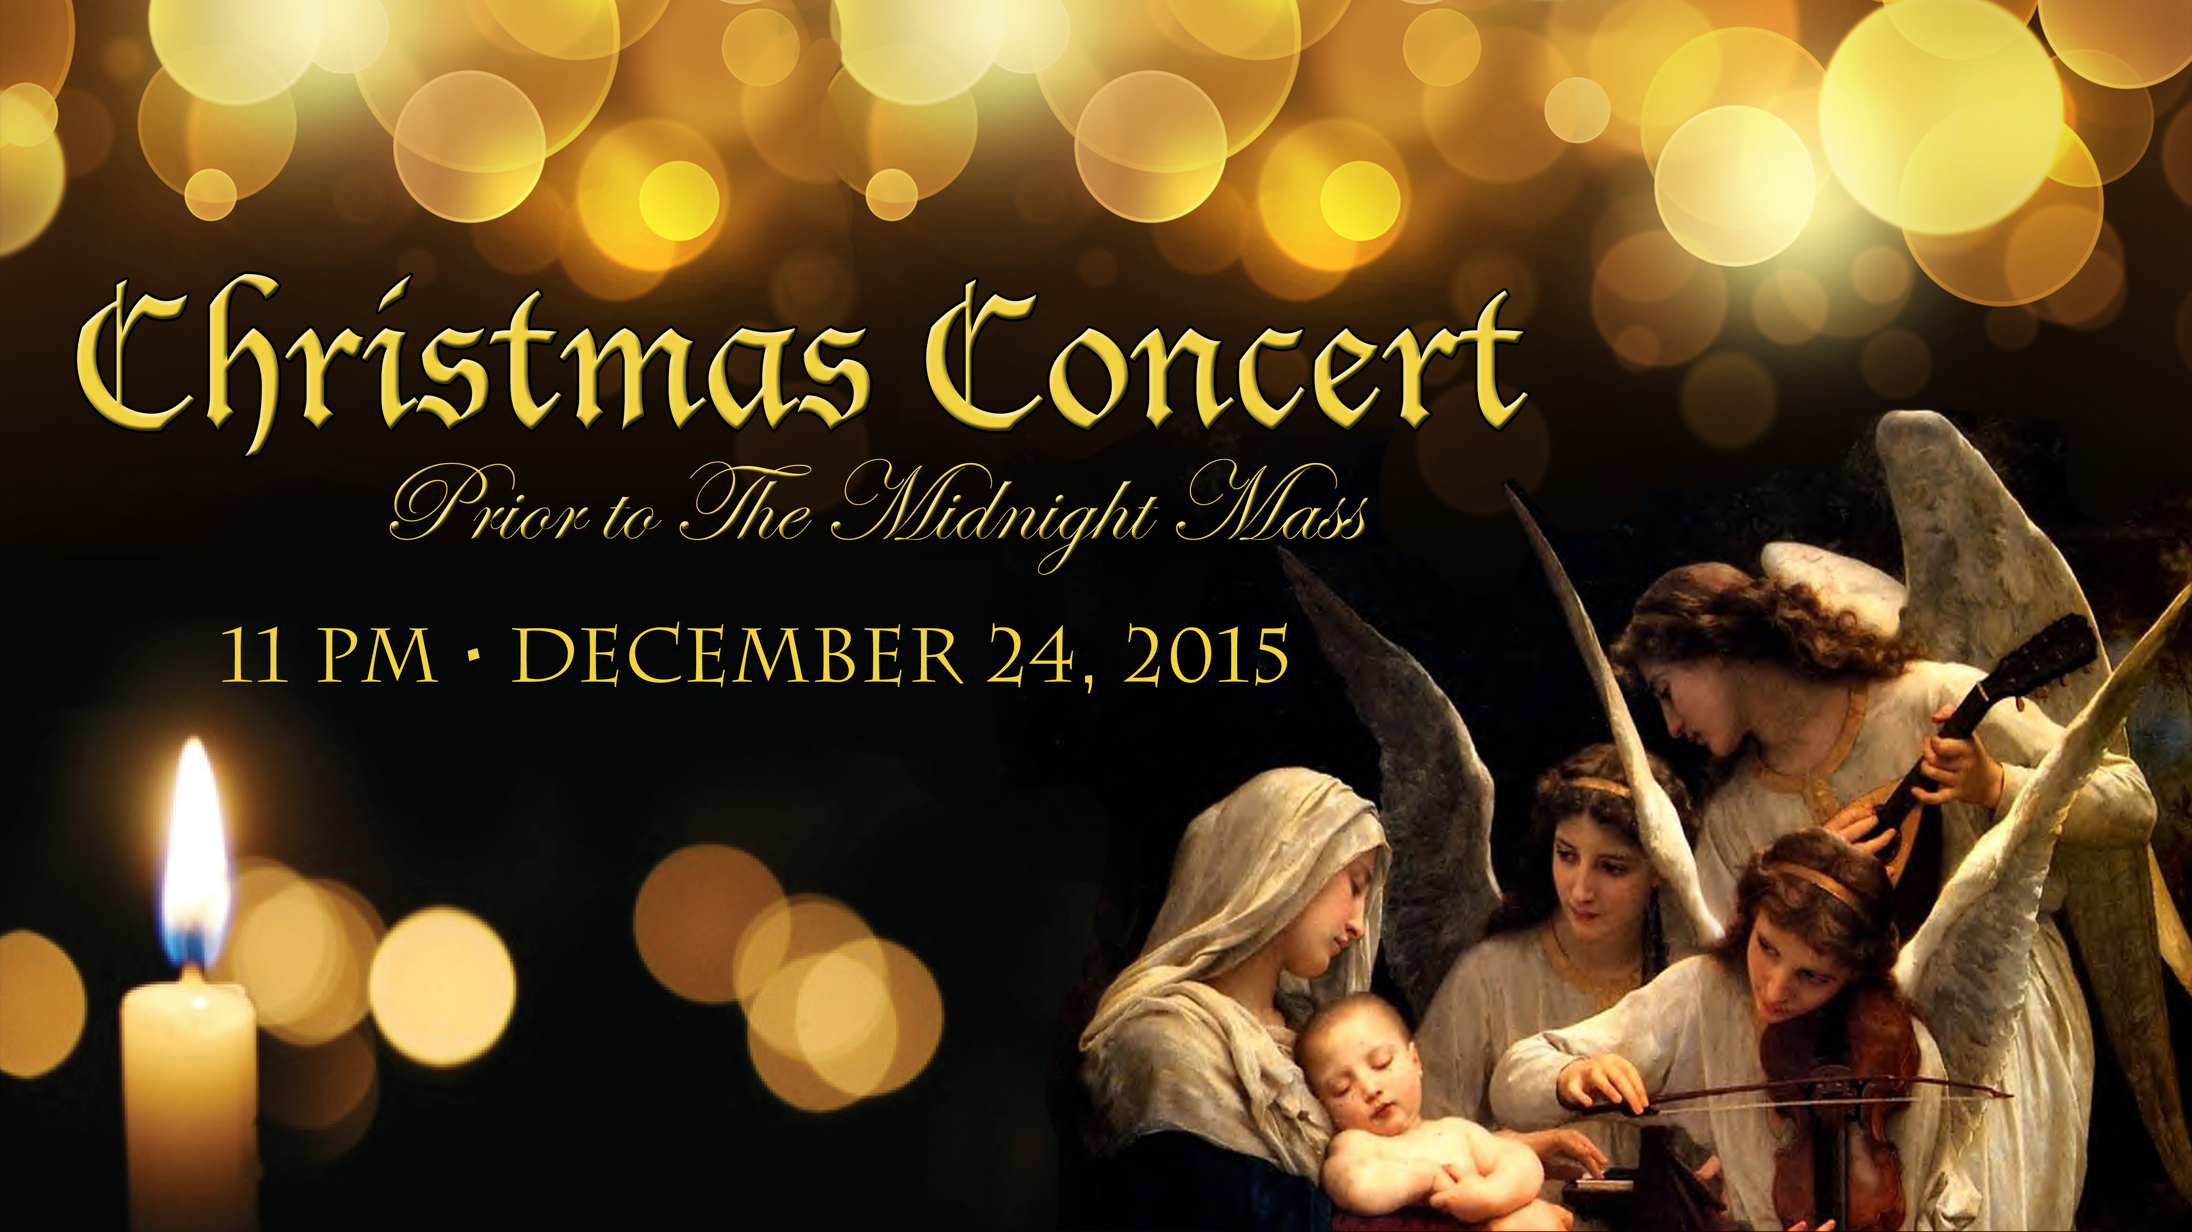

Third Annual Christmas Bazaar
November 20, 21 and 22
Attention: There will be a work day on Saturday, October 10 at 10 a.m. in Gillespie Hall! We need your ideas! It will take all of us participating to make our Bazaar a success!!!

Eggrolls by Agnes, order now.
She will only make 20 dozen.
They are $40 per dozen.
Pick up will be Friday, October 16.
Place order and pay at the office.

Order Tamales by Carmen
at $25.00 per dozen.
Order and pay at the office.
Pick up will be
Saturday, Nov 14.

The profit will equally be divided between three Parishes: Walters, Duncan and Marlow for the purpose of the building fund. We need your time, talent and treasure to make this event successful.

You can have a Mass said for someone's intentions at their birthday, wedding, baptism, or in memory of your deceased loved ones. Contact he office for days and times that you wish to have the Mass celebrated. What a precious gift!

CHOIR NEWS: Christmas Practice

December 20, Sunday @ 11 AM
December 20, Sunday @ 6 PM with choir and orchestra
December 23, Wednesday @ 7 PM

December 24, Thursday:
3 PM – Children's/Youth Mass warm-up
4 PM – Children's/Youth Mass--Please come sing if you can, to encourage our children!
10 PM – Rehearsal with choir and orchestra
11 PM – Concert begins
Midnight Mass

Everyone is invited to come help decorate the Church for Christmas on
Monday, December 21 at 6 p.m.

Great News!!!
Come and join us every week day for Adoration of the Blessed Sacrament at 11:30 a.m. The Divine Mercy Chaplet and Rosary will begin at 11:40 a.m. followed by our daily Mass at 12:10 p.m. Les invitamos todos los días a la adoración del Santísimo a las 11:30 a.m. antes de nuestra misa diaria 12:10p.m.

Duncan Altar Society
Christmas Bake Sale
Saturday and Sunday,
December 19-20
after all weekend Masses

Bring your items for sale and
plan to purchase wonderful baked
goods for Christmas.
Thank you all!

!!!Religious Education News!!!
1st-7th Grades, Wednesdays, 6:00-7:30 p.m.
8th-12th Grades,
Sundays,11:00 a.m. - 12:30 p.m.
No Classes:
Sunday, Dec 20 & Dec 27, Jan 3
Wednesday Dec 23 & Dec 30, Jan 6


CHRISTMAS DONATIONS
There are Envelopes in the pews for donations for our Christmas flowers, decorations, and music.
Thank you for your generosity.

donaciones para de navidad
Hay Sobres en las bancas para donaciones para las Flores y Decoraciones de Navidad.
Gracias por su generosidad.

Please Note: You can always donate via automatic withdrawal directly to our church's account. It is easy, simple and at the end of the fiscal year you will receive a tax letter acknowledging your donations. For more information stop by the office after each Mass. Thank you for your support.

ATTENTION:
The Knights of Columbus will lead the Rosary on the last Sunday of every month. The Rosary will be in the Chapel starting at 9:30 a.m. before the 10 a.m. Mass. We would dedicate the Rosary to the deceased members of the K of C of our Parish.
Abuse of Minors Response Hotline 405-720-987 or DHS at 1-800-522-3511. Telefóno Pastoral para Reportar Abuso de Menores 405-720-9878 o el Departamento de Servicios Humanos 1-800-522-3511.

Saint Patrick Catholic Church
THIRD AND OHIO POST OFFICE BOX 151
Walters, Oklahoma 73572
************************************
Collections:
Dec 13: Operating: $413.69 Bldg: $250.00

DUNCAN COLLECTIONs FOR Nov Dec 12-13:
Duncan: $2,429.65
Weekly Electronic Donations: $1,100.00
Food Bank: $633.00
Scholarship: $15.00
Ryan: $141.00
Thank you for your generosity!!!

