
Second Sunday of Advent
December 6, 2015

Mass Intentions / Peticiones de Misa

The Immaculate Conception of the Blessed Virgin Mary,
Tuesday, December 8,
is a Holy Day of Obligation.
We invite you
to come to
12:10 p.m. Mass in Duncan
or 7:00 p.m. Mass in Marlow.
Sat | Dec 5 | 4:00p D | (+)Jack Boxell by The Family
 |  | 6:00p R | 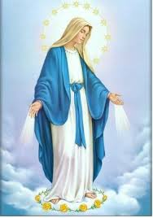For Parishioners
Sun | Dec 6 | 8:00a M | For the Parishioners
 |  | 10:00a D | (+)Pedro Martinez by Alicia
 |  | 12:00p W
 |  | 2:00p D | (+)Angel Chacin by Acosta and Medina Family
Mon | Dec 7 | 12:10p D | (+)Jack Geurkink
Tues | Dec 8 | 12:10p D | (+)Jack Geurkink
 |  | 7:00p M
Wed | Dec 9 | 12:10p D | (+)Pedro Martinez by Alicia | Christmas Mass Schedule  Thursday, December 24  4 p.m. Duncan  4 p.m. Marlow  6 p.m. Ryan  6 p.m. Walters  Midnight Mass in Duncan  Friday, December 25  10 a.m. Duncan
Thur | Dec 10 | 12:10p D | Int of Howard Doerr by The Wolfgang-Deeg Family
Fri | Dec 11 | 12:10p D | Happy Birthday and special blessings for Anna Fitts
Sat | Dec 12 | 4:00p D
 |  | 6:00p R | Int of Rosorio
 |  | 7:00p D | Guadalupe Mass
Sun | Dec 13 | 8:00a M
 |  | 10:00a D | (+)Joseph Phan &  The Pham Family
 |  | 12:00p W | For Parishioners
 |  | 2:00p D | NO MASS | New Year's  Mass Schedule  Thursday, December 31,  New Year's Eve  4 p.m. Marlow  4 p.m. Ryan  6 p.m. Walters  Friday, Jan 1, New Year's Day  10 a.m. Duncan  You can have a Mass said for someone's intentions at their birthday, wedding, baptism, or in memory of your deceased loved ones. Contact the office for days and times that you wish to have  the Mass celebrated.  What a precious gift!
Great News!!!
Come and join us every week day for Adoration of the Blessed Sacrament at 11:30 a.m. The Divine Mercy Chaplet and Rosary will begin at 11:40 a.m. followed by our daily Mass at 12:10 p.m.
Les invitamos todos los días a la adoración del Santísimo a las 11:30 a.m. antes de nuestra misa diaria 12:10p.m.



Assumption Parish and its Missions: Marlow, Walters & Ryan
are invited to a Holiday Youth Dinner
Wednesday, December 16

The Duncan Religious Education Youth present,
"The Nativity" at Assumption Church at 6:15 p.m.

After the play the youth and their families
are invited for a holiday dinner
sponsored by the Knights of Columbus
in the Religious Education Building.
A very special guest has been invited.
Third Annual Christmas Bazaar
November 20, 21 and 22
Attention: There will be a work day on Saturday, October 10 at 10 a.m. in Gillespie Hall! We need your ideas! It will take all of us participating to make our Bazaar a success!!!

Eggrolls by Agnes, order now.
She will only make 20 dozen.
They are $40 per dozen.
Pick up will be Friday, October 16.
Place order and pay at the office.

Order Tamales by Carmen
at $25.00 per dozen.
Order and pay at the office.
Pick up will be
Saturday, Nov 14.

The profit will equally be divided between three Parishes: Walters, Duncan and Marlow for the purpose of the building fund. We need your time, talent and treasure to make this event successful.


You can have a Mass said for someone's intentions at their birthday, wedding, baptism, or in memory of your deceased loved ones. Contact he office for days and times that you wish to have the Mass celebrated. What a precious gift!

Abuse of Minors Response Hotline 405-720-987 or DHS at 1-800-522-3511. Telefóno Pastoral para Reportar Abuso de Menores 405-720-9878 o el Departamento de Servicios Humanos 1-800-522-3511.

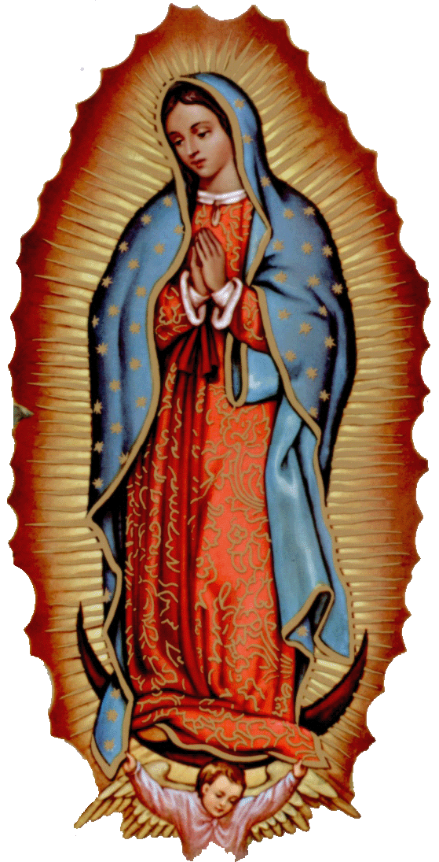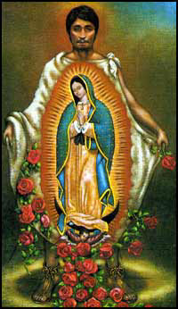
la fiesta de
La VIRGEN DE GUADALUPE

Todos están invitados a la celebración anual
de la Virgen de Guadalupe!

El Sabado, 12 de diciembre
6:00 pm ---------------------- El Rosario
7:00pm ---------------------- La Misa
Después de Misa ----------- La Cena
Después de Cena ----------- Matachines
Bailables

Les avisamos que la misa de 2 p.m.,
el Domingo esta cancelada.

Our lady of Guadalupe celebration

Everyone is invited to the annual celebration
of the Virgin of Guadalupe!

Saturday, December 12
6:00 pm ------------------------ Rosary
7:00pm ------------------------ Mass
After Mass -------------------- Dinner
After Dinner ------------------ Matachines
Folkloric Dances

Please be advised that 2p.m. Mass
on Sunday is cancelled.

DUNCAN COLLECTIONs FOR Nov 28-29:
Duncan: $2,715.79
Weekly Electronic Donations: $1,100.00
Food Bank: $859.25
Human Development: $10.00
Building Fund: $60.00
Thank you for your generosity!!!

Saint Patrick Catholic Church
THIRD AND OHIO POST OFFICE BOX 151
Walters, Oklahoma 73572
************************************
Collections:
Nov 29: Operating: $577.25 Bldg: $125.00

Catholic Food Bank News:
Beginning with this Sunday until December 8 the Feast of Immaculate Conception we will be taking a second collection for our Food Bank. We hope to give extra food to those who are in need during this holiday season. May God Bless you for your generosity.
Duncan Altar Society
Christmas Bake Sale
Saturday and Sunday,
December 19-20
after all weekend Masses

Bring your items for sale and
plan to purchase wonderful baked
goods for Christmas.
Thank you all!

Please Note: You can always donate via automatic withdrawal directly to our church's account. It is easy, simple and at the end of the fiscal year you will receive a tax letter acknowledging your donations. For more information stop by the office after each Mass. Thank you for your support.

ATTENTION: The Knights of Columbus will lead the Rosary on the last Sunday of every month. The Rosary will be in the Chapel starting at 9:30 a.m. before the 10 a.m. Mass. We would dedicate the Rosary to the deceased members of the K of C of our Parish.
CHOIR NEWS:
Join the Choir at our Church!
Christmas & Handbell rehearsals' schedule – Every Sunday at 11 AM (except the weekend after Thanksgiving) until Christmas & December 24:
December 6, 13, 20, 24

!!!Religious Education News!!!
1st-7th Grades, Wednesdays, 6:00-7:30 p.m.
8th-12th Grades,
Sundays,11:00 a.m. - 12:30 p.m.
No Classes:
Sunday, Dec 20 & Dec 27, Jan 3
Wednesday Dec 23 & Dec 30, Jan 6

