Our Lord Jesus Christ, King of the Universe
November 22, 2015

Mass Intentions / Peticiones de Misa

Sat | Nov 21 | 4:00p D | (+)Rosalba, Rosio, Noeli Vargez  Christmas Mass Schedule  Thursday, December 24  4 p.m. Duncan  4 p.m. Marlow  6 p.m. Ryan  6 p.m. Walters  Midnight Mass in Duncan  Friday, December 25  10 a.m. Duncan
 |  | 6:00p R | For Parishioners
Sun | Nov 22 | 8:00a M | (+)Mr. & Mrs. George Rath  By The Couvillion Family
 |  | 10:00a D | (+)Joseph Phan and The Intentions of the Pham Family
 |  | 12:00p W
 |  | 2:00p D | (+)Juan Chacom by  The Acosta-Medina Family
Mon | Nov 23 | 12:10p D | Intentions of Irene Green  by Tom & Edie Stone
Tues | Nov 24 | 12:10p D | (+)George E. Coughlin
Wed | Nov 25 | 12:10p D | (+)Glen A. Neal | New Year's  Mass Schedule  Thursday, December 31,  New Year's Eve  4 p.m. Marlow  4 p.m. Ryan  6 p.m. Walters  Friday, Jan 1, New Year's Day  10 a.m. Duncan
Thur | Nov 26 | 12:10p D | (+)Virginia R. Neal
Fri | Nov 27 | 12:10p D | (+)Clarence & Ida Neal
Sat | Nov 28 | 4:00p D | (+)George E. Coughlin
 |  | 6:00p R
Sun | Nov 29 | 8:00a M | (+) Mr. & Mrs Peter Couvillion by The Couvillion Family
 |  | 10:00a D | (+)Joseph Phan & the Intentions of the Pham Family
 |  | 12:00p W | For Parishioners
 |  | 2:00p D | (+)Anna Mae Jones by  Maria Jones & Lee Jones | You can have a Mass said for someone's intentions at their birthday, wedding, baptism, or in memory of your deceased loved ones. Contact the office for days and times that you wish to have  the Mass celebrated.  What a precious gift!

Great News!!!
Come and join us every week day for Adoration of the Blessed Sacrament at 11:30 a.m. The Divine Mercy Chaplet and Rosary will begin at 11:40 a.m. followed by our daily Mass at 12:10 p.m.
Les invitamos todos los días a la adoración del Santísimo a las 11:30 a.m. antes de nuestra misa diaria 12:10p.m.

Platicas del Sacramento de Bautizmo
en Español
del año 2015 Serań en:
Noviembre 21,
Son a la 7 p.m. en La capilla.
Para mas informacioń
llame a la oficina
580-255-0590 ex 11,
o Carmen Garcia 580-255-6337 Gracias

Third Annual Christmas Bazaar
November 20, 21 and 22
Attention: There will be a work day on Saturday, October 10 at 10 a.m. in Gillespie Hall! We need your ideas! It will take all of us participating to make our Bazaar a success!!!

Eggrolls by Agnes, order now.
She will only make 20 dozen.
They are $40 per dozen.
Pick up will be Friday, October 16.
Place order and pay at the office.

Order Tamales by Carmen
at $25.00 per dozen.
Order and pay at the office.
Pick up will be
Saturday, Nov 14.

The profit will equally be divided between three Parishes: Walters, Duncan and Marlow for the purpose of the building fund. We need your time, talent and treasure to make this event successful.

ATTENTION: The Knights of Columbus will lead the Rosary on the last Sunday of every month starting with this month on November 29. The Rosary will be in the Chapel starting at 9:30 a.m. before the 10 a.m. Mass. We would dedicate the Rosary to the deceased members of the K of C of our Parish.
The Immaculate Conception of the Blessed Virgin Mary, Tuesday, December 8, is a Holy Day of Obligation. We invite you to come to 12:10 p.m. Mass in Duncan or 7:00 p.m. Mass in Marlow.
You can have a Mass said for someone's intentions at their birthday, wedding, baptism, or in memory of your deceased loved ones. Contact he office for days and times that you wish to have the Mass celebrated. What a precious gift!

Abuse of Minors Response Hotline 405-720-987 or DHS at 1-800-522-3511. Telefóno Pastoral para Reportar Abuso de Menores 405-720-9878 o el Departamento de Servicios Humanos 1-800-522-3511.

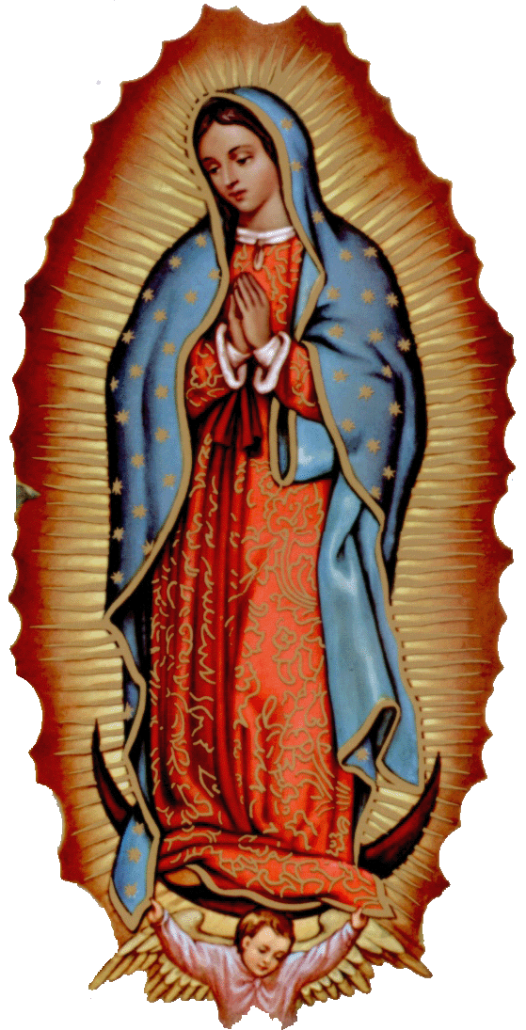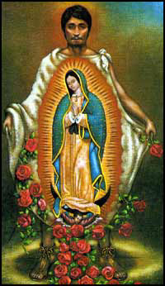
Our lady of Guadalupe celebration

Everyone is invited to the annual celebration
of the Virgin of Guadalupe!

Saturday, December 12
6:00 pm ------------------------ Rosary
7:00pm ------------------------ Mass
After Mass -------------------- Dinner
After Dinner ------------------ Matachines
Folkloric Dances

Please be advised that 2p.m. Mass
on Sunday is cancelled.
la fiesta de
La VIRGEN DE GUADALUPE

Todos están invitados a la celebración anual
de la Virgen de Guadalupe!

El Sabado, 12 de diciembre
6:00 pm ---------------------- El Rosario
7:00pm ---------------------- La Misa
Después de Misa ----------- La Cena
Después de Cena ----------- Matachines
Bailables

Les avisamos que la misa de 2 p.m.,
el Domingo esta cancelada.

The heat and air conditioning system at our Catholic Food Bank is thirty years old. Therefore, we have inquired and obtained an estimate to replace it. The total cost of labor and parts is $5,900.00. The Altar Society has given $1,000.00 and Hispanic Charismatic Group gave $300.00 towards this Project. As you can see we are still in need of $3,600.00 to complete this task. Thank you.
Please Note: You can always donate via automatic withdrawal directly to our church's account. It is easy, simple and at the end of the fiscal year you will receive a tax letter acknowledging your donations. For more information stop by the office after each Mass.
Thank you for your support.

CHOIR NEWS:
Join the Choir at our Church!
Christmas & Handbell rehearsals' schedule – Every Sunday at 11 AM (except the weekend after Thanksgiving) until Christmas & December 24:
November 22
December 6, 13, 20, 24

Catholic Food Bank News:
Beginning with this Sunday until December 8 the Feast of Immaculate Conception we will be taking a second collection for our Food Bank. We hope to give extra food to those who are in need during this holiday season. May God Bless you for your generosity.
!!!Religious Education News!!!
1st-7th Grades, Wednesdays, 6:00-7:30 p.m.
8th-12th Grades,
Sundays,11:00 a.m. - 12:30 p.m.

Attention No Class: Sunday, Nov 22 & 29
Wednesday, Nov 25

DUNCAN COLLECTIONs FOR Nov 14 & 15:
Duncan: $1,841.41
Weekly Electronic Donations: $1,100.00
Food Bank: $620.00
Food Bank Air Condition Project: $1,000.00
Building: $5.00
Ryan: $189.00
Thank you for your generosity!!!

Catholic Young Adults of Oklahoma City
Join us for faith, fellowship and fun in OKC! Open to all young adults (ages 18-39, married or single) in the archdiocese. Visit our Facebook page (Catholic Young Adults of OKC) for events and information or e-mail info@catholicyoungadultsokc.com.

Saint Patrick Catholic Church
THIRD AND OHIO POST OFFICE BOX 151
Walters, Oklahoma 73572
************************************
Collections:
November 15: Operating: $ Bldg: $

