8
Twenty-seventh Sunday in Ordinary Time
October 4, 2015

!!!Religious Education News!!!
1st-7th Grades, Wednesdays, 6:00-7:30 p.m.
8th-12th Grades,
Sundays,11:00 a.m. - 12:30 p.m.

Please Notice:
No Class: Wednesday, Oct 14
or Sunday, Oct 18 (Fall Break)

Teacher's Meeting: Sunday, Oct 25, 11 a.m.

Mass Intentions / Peticiones de Misa

Sat | Oct 3 | 4:00p D | Frances Medina 80th Birthday  By The Gutierrez Family
 |  | 6:00p R | (+) Kristina
Sun | Oct 4 | 8:00a M | Special Intention of  Chris Pittman
 |  | 10:00a D | (+)Carol Hufnagel by Jim
 |  | 12:00p W | (+)Kristina
 |  | 2:00p D | (+) Crencio Medrano by  Alicia Martinez
Mon | Oct 5 | 12:10p D | (+) Kristina and  (+)Jesus Rocha by Maria Jones  Third Annual Christmas Bazaar  November 20, 21 and 22  Attention: There will be a work day on Saturday, October 10 at 10 a.m. in Gillespie Hall! We need your ideas! It will take all of us participating to make our Bazaar a success!!!  Eggrolls by Agnes, order now.  She will only make 20 dozen.  They are $40 per dozen.  Pick up will be Friday, October 16.  Place order and pay at the office.  Order Tamales by Carmen  at $25.00 per dozen.  Order and pay at the office.  Pick up will be  Saturday, Nov 14.  The profit will equally be divided between three Parishes: Walters, Duncan and Marlow for the purpose of the building fund. We need your time, talent and treasure to make this event successful.
Tues | Oct 6 | 12:10p D | (+) Kristina and  (+) Jack Geurkink by  Ann Geurkink
Wed | Oct 7 | 12:10p D | (+) Kristina
Thur | Oct 8 | 12:10p D | (+)Kristina
Fri | Oct 9 | 12:10p D | (+) Kristina
Sat | Oct 10 | 4:00p D | (+)Carol Hufnagel by Jim
 |  | 6:00p R | (+)Kristina
Sun | Oct 11 | 8:00a M | (+)Bill McCoy by  Mr. & Mrs. Reginald Lasater
 |  | 10:00a D | Int of Howard Doerr by The Wolfgang-Deeg Family
 |  | 12:00p W | (+)Kristina
 |  | 2:00p D | (+)Don Trostle & Jake Seratte by The Family | 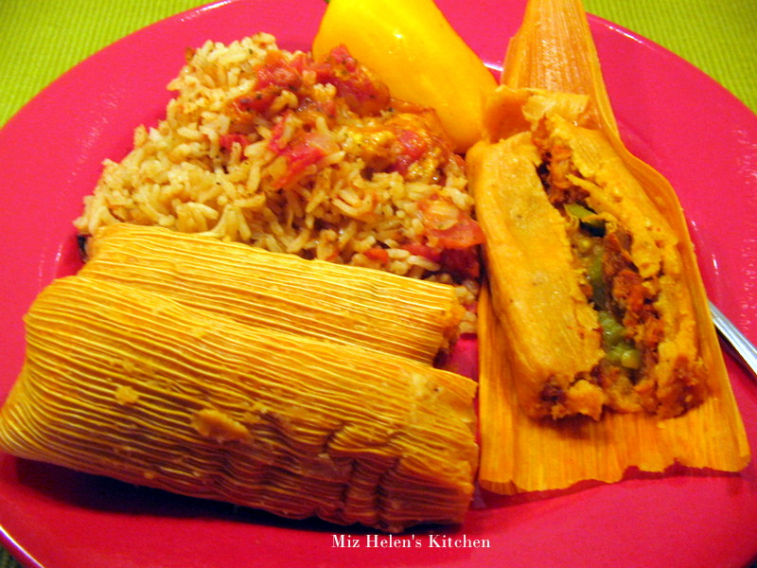  You can have a Mass said for someone's intentions at their birthday, wedding, baptism, or in memory of your deceased loved ones. Contact the office for days and times that you wish to have  the Mass celebrated.  What a precious gift!
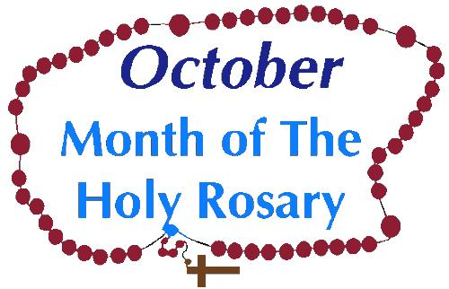

The Month of October is dedicated to Our Lady of the Rosary. Therefore, we would like to invite you every Wednesday at
7 p.m. for Adoration of the Blessed Sacrament and Rosary in our Chapel.

Christmas Bazaar Raffle
1st Prize $1,000 Visa Card,
2nd Prize $500 Visa Card
3rd Prize $250 Visa Card

One raffle ticket $5.00 or
5 tickets for $20.00
The drawing will be held on
Sunday, Nov 22 at 5 p.m.

You don't have to be present to win!
Good Luck!!!



T-Shirts for sale after all Masses
to benefit our Christmas Bazaar.
The prices are: Onesies: $20.00,
Youth: $25.00, Adult: S/M/L $28.00,
XL/XXL/XXXL: $30.00.
We are taking orders if we don't have your size. Payment is expected at the time of the order.

You can have a Mass said for someone's intentions at their birthday, wedding, baptism, or in memory of your deceased loved ones. Contact he office for days and times that you wish to have the Mass celebrated. What a precious gift!

Te invitamos al grupo de oracion
todas los martes a las 7 p.m.

Abuse of Minors Response Hotline 405-720-987 or DHS at 1-800-522-3511. Telefóno Pastoral para Reportar Abuso de Menores 405-720-9878 o el Departamento de Servicios Humanos 1-800-522-3511.


Beginning Experience
There is help for the heartache of separation, divorce and widowhood at a Beginning Experience Weekend. Trained team members who have suffered the loss of a loved one share their experience as they lead participants through presentations, private reflections and small group sharing. The next Beginning Experience Weekend will be Oct. 23-25 at the Catholic Pastoral Center. To register, contact the Office of Family Life at (405) 721-8944. To download the registration form, go online to www.archokc.org/office-of-family-life/home.

CHOIR NEWS:
Join the Choir at our Church!

Adult Choir Practice:
Saturdays at 2:45 p.m.,
Sundays at 8:45 a.m.

Bell Choir Practice:
Saturdays from 5:00-5:45 p.m.

Spanish Choir Practice:
Sundays at 1:00 p.m.

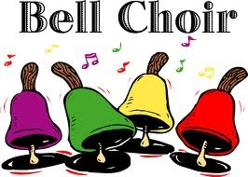



Red Mass
On Oct. 31, a Red Mass will be celebrated at the regularly scheduled 5 p.m. Mass at the Cathedral of Our Lady of Perpetual Help, OKC. Archbishop Coakley will be the principal celebrant. The Most Rev. Anthony Taylor, bishop of Little Rock, will deliver the homily. Reception following. A Red Mass is dedicated to seeking guidance from the Holy Spirit for all who seek justice, and offers the opportunity to reflect on what Catholics believe is the responsibility of all in the legal profession. The Red Mass takes its name from the red vestments worn at the Mass, symbolic of the tongues of fire that descended on the Apostles at Pentecost.
Aparten la fecha
El 31 de octobre se celebrara una Misa Roja en el horario regular de la Misa de las 5 p.m. en la Catedral de Nuestra Señora del Perpetuo Socorro, de Oklahoma City. El Arzobispo Coakley estará presidiendo la celebración. El Reverendísimo Anthony Taylor, Obispo de Little Rock, estará dando la homilía. Habrá una recepción después en el Centro Connor. En los Estados Unidos, una Misa Roja para jueces, abogados y funcionarios del gobierno es tradicionalmente celebrada coincidiendo con la celebración de la Corte Suprema de Estados Unidos en el primer lunes de octubre. (La Misa Roja toma su nombre de los ornamentos rojos utilizados ​​en la Misa, símbolo de la s lenguas de fuego que descendieron sobre los Apóstoles en Pentecostés.) La Misa estará dedicada a la búsqueda de la guía del Espíritu Santo para todos aquellos que buscan la justicia y ofrece la oportunidad de reflexionar sobre lo que los Católicos creen que es la responsabilidad de todos en la profesión legal.

Website Sponsorships Available
In the weeks ahead, our parish representative from Solutio, Inc., will be setting up the advertising for our website for the year. Please consider participating in this effort since the revenue from the ads is what makes the website possible at no cost to the parish. It’s a great way to get your name in front of the families in the parish. Advertisements may be purchased for a business, family memorial, or you can sponsor an ad supporting Catholic Charities, Knights of Columbus, Vocations, etc. Please give these ideas some thought. We need and appreciate your help! If you are interested or just curious as to prices and want more information, please contact 580.713.0264 or Sponsorship@SolutioSoftware.com.

Plan ahead for the Anniversary Mass
Archbishop Coakley invites married couples who are celebrating milestone anniversaries (25, 40, 50+) in the calendar year 2015 to attend a special Anniversary Mass on Sunday, Nov. 8, at 3 p.m., at The Cathedral of Our Lady of Perpetual Help, 3214 N. Lake Ave., OKC. Reception following. Contact the Office of Family Life at (405) 721-8944. The archbishop will impart his blessing and the local Catholic community will rejoice in your example and commitment to the Sacrament of Marriage.

Misa celebrando los Aniversarios
El Arzobispo Coakley invita a las parejas casadas que estén celebrando su aniversario especial (25, 40, 50+) el presente año 2015 para que asistan a una Misa Especial de Aniversario el domingo 8 de noviembre, a las 3 p.m. en la Catedral de Nuestra Señora del Perpetuo Socorro, 3214 N. Lake Ave., OKC. Después de la Misa habrá una recepción. Contacte a la Oficina de Vida Familiar al (405) 721-8944. El Arzobispo le dará su bendición y la comunidad local se alegrará en su ejemplo y compromiso al Sacramento de Matrimonio.

Saint Patrick Catholic Church
THIRD AND OHIO POST OFFICE BOX 151
Walters, Oklahoma 73572
************************************
Collections:
September 20: Operating: $316.25, Bldg: $250.00
September 27: Operating: $520.27, Bldg: $145.00

DUNCAN COLLECTIONs FOR September 26-27:
Duncan: $3,043.65
Weekly Electronic Donations: $1,400.00
Food Bank: $18.00

Ryan: $113.00
Thank you for your generosity!!!

Please Note: You can always donate via automatic withdrawal directly to our church's account. It is easy, simple and at the end of the fiscal year you will receive a tax letter acknowledging your donations. For more information stop by the office after each Mass. Thank you for your support.

Catholic Young Adults of Oklahoma City
Join us for faith, fellowship and fun in OKC! Open to all young adults (ages 18-39, married or single) in the archdiocese. Visit our Facebook page (Catholic Young Adults of OKC) for events and information or e-mail info@catholicyoungadultsokc.com.

