Eleventh Sunday in Ordinary Time
June 16, 2013

Mass Intentions / Peticiones de Misa

We wish to extend a warm welcome to
Fr. Balaraju Pudota, our new Associate Pastor.

Sat | Jun 15 | 4:00p D | (+)James Beavers by The Family
 |  | 6:00p R | For the Parishioners
Sun | Jun 16 | 8:00a M | Intentions of Joe Lockovich by Phil & Louise Adams  We would like to invite everyone to attend a Good-bye Party for Fr. Joseph on Sunday, June 30 at 5 p.m. in Gillespie Hall. The Knights of Columbus are providing hamburgers and hot dogs. We will have a money tree for Fr. Joseph.
 |  | 10:00a D | (+)Terry Martin by Don & Carmie Ferland
 |  | 12:00p W
 |  | 2:00p D | (+)Fr. Roberto Quant by Marie & Lee Jones | We would like to invite everyone to attend a Good-bye Party for Fr. Joseph on Sunday, June 30 at 5 p.m. in Gillespie Hall. The Knights of Columbus are providing hamburgers and hot dogs. We will have a money tree for Fr. Joseph.  We would like to invite everyone to attend a Good-bye Party for Fr. Joseph on Sunday, June 30 at 5 p.m. in Gillespie Hall. The Knights of Columbus are providing hamburgers and hot dogs. We will have a money tree for Fr. Joseph.
Mon | Jun 17 | 12:10p D | (+)James Beavers by The Family
Tues | Jun 18 | 12:10p D | (+)Janelle Brant by Don & Carmie Ferland  Attention all Volunteers:  If you are a volunteer in the Church (Ushers, Eucharistic Ministers, Choir Members, etc.) please come by the office and get a Safe Environment Application. We must have a completed application for all those who volunteer in the Church.
Wed | Jun 19 | 12:10p D | Intentions of Ruth J. Coughlin for Blessings and Good Health
Thur | Jun 20 | 12:10p D | (+)Jesse Moore
Fri | Jun 21 | 12:10p D | (+)Jesse Moore
Sat | Jun 22 | 4:00p D | (+)Jesse Moore and  (+)Barbara McCartney
 |  | 6:00p R | Intentions of Bill McCoy and  (+)Barbara McCartney  Did you know?  You can have a Mass said in memory of a loved one. What a wonderful gift! A Gregorian Mass is a set of thirty Masses said for the repose of the soul of a deceased love one. Stop by the office to reserve your date(s).
Sun | Jun 23 | 8:00a M | For the Parishioners
 |  | 10:00a D | (+)Jesse Moore
 |  | 12:00p W
 |  | 2:00p D | (+)Florencio Cadena by The Family
Volunteers Needed
for St. Vincent de Paul on Tuesdays 1:30-3:30 p.m. Please contact Lee Jones if you are interested! God bless you.
Please remember the Divine Mercy Chaplet and Rosary are said daily at
11:45 a.m. before the 12:10 Mass.
Come spend time with Jesus!

New Floor Fund Project
Thank you for your generosity. We have collected $60,000
$44,000 and still need $16,000 to meet our goal.
We are taking a second collection every Sunday
for this Project. Should you wish to use an envelope,
please use the envelopes found in the pews. $44,000
Thank you for your generosity. May God Bless You. Fr. Peter
Proyecto del nuevo piso de la iglesia
Damos gracias a las personas que estaban
trabajandopara el proyecto del nuevo piso $20,000
en nuestra iglesia. Todavía necesitamos colectar
$16,000 para este objetivo. Todos los Domingos $15,000
vamos hacer la segunda colecta para este Proyecto.
Muchas Gracias a Todos. $13,000

405-720-9878 Abuse of Minors Pastoral Response Hotline 405-720-9878
You may also contact Oklahoma Department of Human Services at 1-800-522-3511.
405-720-9878 Línea Telefónica Pastoral para Reportar Abuso de Menores 405-720-9878
También puede comunicarse con el Departamento de Servicios Humanos al 1-800-522-3511.

Altar Society News:
Gift Shop and Book Store!
Many Religious Articles for sale: rosaries, prayer cards, books, tote bags, medals, etc!
Many Divine Mercy and
Blessed John Paul II items! Many gift items!
Please support your Altar Society!

Year of Faith Pilgrimage Sites
Did you know. . .
The sites of interest stop at the
Assumption of the Blessed Virgin Mary
Parish in Duncan?

When: The pilgrimage sites are open from 9:30 a.m. to noon and 1:00-3:00 p.m. weekdays June 17 through August 16. The sites will also be open on three Sundays - June 23, July 21 and August 18 from 11:00 a.m. to 4:00 p.m.

Why: To personally encounter Christ in the sacred spaces of the Archdiocese of Oklahoma City and to learn the history of the Church in central and western Oklahoma.
Please see the Sooner Catholic dated June 2,
back page for more information!

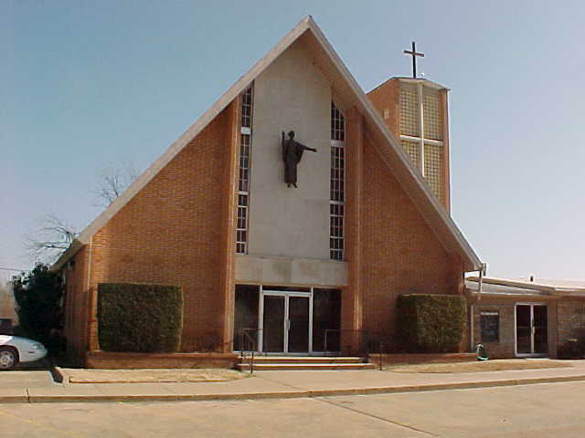
Website Sponsorships Available!
- In the weeks ahead, our parish representative from Solutio, Inc., will be setting up the advertising for our website for the year.
- Please consider participating in this effort since the revenue from the ads is what makes the website possible at no cost to the parish.
- It’s a great way to get your name in front of the families in the parish. Advertisements may be purchased for a business, family memorial, or you can sponsor an ad supporting Catholic Charities, Knights of Columbus, Vocations, etc.
- Please give these ideas some thought. We need and appreciate your help! If you are interested or just curious as to prices and want more information, please contact 580.713.0264 or Sponsorship@SolutioSoftware.com.

Catholic Charities of Lawton will offer case management and counseling services at our Church twice a month. The counselors will be here on Thursdays, June 27, July 11 and 25 and August 8 and 22. In order to take advantage of their service you must make an appointment by calling the following number 580-353-1811.

We're looking for monthly sponsors
for our billboard
on Highways 81 & 7!
The cost is $285.00 per month.
Call the office if you're interested!
Thank you to the following sponsors:
June: Frank & Valentina Acosta
July: Jim & Agnes Surjaatmadja
August: Don & Bette Creel
September: Don & Carmie Ferland
October: In Memory of Jo Ann McCoy
November: Hispanic Cursillo Movement

It's here! Our web page get all the news at www.AssumptionDuncanOK.com

Please remember you can support
your Church with automatic donations!
Sign up today to automatically donate
your Sunday offering.
In order for us to process your automatic donation, we will need from you: voided check and a signed authorization form.
Please come to the office after one of our weekend Masses or during the week.

DUNCAN COLLECTIONs FOR
june 2:
Duncan: $2,264.81
Disaster Relief: $250.00
Building Fund: $611.50
Weekly Direct Deposit Donations: $1,100.00
Ryan $117.00

Saint Patrick Catholic Church
THIRD AND OHIO POST OFFICE BOX 151
Walters, Oklahoma 73572
**************************************
Collections:
June 2: Operating: $314.00
Building: $250.00

Please remember your Parish in your will.

