8
Twenty-Fourth Sunday in Ordinary Time
September 13, 2015

!!!Religious Education News!!!
1st-7th Grades, Wednesdays, 6:00-7:30 p.m.
8th-12th Grades,
Sundays,11:00 a.m. - 12:30 p.m.

Enrollment will be held the this weekend
after all Masses

R.E. Classes will resume
Sunday, September 20 and
Wednesday September 23!

Mass Intentions / Peticiones de Misa

Sat | Sep 12 | 4:00p D | (+)Kristina
 |  | 6:00p R | For the Parishioners
Sun | Sep 13 | 8:00a M
 |  | 10:00a D | (+) Bill McCoy
 |  | 12:00p W | (+) Kristina
 |  | 2:00p D
Mon | Sep 14 | 12:10p D | (+)Don Trostle and Jake Seratte by The Family  (+)Kristina
Tues | Sep 15 | 12:10p D | 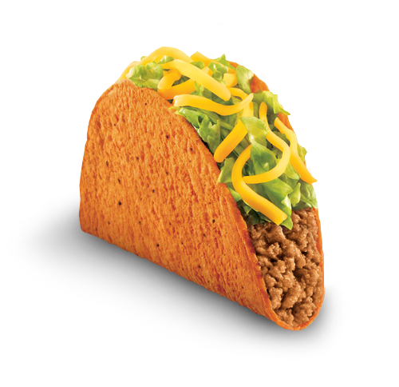(+)Kristina
Wed | Sep 16 | 12:10p D | (+)Kristina  Tacos for Sale September 20  after the 10 a.m. and 2 p.m. Masses. There will be pork tacos with  homemade flour and corn tortillas  along with red and green salsa. Thank you.
Thur | Sep 17 | 12:10p D | (+)Kristina
Fri | Sep 18 | 12:10p D | (+)Kristina
Sat | Sep 19 | 4:00p D | (+)George E. Coughlin
 |  | 6:00p R | (+)Kristina
Sun | Sep 20 | 8:00a M
 |  | 10:00a D
 |  | 12:00p W
 |  | 2:00p D | (+)Kristina | You can have a Mass said for someone's intentions at their birthday, wedding, baptism, or in memory of your deceased loved ones. Contact the office for days and times that you wish to have  the Mass celebrated.  What a precious gift!
Thanks to your generosity our Catholic Food Bank was able to help 593 families for a total of 1,684 people in July and August!
T-Shirts for sale after all Masses
to benefit our Christmas Bazaar.
The prices are: Onesies: $20.00,
Youth: $25.00, Adult: S/M/L $28.00,
XL/XXL/XXXL: $30.00.
We are taking orders if we don't have your size. Payment is expected at the time of the order.

Third Annual Christmas Bazaar
November 20, 21 and 22
Order Tamales by Carmen
at $25.00 per dozen.
Order and pay at the office.
Pick up will be
Saturday, Nov 14.

Eggrolls by Agnes, order now.
She will only make 20 dozen.
They are $40 per dozen.
Pick up will be Friday, October 16.
Place order and pay at the office.

The profit will equally be divided between three Parishes: Walters, Duncan and Marlow for the purpose of the building fund. We need your time, talent and treasure to make this event successful.

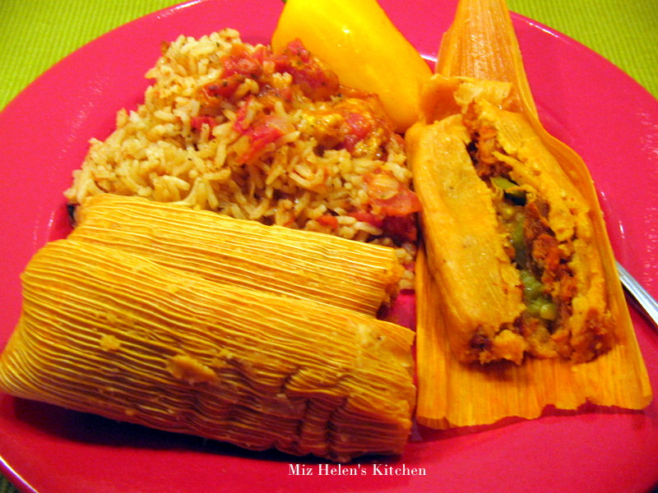
Website Sponsorships Available
In the weeks ahead, our parish representative from Solutio, Inc., will be setting up the advertising for our website for the year.

Please consider participating in this effort since the revenue from the ads is what makes the website possible at no cost to the parish.

It’s a great way to get your name in front of the families in the parish. Advertisements may be purchased for a business, family memorial, or you can sponsor an ad supporting Catholic Charities, Knights of Columbus, Vocations, etc.

Please give these ideas some thought. We need and appreciate your help! If you are interested or just curious as to prices and want more information, please contact 580.713.0264 or Sponsorship@SolutioSoftware.com.

You can have a Mass said for someone's intentions at their birthday, wedding, baptism, or in memory of your deceased loved ones. Contact he office for days and times that you wish to have the Mass celebrated. What a precious gift!

Te invitamos al grupo de oracion
todas los martes a las 7 p.m.

Abuse of Minors Response Hotline 405-720-987 or DHS at 1-800-522-3511. Telefóno Pastoral para Reportar Abuso de Menores 405-720-9878 o el Departamento de Servicios Humanos 1-800-522-3511.


Parish Youth Soccer Challenge

Wednesday, Sept 30, 2015
Where: Assumption Church School Grounds
Time: 6:00 PM until 8:00 PM
All boys & girls ages 10-14 are encouraged to participate and be eligible to win new soccer balls and qualify for the Knights of Columbus District Soccer Challenge. The Knights of Columbus will also offer a ‘Free Hot Dog, Chips and Drink Meal’ during the event. So grab your parents and treat them to supper and have fun kicking the soccer ball. All Parishioners are welcome to come out and enjoy the Wednesday evening event & meal. It should be lots of fun for everyone.
CHOIR NEWS:
Join the Choir at our Church!

Adult Choir Practice:
Saturdays at 2:45 p.m.,
Sundays at 8:45 a.m.

Bell Choir Practice:
Saturdays from 5:00-5:45 p.m.

Spanish Choir Practice:
Sundays at 1:00 p.m.

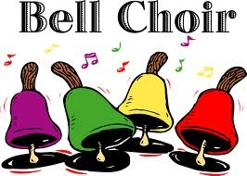



OKTOBERFEST

When: Friday, October 9, 2015
6:30 PM - ????

Where: Immaculate Conception Catholic Church – Marlow

Come join us for some good old fashioned German food and drink, and German Beer!

We’ll have Brat’s, and some wonderful strudels

Feel free to bring your own German food side dish

Let us know you are coming---email Bill Havron at billhavron@yahoo.com, or 580-512-6867
before October 2nd.

Birth Choice Needs Volunteers
You can make a difference in someone’s life! Volunteers work 2-4 hour shifts. Duties include answering phones, administering pregnancy tests, clerical work and work in clothing room. Nurses needed for clinic and ultrasound. Bilingual volunteers also needed. Volunteer Training-Saturday, Sept. 19. 9 a.m. - 12 p.m. 4701 S. Western, OKC. For more information, call Barbara at 606-8426.


DUNCAN COLLECTIONs FOR September 5-6:
Duncan: $2,326.97
Weekly Electronic Donations: $1,500.00
Food Bank: $777.00
St. Vincent de Paul: $153.00
Building Fund: $40.00
Fr. Peter's Coffee Mug for the Food Bank: $174.55
Ryan: $164.10
Thank you for your generosity!!!

Please Note: You can always donate via automatic withdrawal directly to our church's account. It is easy, simple and at the end of the fiscal year you will receive a tax letter acknowledging your donations. For more information stop by the office after each Mass.
Thank you for your support.

Annual Young Adult Mass and Cookout
Catholic Young Adults of Oklahoma City
Join us for faith, fellowship and fun in OKC! Open to all young adults (ages 18-39, married or single) in the archdiocese. Visit our Facebook page (Catholic Young Adults of OKC) for events and information or e-mail info@catholicyoungadultsokc.com.

Duncan Altar Society News:
Dues will be collected on the weekends of
September 12, 13 and 19, 20
after all Duncan Masses.
All ladies of the Parish
are members of the Altar Society!
The next meeting is
Thursday, October 1 after 12:10 p.m. Mass

WOMEN OF FAITH/WOMEN OF ACTION
FALL LUNCHEON
Most Reverend Paul S. Coakley, Archbishop of Oklahoma City, is special guest speaker for the Women of Faith/Women of Action fall luncheon on Saturday September 19, 2015 to be held at the Catholic Pastoral Conference Center. Archbishop Coakley is currently the Chairman, Catholic Relief Services Board of Directors. He will speak about his involvement with helping and serving those in need in 93 countries representing the United States Catholics. Doors will open at 11:00am so you will be able to shop our Fair Trade booth and visit Catholic Relief Services and the National Council of Catholic Women’s booths. A Buffet luncheon will be served. A donation shall be made to Catholic Relief Services. Registration is now open and seating is limited. Cost is $25. Text/email Chris Thomas (thomaschrisL@sbcglobal.net)405-306-5187 or Mary Ann Schmitt (smaschm@aol.com) 405-650-9674.

Saint Patrick Catholic Church
THIRD AND OHIO POST OFFICE BOX 151
Walters, Oklahoma 73572
************************************
Collections:
September 6: Operating: $453.79 Bldg: $504.00

