8
Twenty-Second Sunday in Ordinary Time
August 30, 2015

Mass Intentions / Peticiones de Misa

Please notice: The office will be closed on Monday, September 7 in observance of Labor Day.
Sat | Aug 29 | 4:00p D | (+)George E. Coughlin
 |  | 6:00p R | For the Parishioners
Sun | Aug 30 | 8:00a M
 |  | 10:00a D | For the Intentions of  !!!Religious Education News!!!  1st-7th Grades, Wednesdays, 6:00-7:30 p.m.  8th-12th Grades,  Sundays,11:00 a.m. - 12:30 p.m.  Enrollment will be held the this weekend  Aug 29-30 and Sep 5-6 after all Masses  R.E. Classes will resume  Sunday, September 20 and  Wednesday September 23!  Edie Stone by Tom Stone
 |  | 12:00p W
 |  | 2:00p D
Mon | Aug 31 | 12:10p D | (+)Jack Geurkink
Tues | Sep 1 | 12:10p D | (+)Jack Geurkink
Wed | Sep 2 | 12:10p D
Thur | Sep 3 | 12:10p D | Living & Deceased Members of the Altar Society
Fri | Sep 4 | 12:10p D
Sat | Sep 5 | 4:00p D | (+)Jack Geurkink By  Shannon & Bennie Wilson
 |  | 6:00p R | For the Parishioners
Sun | Sep 6 | 8:00a M | On the weekend of September 5-6 there will be a second collection for our Food Bank. This collection will help us to prepare ourselves for the Thanksgiving and Christmas holidays.
 |  | 10:00a D | (+)Al Bernal by Suzanne
 |  | 12:00p W
 |  | 2:00p D |  | You can have a Mass said for someone's intentions at their birthday, wedding, baptism, or in memory of your deceased loved ones. Contact the office for days and times that you wish to have  the Mass celebrated.  What a precious gift!
T-Shirts for sale after all Masses
to benefit our Christmas Bazaar.
The prices are: Onesies: $20.00,
Youth: $25.00, Adult: S/M/L $28.00,
XL/XXL/XXXL: $30.00.
We are taking orders if we don't have your size. Payment is expected at the time of the order.

Christmas Bazaar Work Day
Our Christmas Bazaar will be held on November 20, 21 and 22. There will be a work day on Saturday, September 12 at 10 a.m. in Gillespie Hall. The profit will equally be divided between three Parishes: Walters, Duncan and Marlow for the purpose of the building fund. We need your time, talent and treasure to make this event successful.

Website Sponsorships Available
In the weeks ahead, our parish representative from Solutio, Inc., will be setting up the advertising for our website for the year.

Please consider participating in this effort since the revenue from the ads is what makes the website possible at no cost to the parish.

It’s a great way to get your name in front of the families in the parish. Advertisements may be purchased for a business, family memorial, or you can sponsor an ad supporting Catholic Charities, Knights of Columbus, Vocations, etc.

Please give these ideas some thought. We need and appreciate your help! If you are interested or just curious as to prices and want more information, please contact 580.713.0264 or Sponsorship@SolutioSoftware.com.

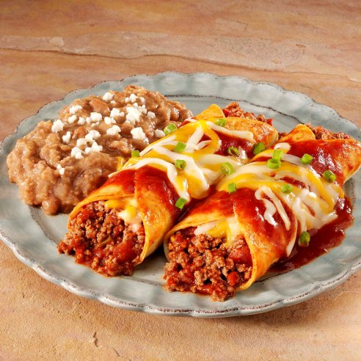
Youth Enchilada Dinner

The Youth will have an
Enchilada Dinner
Sunday, August 30
after the 10 a.m. and
2:00 p.m. Masses in the
R.E. Building.
The cost is $7.00.
Please support the Youth
of our Parish!
You can have a Mass said for someone's intentions at their birthday, wedding, baptism, or in memory of your deceased loved ones. Contact he office for days and times that you wish to have the Mass celebrated. What a precious gift!

Abuse of Minors Response Hotline 405-720-987 or DHS at 1-800-522-3511. Telefóno Pastoral para Reportar Abuso de Menores 405-720-9878 o el Departamento de Servicios Humanos 1-800-522-3511.

Duncan Altar Society News:
Meeting Thursday, September 3 after 12:10 Mass. Bring a dish and a friend!
We have new items at our Gift Shop.

CHOIR NEWS:
Join the Choir at our Church!

Adult Choir Practice:
Saturdays at 2:45 p.m.,
Sundays at 8:45 a.m.

Bell Choir Practice:
Saturdays from 5:00-5:45 p.m.

Spanish Choir Practice:
Sundays at 1:00 p.m.



Prayer Day for the Retired
Wednesday, September 2 at the Catholic Pastoral Center, Room 14/15. The Presenter is George Rigazzi, "The History of the Church in Oklahoma." There is a 9:30 a.m. registration with lunch at 11:30 a.m. The cost is $7.00. To register and attend call 405-721-5651 x 158.

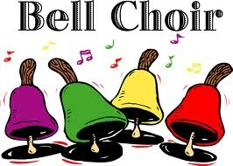



South Region of Oklahoma City
Archdiocesan Council of Catholic Women (ACCW)
Saturday, September 12, 2015 at Immaculate Conception: Fifth Quarterly Meeting. Mark and Fran Gildon will present a slide show on their trip to Jerusalem. Registration is at 9 a.m. with lunch at noon. Bring an item for the silent auction. Lunch will cost $6.00. Please RSVP to Susan Evans at 580-251-0956 by Wednesday, Sep 9!
***
Save the Date: Archbishop Coakley will be guest speaker at the Archdiocesan Council of Catholic Women’s fall luncheon on Sat., Sept. 19, at the Catholic Pastoral Center. He will discuss his involvement as chairman of the USCCB/Catholic Relief Services Board. Registration is $25. Contact Chris Thomas at thomaschrist@sbcglobal.net or (405) 306-5187 or Mary Ann Schmitt (smaschm@aol.com)405-650-9674.

Marriage Encounter Weekend coming:
In the second reading we are told, "Be doers of the word and not hearers only." Does your marriage show others Christ's love? The next Worldwide Marriage Encounter Weekend is September 11-13 at the Catholic Pastoral Center, 7501 NW Expressway, Oklahoma City, OK. Weekends fill up quickly so a prompt response is encouraged. For more information, please contact Rick & Bev Feller at 405-323-9119 or to complete application information on line at meoklahoma.org

Annual Young Adult Mass and Cookout
This event for young adults will take place Saturday, Sept. 12, from 2:15 p.m. to 6 p.m. at the Catholic Pastoral Center, conference room C-1. Registration begins at 2:15 p.m. Fr. Simeon Spitz of St. Gregory’s Abbey will give a presentation. Mass with Archbishop Coakley will be at 4 p.m.; dinner at 5 p.m. Cost is $10. To register, contact the Youth and Young Adult Office by Sept. 3 at (405) 721-9220 or bjaime@archokc.org.
+++
Catholic Young Adults of Oklahoma City
Join us for faith, fellowship and fun in OKC! Open to all young adults (ages 18-39, married or single) in the archdiocese. Visit our Facebook page (Catholic Young Adults of OKC) for events and information or e-mail info@catholicyoungadultsokc.com.

WOMEN OF FAITH/WOMEN OF ACTION
FALL LUNCHEON
Most Reverend Paul S. Coakley, Archbishop of Oklahoma City, is special guest speaker for the Women of Faith/Women of Action fall luncheon on Saturday September 19, 2015 to be held at the Catholic Pastoral Conference Center. Archbishop Coakley is currently the Chairman, Catholic Relief Services Board of Directors. He will speak about his involvement with helping and serving those in need in 93 countries representing the United States Catholics. Doors will open at 11:00am so you will be able to shop our Fair Trade booth and visit Catholic Relief Services and the National Council of Catholic Women’s booths. A Buffet luncheon will be served. A donation shall be made to Catholic Relief Services. Registration is now open and seating is limited. Cost is $25. Text/email Chris Thomas (thomaschrisL@sbcglobal.net)405-306-5187 or Mary Ann Schmitt (smaschm@aol.com) 405-650-9674.

Saint Patrick Catholic Church
THIRD AND OHIO POST OFFICE BOX 151
Walters, Oklahoma 73572
************************************
Collections:
August 23: Operating: $395.00

DUNCAN COLLECTIONs FOR August 22-23:
Duncan: $2,719.37
Weekly Electronic Donations: $1,400.00
Hispanic Garage Sale: $1,000.00
Catholic University: $259.72
Building Fund: $40.00
Food Bank: $9.00
St. Vincent de Paul: $9.00
Ryan: $227.00
Thank you for your generosity!!!

Please Note: You can always donate via automatic withdrawal directly to our church's account. It is easy, simple and at the end of the fiscal year you will receive a tax letter acknowledging your donations. For more information stop by the office after each Mass.
Thank you for your support.

