Nineteenth Sunday in Ordinary Time
August 9, 2015

The Assumption of the
Blessed Virgin Mary,
Saturday, August 15

There will be a Mass
in Duncan at 10 am

Collection will be taken for the benefit of our Food Bank.

Mass Intentions / Peticiones de Misa

Sat | Aug 8 | 4:00p D | 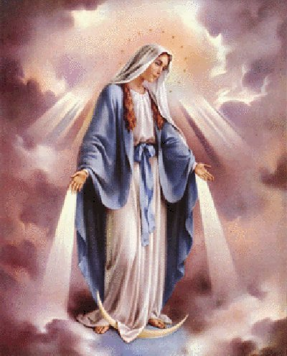(+)Paula Estrada  by Alicia Martinez
 |  | 6:00p R | For the Parishioners
Sun | Aug 9 | 8:00a M | (+)Don Trostle & Jake Seratte
 |  | 10:00a D | (+)Alfred Pittman
 |  | 12:00p W
 |  | 2:00p D | (+)Anna Mae Jones by  Lee & Maria Jones
Mon | Aug 10 | 12:10p D | (+)George E. Coughlin
Tues | Aug 11 | 12:10p D | Intentions of Howard Doerr by The Wolfgang-Deeg Family
Wed | Aug 12 | 12:10p D | Safe travels for Luke and Alina by Anna Fitts  !!!Religious Education News!!!  1st-7th Grades, Wednesdays, 6:00-7:15 p.m.  8th-12th Grades,  Sundays,11:15 a.m. - 12:30 p.m.  Enrollment will be held the weekends of Aug 22-23 and 29-30 after all Masses  R.E. Classes will resume  Sunday, September 20 and  Wednesday September 23!  We are in need of two teachers!  Please consider giving of your time and talent to teach our youth. You will gain many rewards!  Please contact the office if you're interested!
Thur | Aug 13 | 12:10p D | Safe travels for Luke and Alina by Anna Fitts
Fri | Aug 14 | 12:10p D | Safe travels for Luke and Alina by Anna Fitts
Sat | Aug 15 | 10:00a D | The Assumption of the Blessed Virgin Mary
 |  | 4:00p D | (+)Krystina by Ann & Anna
 |  | 6:00p R
Sun | Aug 16 | 8:00a M
 |  | 10:00a D | (+)Marguerite Moore
 |  | 12:00p W
 |  | 2:00p D |  | You can have a Mass said for someone's intentions at their birthday, wedding, baptism, or in memory of your deceased loved ones. Contact the office for days and times that you wish to have  the Mass celebrated.  What a precious gift!
Guadalupe 4th Annual
Garage Sale
Saturday, August 15!
Assumption's R.E. Building
We're accepting donations: furniture,
clothing, toys, dishes, etc...
To pick up items please call:
Noé Sanchez 475-4892

Annual Young Adult Mass and Cookout
This event for young adults will take place Saturday, Sept. 12, from 2:15 p.m. to 6 p.m. at the Catholic Pastoral Center, conference room C-1. Registration begins at 2:15 p.m. Fr. Simeon Spitz of St. Gregory’s Abbey will give a presentation. Mass with Archbishop Coakley will be at 4 p.m.; dinner at 5 p.m. Cost is $10. To register, contact the Youth and Young Adult Office by Sept. 3 at (405) 721-9220 or bjaime@archokc.org.
Catholic Young Adults of Oklahoma City
Join us for faith, fellowship and fun in OKC! Open to all young adults (ages 18-39, married or single) in the archdiocese. Visit our Facebook page (Catholic Young Adults of OKC) for events and information or e-mail info@catholicyoungadultsokc.com.

We pray the
Chaplet of Divine Mercy
and the Rosary
Monday through
Friday at
11:45 a.m.
before the 12:10 Mass.
Everyone is invited
to participate and
spend time with Jesus!

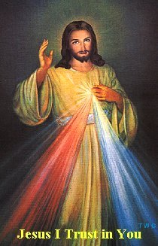

You can have a Mass said for someone's intentions at their birthday, wedding, baptism, or in memory of your deceased loved ones. Contact he office for days and times that you wish to have the Mass celebrated. What a precious gift!

Abuse of Minors Response Hotline 405-720-987 or DHS at 1-800-522-3511. Telefóno Pastoral para Reportar Abuso de Menores 405-720-9878 o el Departamento de Servicios Humanos 1-800-522-3511.

Duncan Altar Society News:
Meeting Thursday, September 3 after 12:10 Mass. Bring a dish and a friend!

We have new items at our Gift Shop.

Southern Region of Oklahoma City
Archdiocesan Council of Catholic Women (ACCW)
Saturday, September 12, 2015 at Immaculate Conception: Fifth Quarterly Meeting. Mark and Fran Gildon will present a slide show on their trip to Jerusalem.

Save the Date: Archbishop Coakley will be guest speaker at the Archdiocesan Council of Catholic Women’s fall luncheon on Sat., Sept. 19, at the Catholic Pastoral Center. He will discuss his involvement as chairman of the USCCB/Catholic Relief Services Board. Registration is $25. Contact Chris Thomas at thomaschrist@sbcglobal.net or (405) 306-5187 or Mary Ann Schmitt (smaschm@aol.com)405-650-9674.

CHOIR NEWS:
Join the Choir at our Church!

Adult Choir Practice:
Saturdays at 2:45 p.m.,
Sundays at 8:45 a.m.

Bell Choir Practice:
Saturdays from 5:00-5:45 p.m.

Spanish Choir Practice:
Sundays at 1:00 p.m.






Marriage Encounter Weekend coming:
Find out God's way for your marriage on an upcoming Worldwide Marriage Encounter Weekend! The next Marriage Encounter weekend is September 11-13 at Catholic Pastoral Center, 7501 NW Expressway, Oklahoma City. Weekends fill up quickly so a prompt response is encouraged. For more information, please contact Rick & Bev Feller at 405-323-9119 or to complete application information on line at meoklahoma.org.

DUNCAN COLLECTIONs FOR August 1-2:
Duncan: $2,258.91
Weekly Electronic Donations: $1,400.00
Building Fund: $20.00
Food Bank: $62.00
St. Vincent de Paul: $248.00
Ryan: $180.00
Thank you for your generosity!!!

Saint Patrick Catholic Church
THIRD AND OHIO POST OFFICE BOX 151
Walters, Oklahoma 73572
************************************
Collections:
August 2: Operating: $476.99 Building: $390.00

Please Note: You can always donate via automatic withdrawal directly to our church's account. It is easy, simple and at the end of the fiscal year you will receive a tax letter acknowledging your donations. For more information stop by the office after each Mass.
Thank you for your support.

Retrouvaille
Hope and healing for troubled, separated and divorced couples can be found at the OKC Retrouvaille Program Aug. 28-30 at the Catholic Pastoral Center, 7501 Northwest Expressway, OKC. Go online to www.retrouvaille.org or call (405) 443-3541.
Workshop for Parish Ministers
We invite all parish ministers to a special workshop called "Intercultural Competencies for Ministers." This workshop is especially for Religious Education directors, school principals, youth directors, deacons and other ministers. The same presentation will be offered twice – Tuesday, Aug. 18, 7 p.m. to 9 p.m., and Wednesday, Aug. 19, 9:15 a.m. to 11:15 a.m. at the Catholic Pastoral Center, 7501 Northwest Expressway, OKC. The speaker will be Dr. Arturo Chavez, president of the Mexican American Catholic College in San Antonio.

The International Dominican Foundation Welcomes Fr. Marcel Sigrist, O.P. at the Catholic Pastoral Center, 7501 Northwest Expressway, Wednesday, August 26, 7:30-9:00 p.m. "Dominican Presence in the Holy Land, 1250 to Today." Rev. Dr. Marcel Sigrist, O.P., is a Dominican priest and director for the Ecole Biblique et Archeologique Francaise de Jerusalem (EBAF). He is the author of numerous articles and books in the area of Mesopotamian Antiquity and Cuneiform. For more information call 405/721-4208.

