Mass Intentions / Peticiones de Misa

The Most Holy Trinity, May 31, 2015

Sat | May 30 | 4:00p D | (+)Jack Geurkink by  On May 27, 2015 Most Reverend Paul S. Coakley, Archbishop of Oklahoma City has appointed Father Bala Raju Pudota as a Pastor of St. Rose of Lima in Perry, Oklahoma. Fr. Bala will take his Pastorship on July 1, 2015.  We want to thank Fr. Bala for his two years of service to Assumption and all its Missions. On Sunday, June 14 at 4 p.m. in Gillespie Hall we will have a Potluck Goodbye Dinner for Fr. Bala.  Everyone is welcome to attend and show their appreciation for Fr. Bala.  Please bring the following dishes according to your last name:  A – I Main Dish: Casseroles, etc.  J – R Side Dish: Vegetables, salads,bread/rolls  S – Z: fruit  Patty & Greg Winegardner
 |  | 6:00p R | For the Parishioners
Sun | May 31 | 8:00a M | (+)Ben Benedict by Ann Boice
 |  | 10:00a D | (+)George E. Coughlin
 |  | 12:00p W | Living & Deceased Members of the Altar Society
 |  | 2:00p D | (+)Florita Millan  by The Millan Family
Mon | June 1 | 12:10p D | (+) Michael Parks
Tues | June 2 | 12:10p D | NO MASS
Wed | June 3 | 12:10p D | NO MASS
Thur | June 4 | 12:10p D | NO MASS
Fri | June 5 | 12:10p D | NO MASS
Sat | June 6 | 4:00p D | (+)Don Trostle and Jake Seratte by The Family
 |  | 6:00p R | (+)Jack Geurkink
Sun | June 7 | 8:00a M | (+)Jack Geurkink
 |  | 10:00a D | (+)Al Bernie by Suzanne
 |  | 12:00a W | For the Parishioners
 |  | 2:00p D | Int of Howard Doerr by  The Wolfgang-Deeg Family
Have you signed up for the
Lance Warren Ordination Reception on Sunday, June 28?
Please sign up after Mass or
in the office during the week!
There is no cost for the dinner.
The last day to sign up is
Sunday, June 14!!!

FIRST FRIDAY ADORATION
ADORACIÓN _{DEL} 1er VIERNES
June 5
7:00 p.m.

You can have a Mass said for someone's intentions at their birthday, wedding, baptism, or in memory of your deceased loved ones. Contact he office for days and times that you wish to have the Mass celebrated. What a precious gift!

The Altar Society will be selling Mexican Stack dinner after 4 p.m. Saturday and 10 a.m. Sunday Mass. The cost of dinner is $6.00 per plate with dessert.

Abuse of Minors Response Hotline 405-720-987 or DHS at 1-800-522-3511. Telefóno Pastoral para Reportar Abuso de Menores 405-720-9878 o el Departamento de Servicios Humanos 1-800-522-3511.

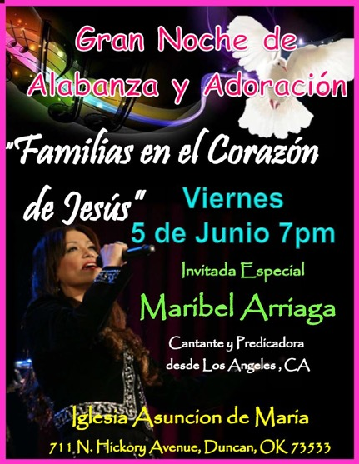
You are cordially invited to the Priesthood Ordination Mass of our Parishioner Lance Warren. The Mass will take place on Saturday, June 27 at 10 a.m. in Our Lady Cathedral in Oklahoma City. We invite you to join us for 5 p.m. Mass at Assumption Catholic Church, Duncan, Oklahoma on Sun Jun 28 during which our newly ordained Father Lance will preside. Due to this important celebration we will cancel 8 a.m. Marlow, 12:00 p.m. Walters and 2 p.m. Spanish Masses. There will a catered reception following the 5 p.m. Mass in the R.E. Building. The reception is free of charge; however, you must sign up to attend after all weekend Masses. Do not call the office to put your name on the list. The last day for sign up is Sunday, June 14, 2015. Let us all show our support for Lance as he begins his Priestly Ministry.

Estas cordialmente invitado a la misa de Ordenación Sacerdotal de Lance Warren. Esta misa será el sábado, 27 de junio a las 10 a. m. en Our Lady Cathedral (iglesia catedral) en Oklahoma City. También, acompáñanos a la misa de 5 p.m. el domingo junio 28 donde recibiremos a Lance como el nuevo sacerdote en nuestra parroquia. Por esta razón, se cancelaran las siguientes misas: 8a.m. en Marlow, 12:00p.m. Walters, y 2:00p.m. misa de español. Solo tendremos una misa a las 5 p.m. Después tendremos una recepción en el edificio de Educación Religiosa. La recepción será gratis pero tendrán que anotarse después de cada misa hasta junio 14, 2015 para saber cuánta comida ordenar. Vamos a apoyar a Lance en su comienzo de su ministerio sacerdotal.
Please remember our Parish in your will.
All are welcome to attend:
Singing Workshop -
Find your voice, unlock your potential;
Sing like a Catholic, pray twice!!!
by Amanda Mara Rizzotto

Singing Fundamentals Introduction
Sunday, May 31 - 7-8 p.m.

Vocal Techniques-Practical Singing
Sunday, June 7 7-8 p.m.
Free Admission

Assumption Catholic Church
Invite your friends and family!
Please Note: You can always donate via automatic withdrawal directly to our church's account. It is easy, simple and at the end of the fiscal year you will receive a tax letter acknowledging your donations. For more information stop by the office after each Mass.
Thank you for your support.

DUNCAN COLLECTIONs FOR may 23-24:
Duncan: $2,185.06
Weekly Electronic Donations: $1,400.00
Food Bank: $75.00
St. Vincent de Paul: $55.00
Building Fund in Memory of Jack Geurkink: $1,595.00
Building Fund: $80.00
Ryan: $372.00

Thank you for your generosity!!!

Vacation Bible School will be from June 8th to June 12th, 4:30pm to 8pm. We will have a volunteer sign-up sheet after Mass May 9th and 10th, or you can call Rosie Lou at 580-678-7001 for more information. We need teachers, snack staff, sports staff, music staff, and volunteers to decorate. High school students are welcome and encouraged to help. Registration will start May 30-31 and June 6-7.

Vacation Bible School (Escuela de Biblia en vacaciones) Se llevara a cabo de el lunes 8 a el 12 de Junio de 4:30 a 8:00 pm. Tendremos una lista para agregar voluntarios después de misa el 9 y 10 de Mayo o puede llamar directamente a Rosie Lou al telefono 580-678-7001. Necesitamos voluntarios siendo maestros, ayudando con las botanas, ayudando con los juegos y deportes, con la música, y voluntarios para decorar. Estudiantes de preparatoria son bienvenidos como voluntarios! Padres de familia podrán registrar a sus hijos después de las misas de el ultimo fin de semana de Mayo y el primer fin de semana de Junio.

