May the Risen Lord bring you
and your family
Easter joy and peace.
Happy Easter.
Fr Bala and Fr. Peter
Mass Intentions / Peticiones de Misa

Easter Sunday of the Resurrection of the Lord, April 5, 2015

Sat | Apr 4 | 8:00p D | Easter Vigil Mass
Sun | Apr 5 | 8:00a M | For the Parishioners
 |  | 10:00a D | (+)George E. Coughlin
 |  | 10:00p W
Mon | Apr 6 | 12:10p D |  Int of Karen, Juanita, Michelle, Carmen and Guadalupe  Assumption of the  Blessed Virgin Mary Church,  Duncan, OK  Requests the honor of  your presence at the  Sacrament of Confirmation of:  Stephanie Chaidez  Gilberto Diaz  Adriana Dominguez  Hanna Forsythe  Jonathan Gomez  Daniel Gonzalez  Keegan Heiss  Carlos Hernandez  Gerardo Hernandez  Angelica Herrera  Mario Izaguirre  Jose Juame  Cade Kelly  Nathaly Leanos  Brooklyn Minden  Chase Minden  Krista Power  Hayley Ramirez  Mallory Rankin  Samantha Rocha  The sacrament will be celebrated by the  Most Reverend Paul S. Coakley,  Archbishop of Oklahoma City  On Friday, the Tenth day of April,  two thousand and fifteen  at seven o’clock p.m.
Tues | Apr 7 | 12:10p D | (+)George E. Coughlin
Wed | Apr 8 | 12:10p D | Int of Howard Doerr by the Wolfgang-Deeg Family
Thur | Apr 9 | 12:10p D | Living & Deceased Members of the altar Society
Fri | Apr 10 | 7:00p D | Confirmation
Sat | Apr 11 | 4:00p D | (+)Glen Neal
 |  | 6:00p R
Sun | Apr 12 | 8:00a M
 |  | 10:00a D | (+)Clarence L. Neal
 |  | 12:00a W
 |  | 2:00p D
Duncan Altar Society News:

We have new items at our Gift Shop for Easter, R.C.I.A., Confirmation, and First Communion.
Come buy your gifts early.

Altar Society Meeting
Thursday, April 9 after 12:10 Mass

Our Catholic Food Bank is looking for two volunteers to work on Thursdays from 9-11 a.m.
Please contact the office if you're interested.

Come and See Weekend
Come and See Weekend will be held April 18-20 at Conception Seminary College. The trip is for young men who are juniors and seniors in high school and older who would like to visit a seminary. This is an excellent opportunity to meet seminarians who are discerning their call to the priesthood. This visit is sponsored by the archdiocesan Vocations Office and is free. Contact your pastor or the Vocations Office at (405) 721-9351 or vocations@archokc.org. The deadline to register is April 8. For additional information, go online to www.conception.edu/vocations/encounter-with-gods-call-weekend.

You can have a Mass said for someone's intentions at their birthday, wedding, baptism, or in memory of your deceased loved ones. Contact he office for days and times that you wish to have the Mass celebrated. What a precious gift!

Abuse of Minors Response Hotline 405-720-987 or DHS at 1-800-522-3511. Telefóno Pastoral para Reportar Abuso de Menores 405-720-9878 o el Departamento de Servicios Humanos 1-800-522-3511.

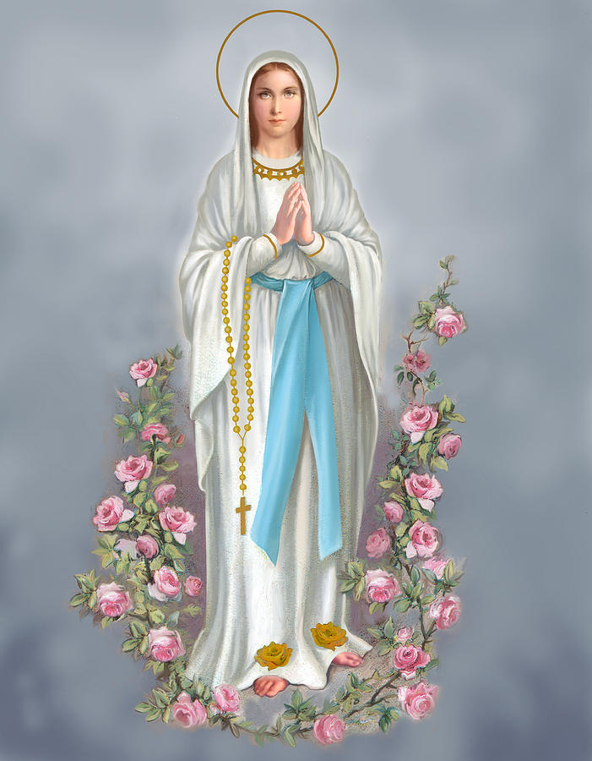

Daughters of Mary/Hijas de Maria
If you are a lady of our Parish you are invited to participate in our group every Wednesday at 11:00 a.m. starting April 15, 2015! Come and join us in the readings of the upcoming Sunday Mass, discussions of our faith, and support for one another. We will meet at Church at 10:45 a.m., starting no later than 11 a.m. We will assist Mass at 12:10 and we will have a potluck for lunch right after. Come and see what we are all about, we will welcome each other as sisters in Christ and daughters of Mary. For questions call Rosie at 575-631-0409.
Si eres una dama de nuestra parroquia estas invitada a participar en nuestro grupo cada Miercoles a las 11:00 am empezando el Miercoles 15 de Abril del 2015! Venga a compartir las lecturas de la misa del Domingo siguiento, una discusion sobre nuestra fe, y apoyo de unas a las otras. Nos vamos a reunir a las 10:45 am para empezar no mas tarde de las 11:00 a.m. Vamos a asistur a misa a las 12:10 y saliendo vamos a compartir el almuerzo, por favor si es possible, traiga su plato favorito! Venga a ver de que se trata; nos vamos a recibir unas a las otras como hermanas en Cristo y como hijas de Maria. Si tiene preguntas por favor llamar a Rosie al 575-631-0409.
!!!Religious Education News!!!
1st-7th Grades, Wednesdays, 6:00-7:15 p.m.
8th-12th Grades,
Sundays, 11:15 a.m. - 12:30
Dates to Remember:
Sun, Apr 5 - Easter Sunday, No Class
Wed., Apr 8 - Confirmation Rehearsal, 6 p.m.
Fri, Apr 10 - Confirmation, Assumption, 7 p.m.
Sun, Apr 19 - Last Class Confirmation 1 & 2
Sun, Apr 26 - Catechists Meeting, 11 a.m.
Lunch Provided
Sun., May 17 - First Communion, 10 a.m.
Wed, May 13 - Last R.E. Class

SCHOLARSHIPS!!! - IT IS THAT TIME AGAIN
ASSUMPTION CATHOLIC CHURCH and the Knights of Columbus Council No. 5168 are again accepting applications for the Jesse Wayne Moore Scholarships for the graduating seniors wishing to further their education this year. A few scholarships, from $300 to $1,500 are available. You may obtain application forms from Jim Surjaatmadja or the Assumption Church Office and submit the applications and the necessary documents ON or BEORE Monday, April 20, 2015 to the Church's office or myself. All applications will be judged on Parish activities, community activities and scholastic achievements.
A note to all Parish Members: On behalf of the Knights and the graduating Seniors, we would like to thank everyone for the generous contributions that help make the Scholarship Program continue throughout the years. But, we will need your support again for the years to come. For this, again we will ask your continued generous monthly contributions. Please write your checks to Assumption Church Scholarship Fund. Thank you again for your continuing support! Jim Surjaatmadja, Scholarship Chairman, Knights of Columbus 5168.

[Type a quote from the dbox.]
Guadalupe 4th Annual Garage Sale Saturday, May 23!
We're accepting donations: furniture,
clothing, toys, dishes, etc...
To pick up items please call: Noé Sanchez 475-4892

CHOIR NEWS:
Join the Choir at our Church!

Adult Choir Practice:
Saturdays at 2:30 p.m., Sundays at 8:45 a.m.

Children's Choir Practice:
Saturdays from 5:00-5:45 p.m.

Spanish Choir Practice:
Sundays at 1:00 p.m.

Please Note: You can always donate via automatic withdrawal directly to our church's account. It is easy, simple and at the end of the fiscal year you will receive a tax letter acknowledging your donations. For more information stop by the office after each Mass.
Thank you for your support.

DUNCAN COLLECTIONs FOR mar 28-29:
Duncan: $2,466.66
Weekly Electronic Donations: $1,375.00
Easter Flower Second Collection: $348.05
St. Vincent de Paul: $94.00
Scholarship: $5.00
Building: $70.00
Food Bank: $105.00
Ryan: $210.00
Thank you for your generosity!!!

Saint Patrick Catholic Church
THIRD AND OHIO POST OFFICE BOX 151
Walters, Oklahoma 73572
************************************
Collections:
Mar 29: Operating: $355.00; Building: $125.00

Please remember our Parish in your will.

