
The Epihany of the Lord
January 4, 2015

For Your Information:
Our Catholic Food Bank
during 2014 has provided services to:
3,635 households with 11,197 people.
Thank you for your generosity and contributions to our
Catholic Food Bank!
Mass Intentions / Peticiones de Misa

Sat | Jan 3 | 4:00p D | Intentions of the  Giannetti Family
 |  | 6:00p R | Int of Mr & Mrs Harold Strong
Sun | Jan 4 | 8:00a M | (+)Andrew Rodiger
 |  | 10:00a D | For the Parishioners
 |  | 12:00p W | Int of the Topping Family
` |  | 2:00p D | For Special Blessings for Krystyne
Mon | Jan 5 | 12:10p D | (+)Leon Fitts by Anna Fitts  We pray the  Chaplet of Divine Mercy  and the Rosary  Monday through Friday at  11:45 a.m.  before the 12:10 Mass.  Everyone is invited to participate and  spend time with Jesus!
Tues | Jan 6 | 12:10p D | Intentions of Richard, Don, Isaiah and Rogelio
Wed | Jan 7 | 12:10p D | Intentions of Miguel, Anna, Blanche, Starzyk Hernandez
Thur | Jan 8 | 12:10a D | Living & Deceased Members of the Altar Society
Fri | Jan 9 | 12:10p D | NO MASS
Sat | Jan 10 | 4:00p D | For the Parishioners
 |  | 6:00p R | Int of Rosalia Scollard
Sun | Jan 11 | 8:00a M
 |  | 10:00a D | 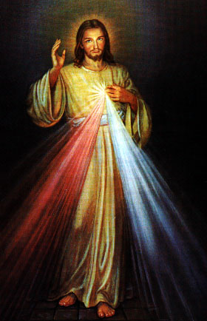Int of Howard Doerr by The Wolfgang-Deeg Family
 |  | 12:00p W | Intentions of Antonio, Maria, Anthony, Theresa and Baby
 |  | 2:00p D
Attention:
There will be no
12:10 p.m. Daily Mass on
Friday, January 9, 2015!

Please remember that you can offer a gift of the Holy Mass for the intention(s) of your loved ones both living and deceased.
Contact the office if you wish to have a Mass celebrated.

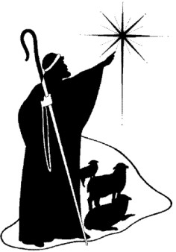
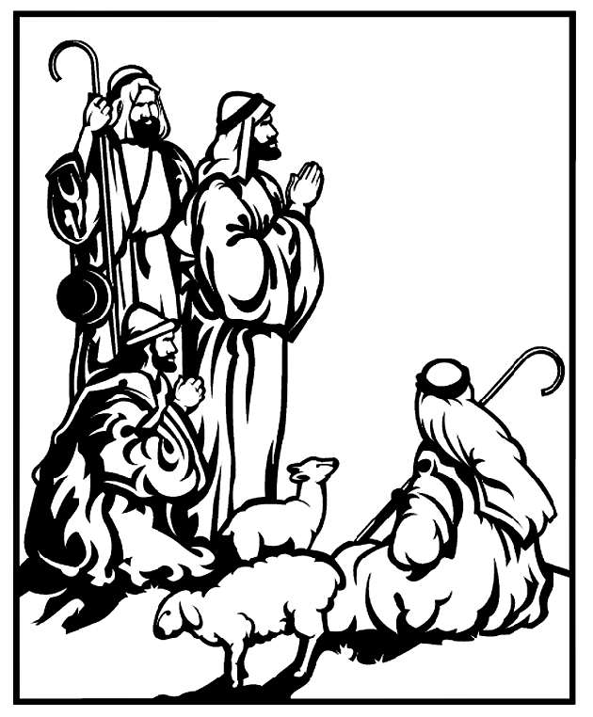

You can have a Mass said for someone's intentions at their birthday, wedding, baptism, or in memory of your deceased loved ones. Contact he office for days and times that you wish to have the Mass celebrated. What a precious gift!

Abuse of Minors Pastoral Response Hotline 405-720-987 or DHS at 1-800-522-3511. Línea Telefónica Pastoral para Reportar Abuso de Menores 405-720-9878 o el Departamento de Servicios Humanos al 1-800-522-3511.

Church Donation Envelopes
Next year you will no longer receive donation envelopes in the mail. The entire year's envelopes will be available for you to pick up at the entrance of the Assumption Church or during the week in the Parish office. The envelopes should arrive shortly and we will let you know when you can pick them up! There has been a delay in receiving our envelopes. We have been assured they will be in next week. Thank you for your patience. Just place your check in the collection you will receive credit!

Please Note: You can always donate via automatic withdrawal directly to our church's account. It is easy, simple and at the end of the fiscal year you will receive a tax letter acknowledging your donations. For more information stop by the office after each Mass.
Thank you for your support.
!!!Religious Education News!!!
1st-7th Grades, Wednesdays, 6:00-7:15 p.m.
8th-12th Grades,
Sundays,11:15 a.m. - 12:30 p.m.
Dates to Remember:
Dec 21-Jan 4: Christmas Holiday, No R.E. Classes
Don't Forget:
Classes resume:
Wednesday, Jan 7 and
Sunday, Jan 11

The Annual Sanctity of Life Mass on Wednesday, January 21 presided over by Archbishop Paul Coakley will begin at 6 p.m. at Our Lady of Perpetual Help Cathedral in Oklahoma City. "As people of faith, we recall Pope Francis' Day for Life greeting that 'each of us is a masterpieces of God's creation' and encourage everyone to treat each person with reverence and respect."



In the Father's Footsteps
Catholic Men's Conference
Saturday, February 28, 2015
Embassy Suites Convention Center
Norman, Oklahoma
Register online Now:
catholicmen.net

IMPORTANT I.R.S. NOTICE
If you require a 2014 tax letter for IRS stating your donations to Assumption Parish or other Missions please contact the office directly. We will NOT mail these statements unless you request them. Please make sure to leave your correct name and address while making your request. If you made cash donations, you're not entitled to receive this letter. Thank you.
The University of Notre Dame Symphony Orchestra will visit OKC during its Winter Tour on Friday, Jan 9. A concert featuring selections from Bach as well as Beethoven's Eight Symphony will be held at 7:30 p.m. at Christ the King Church, 8005 Dorset Drive, Nichols Hills. The event is free and open to the public.
DUNCAN COLLECTIONs FOR dec 20-21
Duncan: $2,803.20
Weekly Electronic Donations: $1,255.00
Building: $135.00
Food Bank: $639.00
Ryan: $147.00

Christmas, Dec 24-25:
Duncan: $2,752.16 Ryan: $325.00

Dec 27-28: $1,315.17
New Building: $20.00
Food Bank: $5.00

Thank you for your generosity!!!

Saint Patrick Catholic Church
THIRD AND OHIO POST OFFICE BOX 151
Walters, Oklahoma 73572
**************************************
Collections:
Dec 14: Operating--$424.00 Building--$25.00
Dec 21: Operating--$387.21 Building--$125.00
Dec 24: Operating--$214.96 Building--$125.00
December 28: Operating--$411.00

Please remember our Parish in your will.
Please remember your Parish in your will.

